Equality Analysis Report
Post-Consultation v3 Final
Integration and Reconfiguration Programme - Clinical Service Model Business Case – Vascular Services
Start Date: | 30 May 2022
NHS Cheshire and Merseyside Integrated Care Board Equality and Inclusion Service (Knowsley, Liverpool, Sefton and St Helens Places) | Andy Woods  Jo Roberts | 23 August 2022  24 August 2022
Trust Lead Officer Signature and Date:
Finish Date: | 24 August 2022
Exec Sign Off Signature and Date
Date of Committee consideration

- Details of service / function:
Vascular services are for people with disorders of the arteries and veins. These include narrowing or widening of arteries, blocked vessels and varicose veins. These disorders can reduce the amount of blood reaching the limbs or brain, or cause sudden blood loss if an over-stretched artery bursts.
Liverpool Vascular and Endovascular Service (LiVES) provides both emergency care and planned treatment to patients with blood vessel disorders (diseases of the arteries, veins and lymphatics). The service cares for patients from across Merseyside, as well as a growing number of patients requiring this specialist care from elsewhere in the north of England, the Isle of Man and North Wales.

The LiVES service works as a single team but are based across several different local hospital sites. The main site for the service is the Royal Liverpool University Hospital. This is where all emergency referrals into the service are sent, and all inpatient care (treatment that requires an overnight stay in hospital) is provided. Meanwhile, routine outpatient appointments and day cases are delivered from four smaller satellite sites based at Aintree University Hospital, Whiston Hospital, Southport Hospital and Liverpool Heart and Chest Hospital.

The chart below shows which areas patients come from for treatment by the service. The figures shown are for 2019/2020:
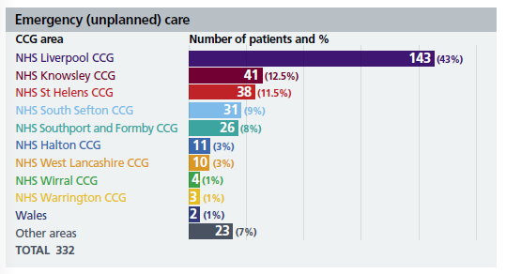
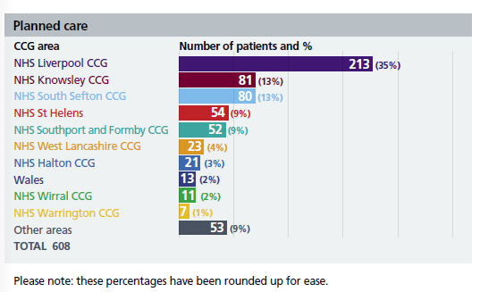
A breakdown of service activity is provided by protected characteristic below:
Sex:
Female: 35%
Male: 65%

Age:
Under 40: 2%
40 to 49: 8%
50 to 59: 13%
60 to 69: 24%
70 to 79: 28%
80 to 89: 19%
90 to 99: 2%

Ethnicity:
White British: 86%
Other ethnic group: 4%
Not specified: 10%

There are a number of reasons why the vascular service is not working as well as it could, and therefore not providing patients with the best possible quality of care. Each of these issues are explained in more detail below.

Lack of theatre and bed space
The single biggest challenge within the current LiVES service is that it doesn’t have enough operating theatre space, or enough dedicated beds, to support the number of patients requiring care. The LiVES service currently delivers most of its daily emergency and inpatient care from the Royal Liverpool Hospital. Only day case operations take place at Aintree University Hospital. This lack of available theatre and bed space puts considerable strain on the service and its ability to effectively meet patient demand for the service. It also makes it difficult to effectively plan for any future increase in demand, which is expected because of a growing number of people living with diabetes, and an ageing population.

Staff shortages for interventional radiology
It can be difficult for the vascular service to attract and keep staff, particularly within interventional radiology (IR), which is a key support service for LiVES. Interventional radiologists use X-rays, CT and ultrasound imaging to guide instruments through the body in order to diagnose and treat patients in the least invasive way possible. Having 24-hours-a-day, seven-days-a-week access to interventional radiology is widely considered to be essential to the smooth running of vascular care services. The LiVES service does not currently have access to around-the-clock interventional radiology support at the Royal Liverpool Hospital. This is because there are not enough vascular IR consultants available. This lack of access to the right imaging staff and equipment can lead to delays in treatment and can mean that the overall experience of care that some patients have isn’t as good as it could be.

Hospital transfers
LiVES is an internationally recognised vascular unit, delivered by a highly skilled and experienced team of consultants, radiologists and other specialist staff. Because of this, the service takes patient transfers from other hospital units from across the region and beyond, including from other parts of the north of England, the Isle of Man and North Wales. These transfers are mainly for diabetes and stroke patients requiring arterial
reconstruction, limb amputation or carotid endarterectomy (removal of fatty deposits in the carotid artery). Many of these patients arrive in the service with very complex medical and rehabilitation needs which require a lengthy period in an operating theatre, and a long hospital stay during their recovery afterwards too. Arranging the transfer of very sick
patients between hospital sites can be complex and time-consuming to arrange and can cause delays to their emergency care while theatre and bed space is found.

Reducing the need for patient transfers between different Liverpool hospital sites by putting vascular services alongside other related services such as stroke, diabetes and orthopaedics based on the Aintree site, would help to alleviate this problem.
There is currently a stroke unit at the Royal Liverpool Hospital, however there are plans underway to create a single Comprehensive Stroke Centre at Aintree University Hospital, subject to the outcome of a public consultation and final decision-making.

How the service currently performs against national standards
Based on data from the National Vascular Registry (NVR) for 2018 – 2020, the LiVES service is one of the busiest vascular units in the country and achieves good outcomes for its patients.

However, the service is performing poorly when it comes to length of time between
referral and treatment. This is largely due to a lack of theatre space, lack of patient
beds, and staffing shortages. Because of this, the service is currently failing to meet national standards and has been put into special measures (an NHS improvement process for services where there are serious concerns about the quality of care) for three key procedures. These include:

Abdominal Aortal Aneurysm (AAA) –
a bulge or swelling in the aorta, the main blood vessel that runs from the heart down to the chest and stomach, which can rupture (burst) and cause life-threatening bleeding.

• Carotid Endarterectomy (CEA) – a surgical procedure to remove a build-up of fatty deposits which cause narrowing of a carotid artery (the main blood vessels that supply blood to the neck, face and brain).

• Critical Limb Ischaemia (CLI) – this is the stopping or restraint of blood to critical limbs, and failure to treat it quicky can result in limb amputation.
What is the legitimate aim of the service change / redesign?
- Demographic needs and changing patient needs. Growing number of people living with diabetes and an ageing population.
- Value for Money-more efficient service
- Alignment with ICB
- Improve quality of care
- Change to service

Proposed Clinical Model
The proposed clinical model would see the relocation of LiVES services to the Aintree University Hospital site. This would be based on expanding to two hybrid theatres, an open theatre, 33 vascular beds, 7 Intermediate Care Beds (Stoddard House) 4 critical care beds, comprehensive outpatient, vascular lab and office facilities, potential for research facilities, and access to CT scanner together with co-location of dependent services.

Vascular surgery and inpatient beds will transfer to the Aintree University Hospital site. All patients requiring vascular surgery and inpatient care will be admitted to Aintree. This reconfiguration intends to improve the quality of care that is delivered and ensure that all patients can access safe, timely and consistent care.

Under these plans, there would be no changes made to any of the current outpatient clinics for this service, which would continue to be offered at Whiston Hospital, Southport Hospital, and Liverpool Heart and Chest Hospital, as well as on the Aintree University Hospital site. In addition, it is proposed that the Royal Liverpool Hospital would start to offer some outpatient appointments too.

The proposed clinical model will impact on medical and nursing staff groups. The main changes will be linked to the transfer of theatre and inpatient Vascular care to the Aintree University Hospital site.

The proposed changes are described further in the following graphic:
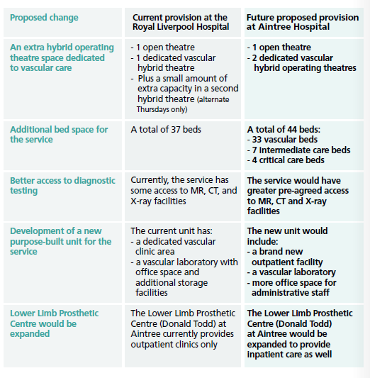

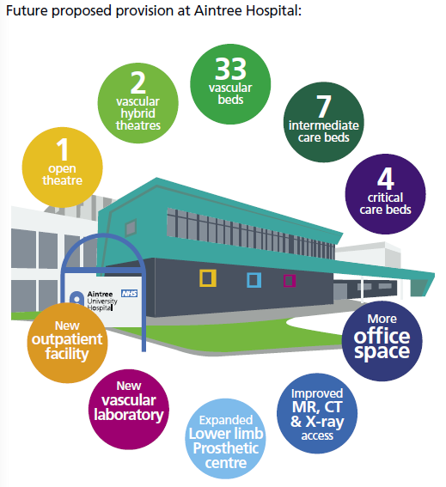

- Consultation

A public consultation about proposals for five Liverpool University Hospitals NHS Foundation Trust (LUHFT) services – breast surgery, general surgery, nephrology, urology, and vascular services took place between 7th June 2022 and August 2022.
Participants could choose which medical areas they wished to comment on (they could choose more than one). 783 people chose to comment on the vascular service proposal.

This data includes those who shared that they were a healthcare professional as well as public responses.
N.B. This analysis is focused on ‘protected characteristics’, so any participant that does not give details cannot be included in the data, as we are looking at the concerns of protected characteristics and what they have said in relation to each other. The task is to test for ‘consensus’ or ‘disagreement’ between protected characteristics which may point to specific needs for specific groups. The full ‘consultation report’ will give a view of the overall generic picture.
Who participated in the Vascular questionnaire?
Vascular services – responses by Sex 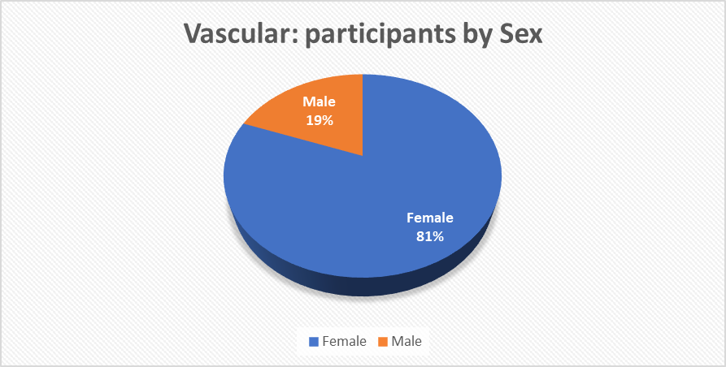
Number of responses by sex.
Female: 537
Male: 128

There were approximately four times more female respondents than male respondents.

Vascular services – responses by Age and Sex
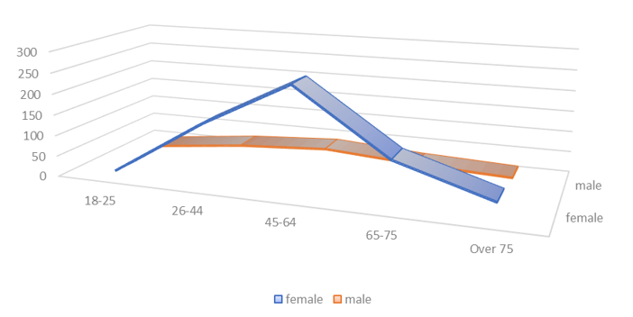
The largest cohort of respondents are in the age range 45-64 for both males and females.
All ages ranges are represented in the consultation.
Female Ages:
18 – 25: 6
26 – 44: 139
45 – 64: 251
65 – 75: 103
Over 75: 35

Male Ages:
18 – 25: 7
26 – 44: 30
45 – 64: 43
65 – 75: 28
Over 75: 19

Vascular services – responses by Disability 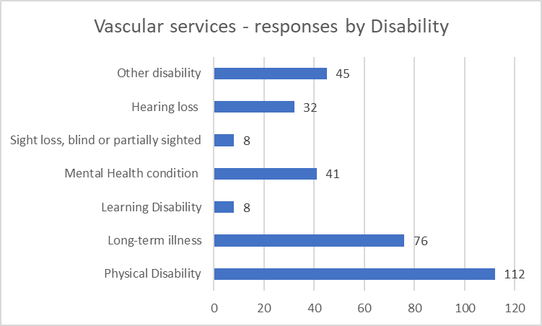
Of the 783 respondents to the vascular services questions, 206 shared that they have a disability or long-term illness. The mid-year ONS population estimates (2020) that the residents of Liverpool City Region are more likely to suffer from a disability or long-term illness that impacts their day-to-day life than regionally and nationally. It is estimated that 22.7% of the Liverpool City Region population have a disability or long-term illness that impacts their day-to-day activities. The responses from people who shared that they have a disability is 26.30% and is therefore a representative number of responses.
Respondents could choose more than one category when describing their disability.
Respondents were able to add their own description of disability when selecting the “other” option. 45 respondents provided their own descriptions. All responses could be grouped into one of the above options or across multiple options where respondents provided information on multiple conditions.
Vascular services – responses by Ethnicity
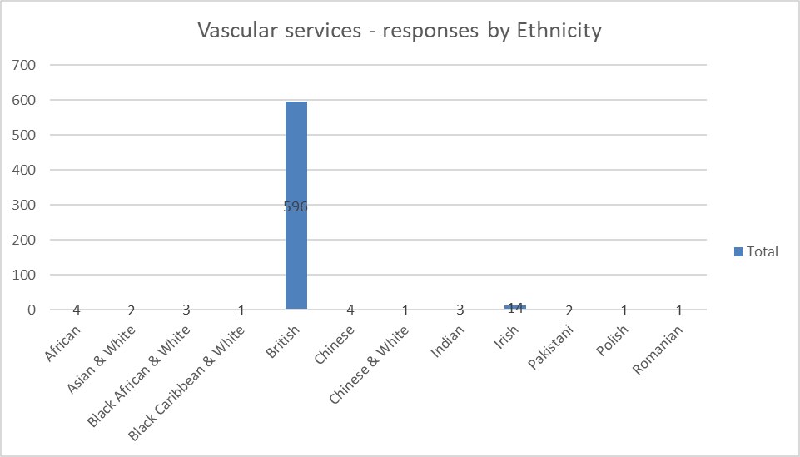
Of the 783 respondents to the vascular services questions, 632 shared their ethnicity.

Vascular services – responses by non-white British ethnic groups
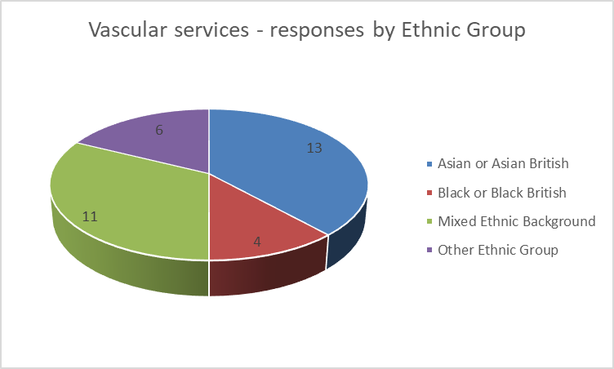
34 people identified as belonging to an ethnic group (non-white British): Asian/Asian British = 13, Black/Black British = 4, Mixed Ethic Background = 11, Other Ethnic Background = 6.
The percentage of responses from black, Asian, mixed ethnicity and other ethnic group is 4.3%. Whilst this is slightly lower representation than the population estimates, it is representative of the percentage of other ethnic groups accessing the service.
The following chart breaks down responses by male and female responses:
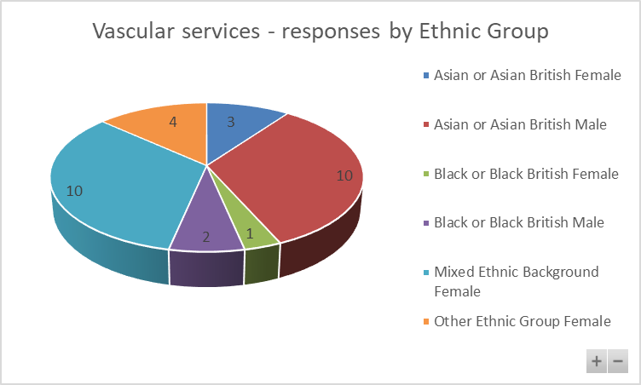
Vascular services – responses by Lesbian, Gay, Bisexual, Queer, plus (LGBQ+)
49 people identified as asexual, bisexual, gay man, gay woman or lesbian, or other.
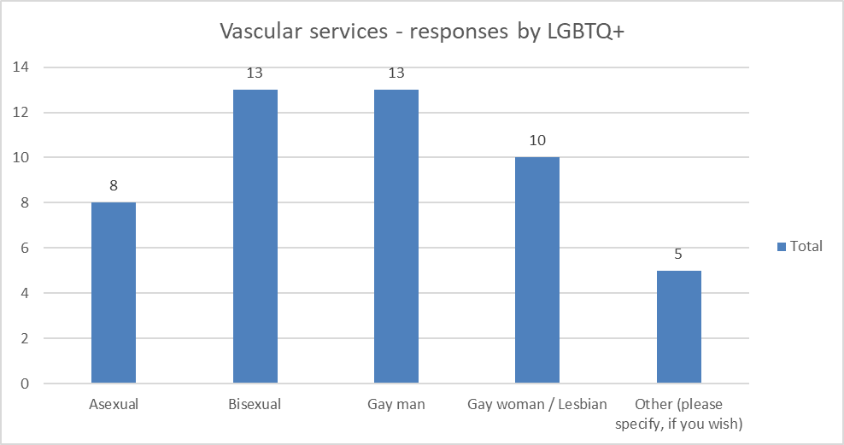
Transgender
One person identified as transgender.
Where there are low numbers, the data and responses are checked to see if they are mentioning any particular problem linked to their protected characteristic
What did participants think?
The questionnaire asked many questions, however, there are three key questions for this analysis: 1) what people think of the options/plans. 2, Can they identify any negative effect on them,3) what are the negative effects.
The reason the Analysis focuses on ‘negatives’ is that it is trying to spot any indirect discrimination, as defined by the Equality Act 2010, If there is no discrimination, or any perceived discrimination can be mitigated then the process can move forward.

Response to the options:
Vascular services – agreement / non- agreement to statements on plans by Sex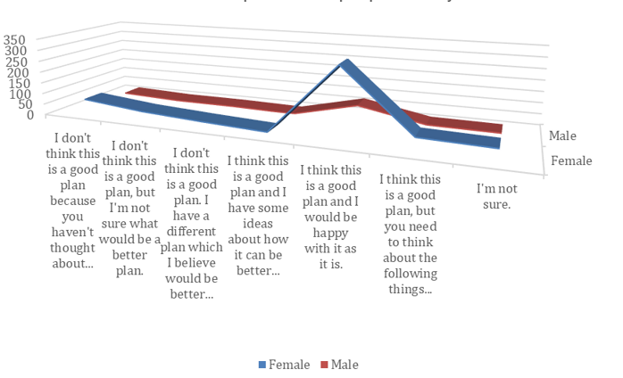
In relation to both males and females, the statement, ‘I think this is a good plan and I would be happy with it as it is’ was selected the most. The same pattern emerges when ‘Age’ is analysed against the statements.
Vascular services – agreement / non- agreement to statements on plans by Disability
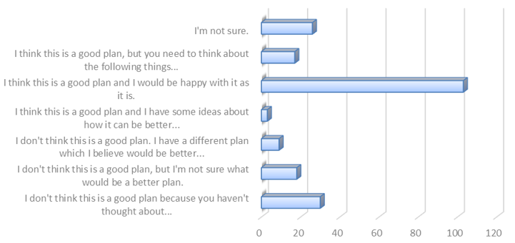
The statement of ‘I think this is a good plan and I would be happy with it as it is’ was selected the most.
There is an uptick of numbers on the last option (30 people) when this is reviewed several concerns are apparent:
- Not too sure what the benefits to change are
- Difficulty with travel
- Concern over access
Vascular services – agreement / non- agreement to statements on plans by Ethnic Group

The statement ‘I think this is a good plan and I would be happy with it as it is’ was the selected the most.
Vascular services – agreement / non- agreement to statements on plans by Sexual Orientation
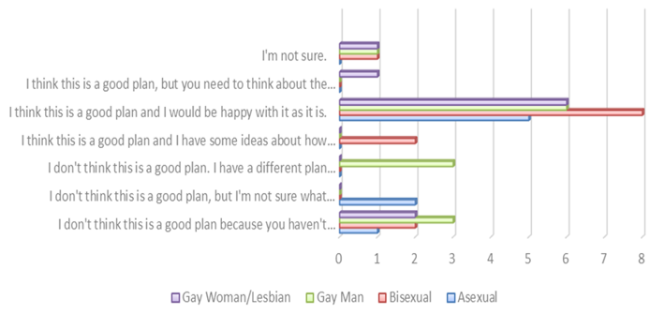
The statement ‘I think this is a good plan and I would be happy with it as it is’ was selected the most.
A comment within the sexual orientation cohort shared their experience of staff behaviour.
Whilst the statement of ‘I think this is a good plan and I would be happy with it as it is’ was selected the most across protected characteristics, the questionnaire gives the opportunity to report issues that might be disadvantageous.
The questionnaire asked: ‘Is there anything else that you would like to tell us about the plan for vascular services to help us make a final decision? For example, are there any parts of the plan that could have a negative effect on you or would put you at a disadvantage compared with other people?’ 130 people said ‘yes’.
The follow up question asks: ‘What would you like to tell us about the plan for vascular services to help make a final decision?’ 130 comments were made. The comments below are an extract of some of the comments.
The concerns that were evident relate to: travel, access, distance, distance for families, quality of care, being oversubscribed, cost, parking, concerns about staff.
Below is an indicative sample of comments (comments are published verbatim however obvious spelling and grammatical errors have been corrected for ease of reading).
Comments provided by females
- A discussion is needed of a different approach to preparing a patient for dialysis when this is a very sudden introduction to a care plan as a means of addressing kidney damage issues, when kidney problems have not been a lifelong problem.
- Please just consider travel distances
- Travelling. It would be a nightmare for me to travel to Aintree as I don't drive. Maybe make a bus route that goes from places further away direct to Aintree. St Helens to Aintree and then diverts around to other areas as well.
- I think accessing the service is the main problem. People who live in south Liverpool like us would struggle to get to Aintree. It is hard enough getting to the royal as there are no bus routes from our area to the royal never mind Aintree. I think accessibility needs looking at for all areas of expertise. If you move one completely to one site people living the opposite side will struggle. Bus routes need to be addressed for our area to the royal never mind going further to Aintree. Thank you
- This plan will lead to me spending much more money coming to my appointments and stress of travel will be harmful to my health.
- Services on the whole should be easily accessible in the community especially in an area which involves the lower limbs....travel and transport are not being considered at all and how difficult it could be for some people.
- I am housebound and no longer drive. I would not be able to get to Aintree at all
- I take my disabled brother to appointments at the Royal, I’m not prepared (don’t have the time) to take him elsewhere. This would incur ambulance transfers which in my experience, are problematic & why I took over. (Many failed to arrive, arrived late causing missed appointments etc)
- This is a very emotive change. If you are admitted to Royal Liverpool in the future with a suspected leaking AAA then you will have less chance of survival than if you are taken to Aintree. NWAS is not sufficiently resourced to transfer real emergencies across trusts- no matter what they say they can do!! From experience they can’t deliver
- My Dad died as a result of being transferred from Chester to Liverpool Heart and Chest hospital. This delay I believe cost him his life due to the Cardiac Arrests he had en route. If emergencies are transferred from areas other than Liverpool city centre to Liverpool hospitals, then there is always this considerable risk. The more time and investment that goes into 'Centres' of specialities the less accommodation is made for distant emergencies.
- Usually have to have an overnight stay in an hotel before Outpatient consultation. So would possibly have to find different hotel
- Parking and travel are worse
Comments provided by males:
- Aintree is further away and difficult to get to.
- Difficulty in travelling - extra cost
- heart condition, with mobility problem, living in south Liverpool, and dependant on public transport
- Parking and travel are worse
- Patient care will be affected. Surgeons are just 1 part of the whole team, you are ignoring the expertise provided by other services like Anaesthesia, nurses and radiology.
- Time taken could risk live and time
- Would be a longer journey to Aintree in an emergency
Comments provided by respondents who shared that they have a disability:
- Aintree hospital is trying to chew more than what it can. Need caution in doing all these changes.
- Aintree is further away and difficult to get to.
- Difficulty in travelling - extra cost
- Doing some changes, the elderly will get confused where to go even more. Some hospitals are hard to travel to one end of Liverpool to another. Liverpool royal is in the centre for everyone
- For people in the city who are not drivers it’s a fair distance to Aintree
- heart condition, with mobility problem, living in south Liverpool, and dependant on public transport
- I am housebound and no longer drive. I would not be able to get to Aintree at all
- Traffic problems are very common and potentially serious. I am attracted to the idea of including vascular services into the Broadgreen department, at least to cover emergencies if this could be possible
- I take my disabled brother to appointments at the Royal, im not prepared (don’t have the time) to take him elsewhere. This would incur ambulance transfers which in my experience, are problematic & why I took over. (Many failed to arrive, arrived late causing missed appointments etc)
- I would NOT attend Aintree - rude, horrible cruel staff.
- It’s too far - I would like the service left as it is.
- Maybe a courtesy minibus for patients travelling to Aintree would help if these proposals go through.
- Patients need to be seen my husband has waited a long time for operation in his legs and hasn’t even been seen by a Dr in about 12 months think it disgusting the way patients are left in pain
- Please just consider travel distances
- Public transport would need to be more integrated
- Services on the whole should be easily accessible in the community especially in an area which involves the lower limbs....travel and transport are not being considered at all and how difficult it could be for some people.
- The distance to Aintree would be too far myself and my visitors.
- This plan will lead to me spending much more money coming to my appointments and stress of travel will be harmful to my health.
- Travelling. It would be a nightmare for me to travel to Aintree as I don't drive. Maybe make a bus route that goes from places further away direct to Aintree. St Helens to Aintree and then diverts around to other areas as well.
- Use plain language, so general public knows what you mean easier?

Comments provided by LGBQ+

- Difficulty in travelling - extra cost
- The distance worries me
- I would NOT attend Aintree - rude, horrible cruel staff.
- Stop moving everything too far from south Liverpool
- Staff already under pressure as there is limited staff. Need to make sure staff health and well-being is also at the forefront of people’s minds when thinking of taking on so much.
- The distance to Aintree from people living in Huyton worries me

Comments provided by ethnic group

- Public transport would need to be more integrated
- This plan will lead to me spending much more money coming to my appointments and stress of travel will be harmful to my health.
- Barriers relevant to the protected characteristics

Vascular disease can be defined by a number of conditions, but it may be that treatment for those conditions is not necessarily delivered through vascular services. Treatment could be delivered through cardiology services for example.
Risk factors of vascular issues relevant to protected characteristics:
- Age: risks increase with age
- Pregnancy and Maternity: risks of vascular issues during pregnancy.
- Race: higher prevalence of chronic diseases in some ethnicities, for example diabetes in South Asian males.
- Sex: higher prevalence in males.
- Other: Family history
Lifestyle factors can also lead to vascular problems such as Smoking, lack of physical activity, unhealthy diet, alcohol intake above recommended levels, overweight and obesity. Other modifiable risk factors include low blood level of high-density lipoprotein (HDL) cholesterol and high blood level of non-HDL cholesterol.
Other comorbidities such as diabetes can also increase risks of vascular complications.
Refer to differential matrix below:

Protected Characteristic | Issue | Remedy/Mitigation
Age | There is increasing incidence of most vascular conditions with age, including aneurysms, symptomatic carotid disease, critically ischaemic limbs and varicose veins.  The transfer of inpatient services to the Aintree site could disproportionately impact older people, particularly those living in the South Liverpool area, who will need to travel further to access the care they require.  Comments provided in the consultation across all ages:  - Please just consider travel distances  - Travelling. It would be a nightmare for me to travel to Aintree as I don't drive. Maybe make a bus route that goes from places further away direct to Aintree.  - I think accessing the service is the main problem  - Usually have to have an overnight stay in an hotel before Outpatient consultation. So would possibly have to find different hotel  - Parking and travel are worse  - Difficulty in travelling - extra cost  - Doing some changes the elderly will get confused where to go even more. Some hospitals are hard to travel to one end of Liverpool to another. Liverpool royal is in the centre for everyone  - Consider parking, do not use parking charges to prop up lack of financial resources.  - Public transport would need to be more integrated | The clinical model aims to address capacity issues that currently impact on the LiVES service, which often lead to delays in care, potentially impacting on the experience of care and the health outcomes for patients.  *Commissioner and trust collaboration required to undertake further travel assessment to map public transport services and work with transport providers.  *Patients need to be informed of hospital travel services (eligibility for patient transport services), access to travel expenses reimbursement scheme. Continue public relations on the issue of travel and accessibility.  *Commissioner and trust ongoing monitoring of emergency and non-emergency patient transport services (North West Ambulance Service – NWAS) to reassure patients of transport times in an emergency from different parts of the area.
Disability | Accessing healthcare services can often present a challenge for people living with a disability.  The transfer of inpatient services from the Royal to Aintree site could disproportionately impact people living with a disability, particularly those living in the South Liverpool area, who will need to travel further to access the care they require.  The main concerns from the consultation related to travel and costs and the difficulties linked to both.  Extract of comments provided from people who shared they have a disability or are a carer.  - I take my disabled brother to appointments at the Royal, I’m not prepared (don’t have the time) to take him elsewhere. This would incur ambulance transfers which in my experience, are problematic & why I took over. (Many failed to arrive, arrived late causing missed appointments etc)  - I am housebound and no longer drive. I would not be able to get to Aintree at all  - Use plain language, so general public knows what you mean easier?  - Difficulty in travelling - extra cost  - For people in the city who are not drivers it’s a fair distance to Aintree heart condition, with mobility problem, living in south Liverpool, and dependant on public transport  - Maybe a courtesy minibus for patients travelling to Aintree would help if these proposals go through  - Services on the whole should be easily accessible in the community especially in an area which involves the lower limbs....travel and transport are not being considered at all and how difficult it could be for some people.  A respondent who shared that they are a staff member at the trust highlighted a number of issues in their additional comments. (Full comment not enclosed so that the staff member cannot be identified).  Concerns relate to travel, flare ups of condition due to stress and anxiety in not being informed/ aware of how the change will impact them which is resulting in increased sickness absence. Concerns around training/ skills in the workforce to deliver the proposed model. | The reconfiguration case sets out a clinical model for Vascular services that maintains equitable care, delivered closer to home where it is clinically appropriate to do so, and supported by accessible specialist inpatient services that are centralised in order to provide optimal care for all.  Vascular outpatients will continue to be available at the Royal Liverpool site.  Clinic activity will still take place at Royal site as well as Aintree, with consultant and vascular nurse specialist clinics held. Also, AAA screening and vascular lab facilities will continue to have a presence at the new Royal.  *Commissioner and trust collaboration required to undertake further travel assessment to map public transport services and work with transport providers.  *Patients need to be informed of hospital travel services (eligibility for patient transport services), access to travel expenses reimbursement scheme. Continue public relations on the issue of travel and accessibility.  *Commissioner and trust ongoing monitoring of emergency and non-emergency patient transport services (North West Ambulance Service – NWAS) to reassure patients of transport times in an emergency from different parts of the area.  It is against the law for a staff member to be treated unfairly because a disability. Employers also have a duty to provide reasonable adjustments. The trust is undertaking a staff consultation on the proposed changes. The staff consultation enables employers to talk and listen to staff and any trade union or other relevant employee representatives about organisational issues and changes which affect them. The aim of consultation is to work together to reach an agreement on a change or find a solution to an issue.
Gender reassignment | A number of publications (e.g. Stonewall 2018, Royal College of Nursing 2020) highlight that people who have undergone gender reassignment or are planning to undergo gender reassignment frequently experience prejudice and discrimination.  One person identified as transgender in the vascular services consultation. When asked overall if they thought the plan was good to improve patient care, they responded that they didn’t think it was a good plan and that they felt the current plan was not safe and that it would result in patient deaths. | Ensure services are inclusive and staff trained appropriately to deliver good quality, personalised care and support.  No responses identified issues of indirect or direct discrimination linked to protected characteristic.  Continued public engagement required to provide assurance on patient safety, quality of care and patient outcomes.
Marriage and Civil Partnership | Partners, spouses etc being involved and able to visit is an important part of patient’s journey. | Trust to undertake regular reviews of visiting policy.
Pregnancy and maternity | Pregnant women are at high risk of developing varicose veins due to several factors including an increase in blood volume, a decrease in blood flow rate, pressure on the vena cava from the uterus, and hormonal changes that dilate the vessels. All of these factors come together to promote the development of bulging, deformed veins, called varicose veins.  15 respondents shared that they were currently pregnant or had a baby in the last 12 months. Two of those respondents provided comments when asked if there was anything further that should be considered in making a final decision. Both comments were specific to concerns around travel and from one in particular travel in the event of an emergency. When asked overall if they felt the plan was good to improve patient care, 86% agreed that it was a good plan or partly agreed that it was a good plan. | The clinical model does not propose any changes to provision across the satellite sites, meaning that services provided at the Liverpool Women’s Hospital for maternity patients will be maintained.  No respondent identified issues of indirect or direct discrimination linked to pregnancy or maternity.
Race | 34 people identified as ‘non white British’ within the Vascular services consultation.  Comments provided in the consultation included:  - Public transport would need to be more integrated  - This plan will lead to me spending much more money coming to my appointments and stress of travel will be harmful to my health. | No responses identified issues of indirect or direct discrimination linked to race.  Ensure services are inclusive and staff trained appropriately to deliver good quality, personalised care, and support.  *Commissioner and trust collaboration required to undertake further travel assessment to map public transport services and work with transport providers.  *Patients need to be informed of hospital travel services (eligibility for patient transport services), access to travel expenses reimbursement scheme. Continue public relations on the issue of travel and accessibility.  *Commissioner and trust ongoing monitoring of emergency and non-emergency patient transport services (North West Ambulance Service – NWAS) to reassure patients of transport times in an emergency from different parts of the area.
Religion and belief | A person’s religion or belief may impact how the perceive or receive medic  al treatment.  442 people shared their religion/ belief as part of the consultation. | Ensure staff are trained in understanding needs associated with religion and belief and engage with chaplaincy services.  No responses identified issues of indirect or direct discrimination linked to religion and/or belief.
Sex (M/F) | As highlighted in the pre-consultation equality analysis report vascular services are accessed by more males than females.  Extract of comments from female respondents in the consultation:  - Please just consider travel distances  - Travelling. It would be a nightmare for me to travel to Aintree as I don't drive. Maybe make a bus route that goes from places further away direct to Aintree. St Helens to Aintree and then diverts around to other areas as well.  - My Dad died as a result of being transferred from Chester to Liverpool Heart and Chest hospital. This delay I believe cost him his life due to the Cardiac Arrests he had en route. If emergencies are transferred from areas other than Liverpool city centre to Liverpool hospitals then there is always this considerable risk. The more time and investment that goes into 'Centres' of specialities the less accommodation is made for distant emergencies.  - This is a very emotive change  - Parking and travel are worse  Extract of comments from male respondents in the consultation:  - Difficulty in travelling - extra cost  - heart condition, with mobility problem living in south Liverpool, and dependant on public transport  - Parking and travel are worse  - Patient care will be affected. Surgeons are just 1 part of the whole team, you are ignoring the expertise provided by other services like Anaesthesia, nurses and radiology.  - Time taken could risk live and time | No responses identified issues of indirect or direct discrimination linked to sex.  *Commissioner and trust collaboration required to undertake further travel assessment to map public transport services and work with transport providers.  *Patients need to be informed of hospital travel services (eligibility for patient transport services), access to travel expenses reimbursement scheme. Continue public relations on the issue of travel and accessibility.  *Commissioner and trust ongoing monitoring of emergency and non-emergency patient transport services (North West Ambulance Service – NWAS) to reassure patients of transport times in an emergency from different parts of the area
Sexual orientation | National data shows that LGBQ+ report difficulty in accessing NHS provision and being treated less favourably.  Respondents in the consultation commented:  - Difficulty in travelling – extra cost  - The distance worries me  - The distance to Aintree from people living in Huyton worries me  - I would NOT attend Aintree - rude, horrible cruel staff.  From the last comment above, one respondent potentially identifies an issue of direct discrimination if the behaviour of staff was because of the respondent’s sexual orientation.  N.B. employers are vicariously liable for the behaviour of staff. Employers must be able to demonstrate that staff have undergone appropriate training. | Ensure services are inclusive and staff trained appropriately to deliver good quality, personalised care and support.  Trust to undertake monitoring of patient experience by protected characteristic (see section 6 below).  Trust to ensure that working towards Navajo accreditation is part of trust equality strategy / equality objective action plans.

- Does this service go the heart of enabling a protected characteristic to access health and wellbeing services?
Yes

- Have you identified any key gaps in service or potential risks that need to be mitigated
The consultation showed that people are in favour of the changes but had concerns about travel and cost. This needs to be addressed by undertaking a transport analysis and looking at the barriers that the participants in the consultation are highlighting; lack of bus routes, lack of parking, cost of parking, etc. and as such must show that the trust is working in a positive way to help patients, including information for them of any support the hospital can give and the criteria for that support.

Whilst hospital transport may be available, this in itself is not a full mitigation – this can only be fully mitigated when the number of eligible patients and those using the service are understood.

Moving services to alternative locations will always impact on travel for some individuals – that disadvantage (of being further away from accessing the service) is not discrimination in and of itself. However, how the trust responds, or does not respond to the challenges (for example not having disability parking spaces for blue badge holders) or understanding travel /parking issues can result in indirect discrimination.

Other Risk Areas | Required Action | By Who/ When
Activity Data – not provided by protected characteristic to assist in monitoring patient outcomes by protected characteristic. | Capture activity data by number as well as percentage.  Report activity by protected characteristic.  Monitoring outcomes by protected characteristic.  Compare outcomes in protected characteristics e.g. male v female.  *Monitor patient experience by protected characteristic.  Embed equality considerations in serious incident reporting process. | Trust / ongoing – linked to complying with Equality Act 2010.
Widening Health inequalities; Travel/ Transport issues | Undertake further travel/ transport analysis.  Share information with travel / transport, access to patient transport services, travel cost reimbursement scheme. | Trust and Commissioners/ timescale to be discussed and agreed.
Patient experience | *Monitor patient experience by protected characteristic.  Ensure staff are able to access training to support patients with specific needs linked to protected characteristic or other vulnerable groups and trust ongoing monitoring of compliance records.  N.B. employers are vicariously liable for the behaviour of staff whilst in the workplace.  Trust to work towards Navajo accreditation. | Trust / ongoing – linked to complying with Equality Act 2010.  In line with trust equality strategy / equality objective action plan.
Staff engagement | Staff consultation | Trust/ in progress

- Is there evidence that the Public Sector Equality Duties will be met (give details) Section 149: Public Sector Equality Duty (review all objectives and relevant sub sections)
PSED Objective 1: Eliminate discrimination, victimisation, harassment, and any unlawful conduct that is prohibited under this act.
The service is for all patients that have need of the service. Staff are trained to deliver a professional service to all patients.

Comments from LGBQ+ may indicate further work is required to ensure services are inclusive. This needs to be addressed as the Trust is vicariously liable for any discriminative or harassing behaviour.
PSED Objective 2: Advance Equality of opportunity.
Refer to sub-sections.
PSED Objective 2: Section 3. sub-section a) remove or minimise disadvantages suffered by people who share a relevant protected characteristic that are connected to that characteristic.
The service is accessible and can support people with different needs, especially people with disabilities.

Moving forward the service will; provide better monitoring of its service users and the outcomes they receive – looking for parity in service delivery and satisfaction levels.
PSED Objective 2: Section 3. sub-section b) take steps to meet the needs of people who share a relevant protected characteristic that are different from the needs of people who do not share it
During the consultation, all protected characteristics mentioned the need for access, parking, and ease of travel.

Whilst public travel is outside the remit of the trust, it can nonetheless liaise with commissioners and transport providers to identify better serving bus routes.

Patients need to be informed of any hospital transport services that they might be entitled to.

PSED Objective 2: Section 3. sub-section c) encourage people who share a relevant protected characteristic to participate in public life or in any other activity in which participation by such people is disproportionately low.
The service does cater for anyone in the catchment area, and it is maintaining local services.

PSED Objective 3: Foster good relations between persons who share a relevant protected characteristic and persons who do not share it. (Consider whether this is engaged. If engaged, consider how the project tackles prejudice, and promotes understanding -between the protected characteristics)
This objective is not engaged.
PSED Section 2: Consider and make recommendation regards implementing PSED into the commissioning process and service specification to any potential bidder/service provider (private/ public/charity sector)
Further work required to capture, report, and monitor services by protected characteristic.

The lead commissioner requires the trust to provide evidence of compliance with PSED through the NHS Standard Contract. Any proposed future changes to service model/ delivery will be subject to separate equality analysis.
- Recommendation to Board
PSED will be met by the reconfiguration of services.

- Actions that need to be taken
Public concern over transport and travel needs to be addressed and further work done on understanding concerns and barriers that this is presenting to some in the community.

Refer to sections 4 and 6.

https://www.liverpoolcityregion-ca.gov.uk/wp-content/uploa7ds/Data-dashboard-2022022586.pdf
Heterosexuality/Straight is not included in the chart as more than 90% of the Cheshire and Merseyside population identifies as heterosexual. Homophobic behaviour and discrimination tends to be targeted at people who express their identify as having a different sexuality or identifying by a sex different to that they were assigned at birth.

