Equality Analysis Report
Post-Consultation v4 Final
Integration and Reconfiguration Programme - Clinical Service Model Business Case – General Surgery
Start Date: | 30 May 2022
NHS Cheshire and Merseyside Integrated Care Board Equality and Inclusion Service (Knowsley, Liverpool, Sefton and St Helens Places) | Andy Woods  Jo Roberts | 17 August 2022  24 August 2022
Trust Lead Officer Signature and Date:
Finish Date: | 24 August 2022
Exec Sign Off Signature and Date
Date of Committee consideration

- Details of service / function:
Guidance Notes: Clearly identify the function & give details of relevant service provision and or commissioning milestones (review, specification change, consultation, procurement) and timescales.
General surgery focuses on the abdominal area and intestines, including the gastrointestinal tract (part of the digestive system), liver, colon, pancreas and other major parts of the endocrine (hormonal) system of the body. It is split into the following areas:
• Colorectal surgery, which focuses on the lower gastrointestinal tract such as the colon and rectum, including operations for colon and rectal cancer, inflammatory bowel disease, anal cancer, prolapses, haemorrhoids and intestinal polyps, as well as bowel screening services;
• Upper gastrointestinal (‘upper GI’) surgery, which is performed on the oesophagus and stomach and includes addressing issues such as oesophago-gastric (gullet and stomach) cancers, reflux, hiatus hernia, Barrett’s oesophagus and ulcer disease;
• Hepato-pancreatobiliary (‘HPB’) surgery, where hepatobilary surgery focuses on the liver, and pancreatobiliary surgery focuses on the pancreas, bile duct and gallbladder.
Emergency general surgery can include conditions such as:
• Acute diverticulitis - when a bulge or pocket in the bowel lining becomes inflamed or infected • Appendicitis - painful swelling of the appendix
• Cholecystitis - inflammation of the gallbladder
• Pancreatitis - inflammation of the pancreas • Incision and drainage of abscesses.
Currently, the general surgery service is provided on a spilt site basis. Both Royal Liverpool Hospital and Aintree University Hospital provide emergency surgical care where Broadgreen Hospital provides elective activity only. Each site provides different models of service. Both sites provide a 7-day Consultant led service for emergency surgery.
These figures from 2019/20 show how many people were admitted for either emergency or planned surgery, at both Aintree Hospital and the Royal Liverpool Hospital, and which areas those patients came from.

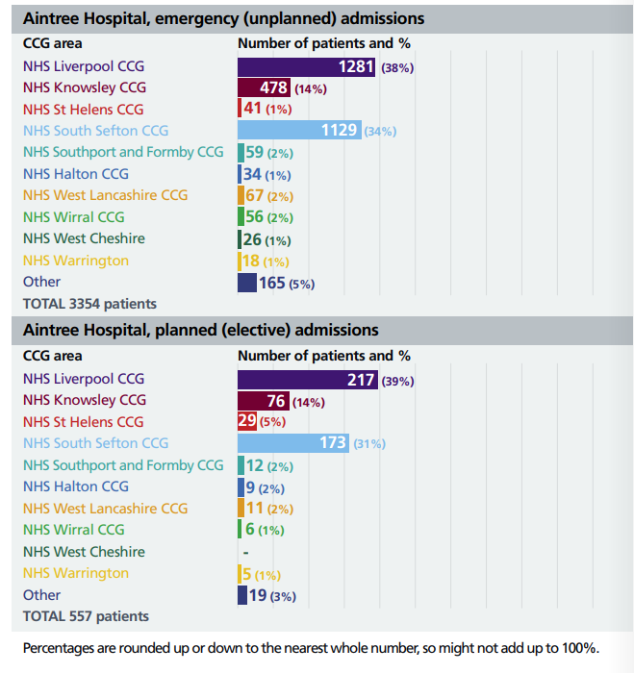

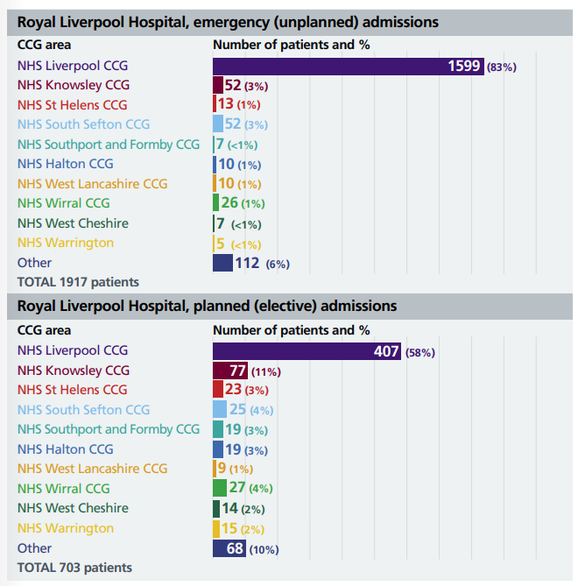
Case for Change – Current Challenges
General surgical emergency admissions are the largest group of all surgical admissions to UK hospitals and account for a large percentage of all surgical deaths. Complications occur in as many as 50% of patients undergoing some common procedures, and these result in dramatic increases in length of stay.
The current clinical models across sites experience constrains and limitations to service provision and are unaligned; having two different service models also increases inequity amongst the population of Liverpool.
Key challenges for the emergency and elective subspecialty across sites include:
Emergency General Surgery
- Clinical Outcomes - Trust performance on clinical /patient outcomes and quality of care are mixed across sites, prompting concerns around the success of operations. These areas include - Consultant present in theatre for high-risk patients (when risk of death ≥ 5%); Length of Stay following Emergency Laparotomy Procedures; and Patient to be reviewed by Consultant within 14 hours of admission.
- Clinical Sustainability - at the Royal site, emergency surgery is provided by sub-specialist surgeons who deliver both emergency and elective care. This model is not consistent with recommendations or clinical evidence on best practice. Care should be provided by consultants trained in emergency surgery and that support for complex patients should be provided by surgeons fully trained and experienced within a sub-specialty.
- Recruitment - There have been difficulties in recruitment of consultants without them already having subspecialty interests.
- Operational Challenges - There is a lack of rapid access service (Ambulatory Care ‘Hot Clinic’) leading to multiple procedures and operations (like uncomplicated hernia, appendicitis, abscess) being performed as inpatient rather than day case. This increases burden on NCEPOD theatre and emergency surgical and anaesthetic teams.
- Estates - There is no ring-fenced assessment space within New Royal dedicated specifically for Emergency General Surgery, so change is needed in order to locate services within an appropriate estate footprint. Furthermore, the current estate in AUH does not provide sufficient capacity to provide safe and quality rapid assessment and efficient patient flow
Elective subspecialty services
- Limited procedure volumes at each site due to fragmentation of services - Volumes of elective colorectal and Upper GI patients are lower at both sites than the national average. The Royal Colleges, Improving Outcomes Guidance, Clinical Networks and NHS national guidelines increasingly relate patient outcomes to catchment population size and emphasise the importance of sufficient clinical volume. It follows that the current provision of services for the Trust’s hospital sites will suffer when minimum surgeon volumes are not attained.
- Clinical sustainability- The fragmentation of services and different clinical models result in variation in patient outcomes and quality of care which also provide operational challenges including length of stay and timely access to care.

What is the legitimate aim of the service change / redesign?
- Demographic needs and changing patient needs are changing because of an ageing population.
- Value for Money-more efficient and equitable services
- Future sustainability of services.

- Change to service
Proposed Clinical Model
The key proposal underpinning the integrated model for general surgery is to consolidate similar services and patients onto the same site, establishing a ‘hot’ (non-elective) site at the AUH site where dedicated teams are in place to carry out emergency surgery, and a ‘cold’ (elective) site at RLH site specialising in carrying out planned surgery, with limited disruption to waiting lists caused by emergency cases.
The separation of elective and non-elective general surgical care will allow both aspects of the service to be managed efficiently, improve availability of staff for pre and post-operative reviews, allow for patients to be seen in a timely manner and treated by appropriate.
Under the proposal, Aintree Hospital would have a single emergency care unit for emergency general surgical admission and provide care seven-days-a-week, in line with best practice. Ambulances would take patients who required emergency surgery straight to Aintree. Meanwhile, the Royal Liverpool Hospital would specialise in planned care, including complex benign (non-cancer) and cancer cases (such as elective upper GI, HPB and colorectal cancer). General surgical emergency cover would still be provided at the Royal Liverpool Hospital for occasional patients who might need emergency surgery but are not well enough to be transferred. This could include patients admitted to the Royal Liverpool Hospital for other conditions, or those who present at the hospital’s accident and emergency department. Planned (elective) care would no longer take place at Broadgreen Hospital. Many patients who would currently use Broadgreen would be treated at the Royal Liverpool Hospital instead, as this will be the site focusing on planned care, however a small number might go to Aintree Hospital if this would be the best place for their condition. Both Aintree Hospital and the Royal Liverpool Hospital would have on-site support from anaesthesiology, radiology (diagnostic and interventional), and intensive care.
- Consultation
A public consultation about proposals for five Liverpool University Hospitals NHS Foundation Trust (LUHFT) services – breast surgery, general surgery, nephrology, urology, and vascular services took place between 7th June 2022 and August 2022.
In total there were 1231 responses to the ‘General Surgey’ service reconfiguration survey.
This data includes those who shared that they were a healthcare professional as well as public responses.
N.B. This analysis is focused on ‘protected characteristics’, so any participant that does not give details cannot be included in the data, as the equality analysis is looking at the concerns of protected characteristics and what they have said in relation to each other. The task is to test for ‘consensus’ or ‘disagreement’ between protected characteristics which may point to specific needs for specific groups. A separate ‘consultation report’ has been produced which will give a detailed view of the overall responses.

Who participated in the General Surgery questionnaire?
General Surgery – responses by Sex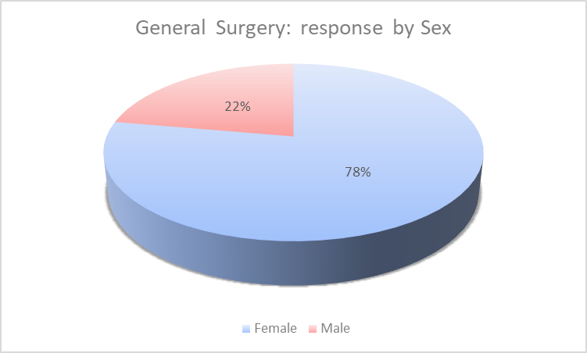
Female: 658 responses
Male: 188 responses
(Other: 1 response , I do not wish to answer this question: 65 responses, No response: 319 responses – these figures are not included in pie chart as they do not indicate a protected characteristic)
The ONS mid-year population estimates (2020) Liverpool City Region has a proportionally larger female population than regionally and nationally, male 48.9%, female 51.1%. This highlights a significant under-representation in survey responses from males.
Participants were also asked to confirm which best described their gender identity from a number of options, 641 respondents were female, 181 male, 2 transgender, 9 other identity, 75 did not wish to answer and 323 did not answer.
358 of the responses were from healthcare professionals. Of those that shared their sex, 214 responses were from females and 42 responses were from males.

General Surgery – responses by Age

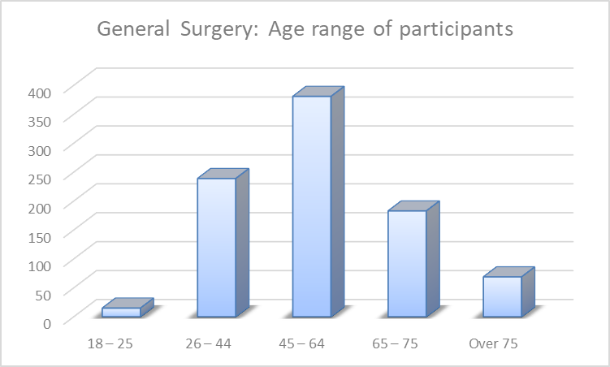
Age Range:
18 – 25 | 15
26 – 44 | 239
45 – 64 | 381
65 – 75 | 183
Over 75 | 69
(I do not wish to answer: 28 responses, No response: 316 - these figures not included in the chart as they do not indicate a protected characteristic)
The mid-year ONS population estimates (2020) for Liverpool City Region indicate there is under-representation in survey responses from those aged 18 to 25.

General Surgery – responses by Age and Sex
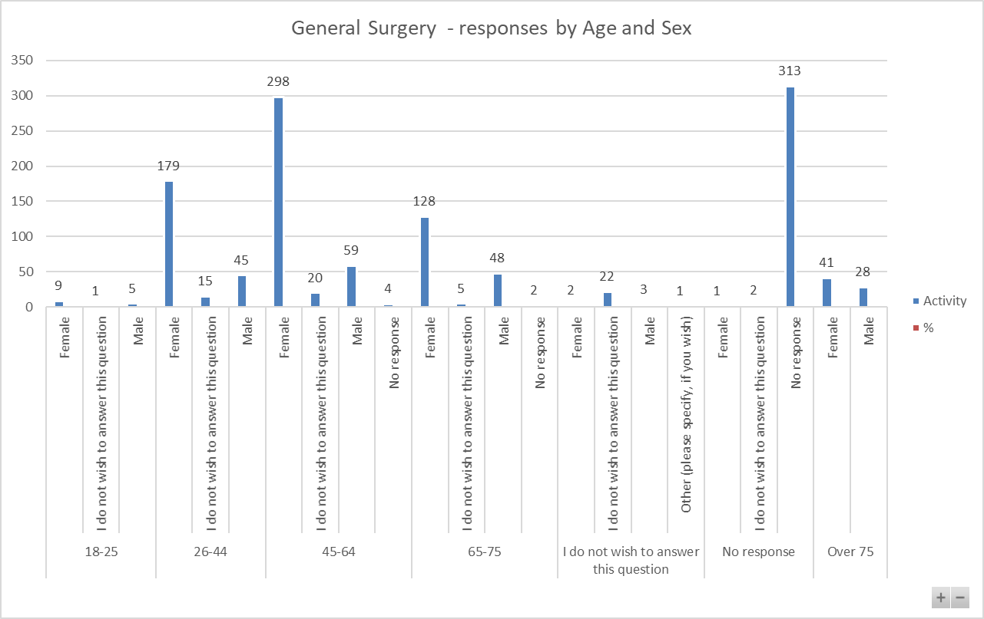
Female
18-25: 9 responses 1.15%
26-44: 171 responses 21.90%
45-64: 364 responses 46.22%
65- 75: 134 responses 17.16%
Over 75: 34 responses 4.35%

Male
18-25: 5 responses 0.64%
26-44: 24 responses 3.07%
45-64: 19 responses 2.43%
65- 75: 14 responses 1.79%
Over 75: 10 responses 1.28%

The largest number of responses was from females aged 45 to 64, followed by females aged 26 to 44 and 65 to 75.

General Surgery – responses by Disability
The mid-year ONS population estimates (2020) that the residents of Liverpool City Region are more likely to suffer from a disability or long-term illness that impacts their day-to-day life than regionally and nationally. It is estimated that 22.7% of the Liverpool City Region population have a disability or long-term illness that impacts their day-to-day activities.
Of the 1231 responses, 252 shared that they have a disability. This is 20.47% which is a slight under-representation.
Respondents were able to select multiple options to this question from the following options: physical disability, learning disability, mental health condition, long-term illness, sight loss, blind, or partially sighted, or other disability which they could then provide their own response.
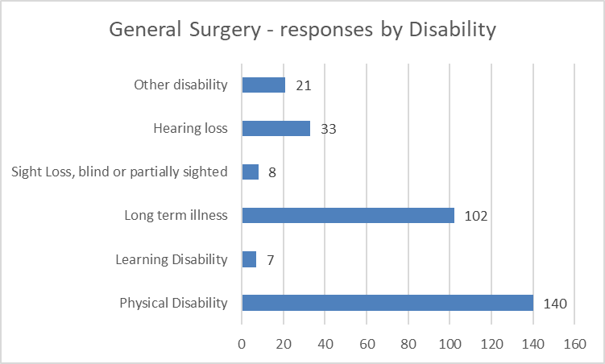

Other disability: of those that shared their sex, 15 females and 6 males shared that they have a disability in the ‘other’ category. All responses could be grouped into one of the above options or across multiple options where respondents provided information on multiple conditions.
Hearing Loss; of those that shared their sex, 23 females and 8 males shared that they had hearing loss.
Sight loss, blind or partially sighted; of those that shared their sex, 7 females and 1 male shared that they had sight loss, were blind or partially sighted.
Long term illness: of those that shared their sex, 76 females and 24 males shared that they had a long-term illness.
Physical Disability: of those that shared their sex, 98 females and 36 males shared that they had a physical disability.
Learning Disability: of those that shared their sex, 4 females and 3 males shared that they had a learning disability.

General Surgery – responses by ethnicity
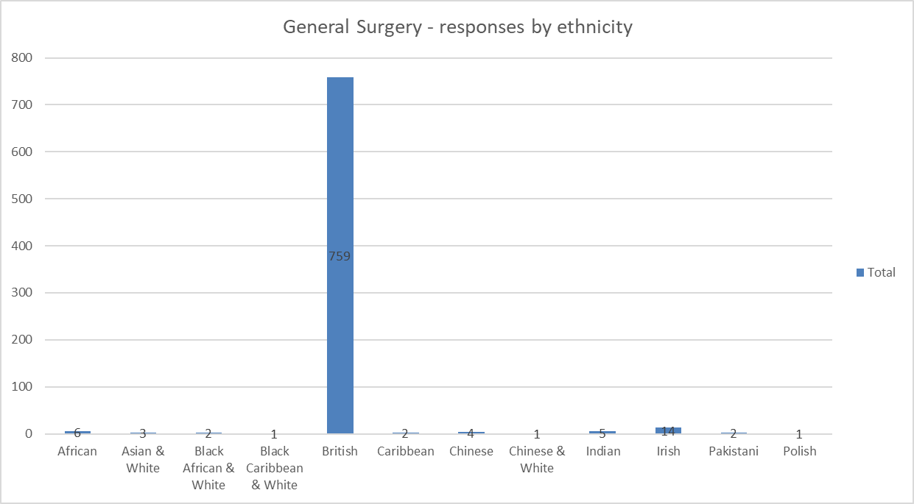

General Surgery – responses by ethnic group (non-white British)
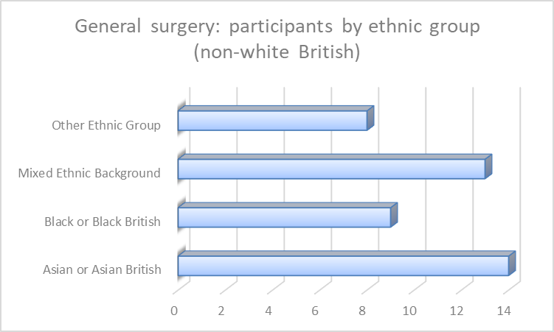
Asian or Asian British: 14 responses 1.14%
Black or Black British: 9 responses 0.73%
Mixed Ethnic Background: 13 responses 1.06%
Other Ethnic Group: 8 responses 0.65%
White: 797 responses 64.74%
I do not wish to answer this question: 76 responses 6.17%
No response: 314 responses 25.51%
The 2011 census highlighted that 5.2% of the Liverpool City Region population were from ethnic minority backgrounds and conversely, the majority of 94.8% was white British.
General Surgery – responses by LGBQ+ participants
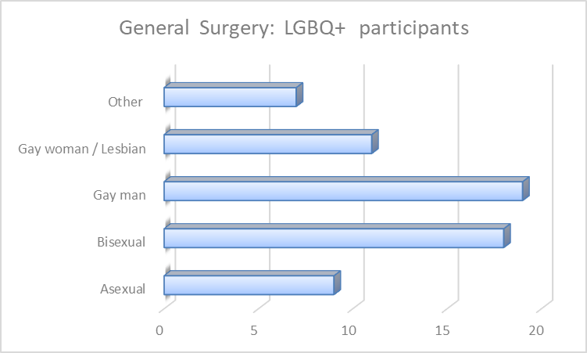
Asexual | 9
Bisexual | 18
Gay man | 19
Gay woman / Lesbian | 11
Other | 7

Out of 1231 participants, 64 participants identified as LGBQ+
General Surgery – responses by transgender:
Two people identified as transgender.
What did participants think?
General Surgery – Agreement / non agreement statements on plans
From the 1231 respondents, 1113 (90%) answered if they thought the plan was good and they’d be happy with it as it is, if they thought it was a good plan but further things needed considering, or if they thought it was a good plan and wanted to share some ideas on how it could be improved, if they didn’t think it was a good plan because it hadn’t been thought about, if they didn’t think it was a good plan but didn’t feel able to suggest anything further for commissioner and trust consideration or if they didn’t think it was a good plan and provided further narrative for consideration or they weren’t sure.
There are however three key questions for this analysis: 1) what people think of the options/plans. 2, Can they identify any negative effect on them,3) what are the negative effects.
The reason the Analysis focuses on ‘negatives’ is that it is trying to identify any indirect discrimination, as defined by the Equality Act 2010, If there is no discrimination, or any perceived discrimination can be mitigated, then the programme of change can move forward.
General Surgery – Agreement / non agreement to statements on plans by Sex
Of the 1113 who responded, 846 shared their sex as follows:
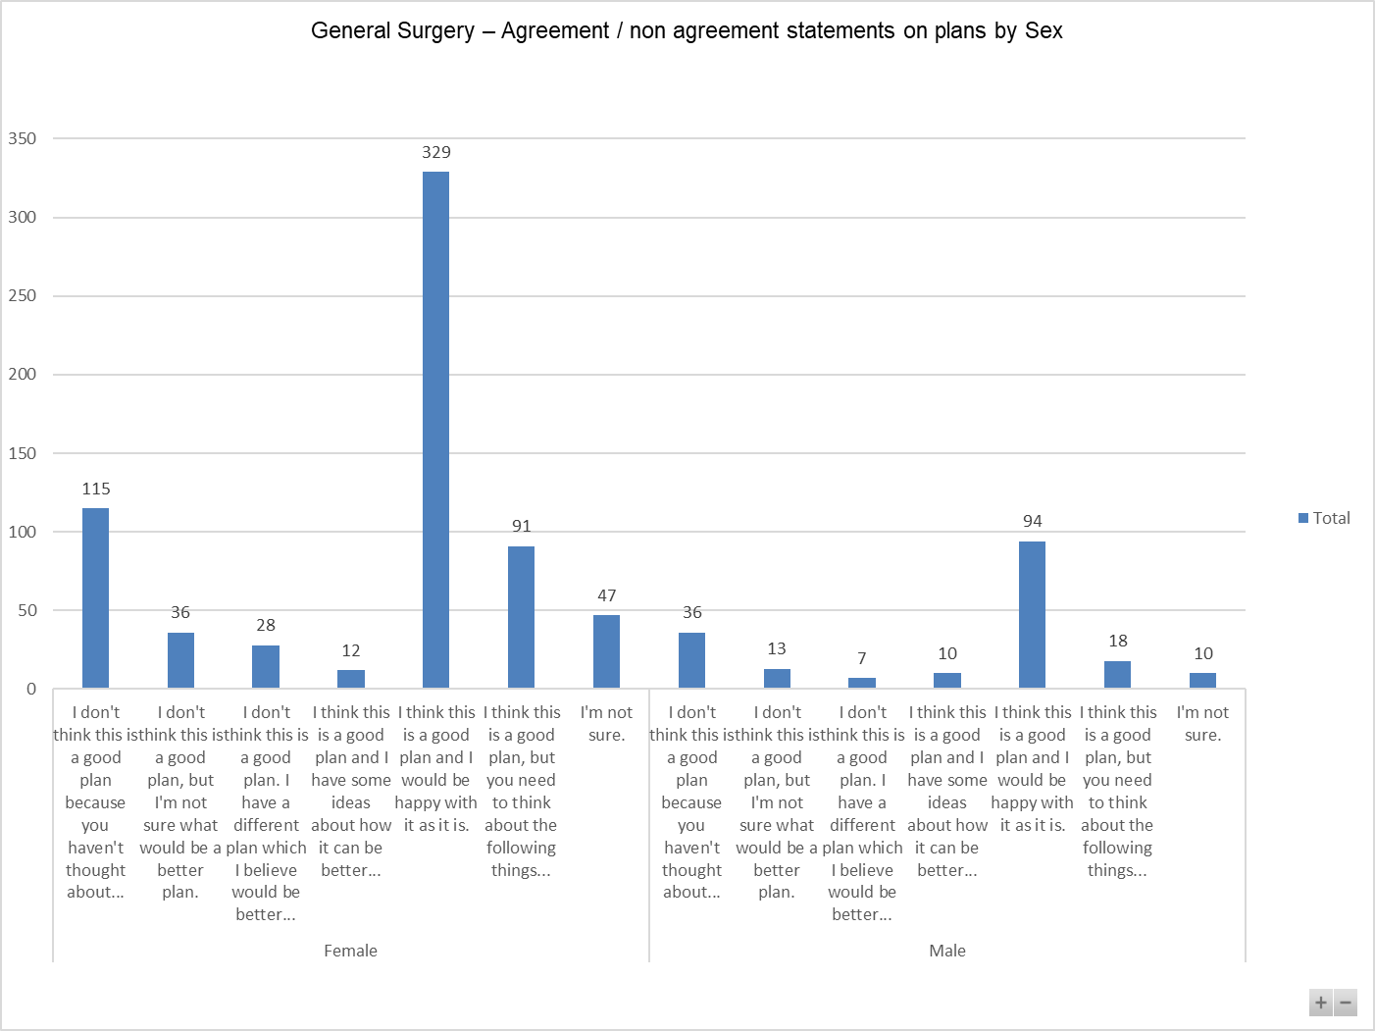
In relation to both males and females, the statement, ‘I think this is a good plan and I would be happy with it as it is’ was selected the most.
General Surgery – Agreement / non agreement to statements on plans by disability
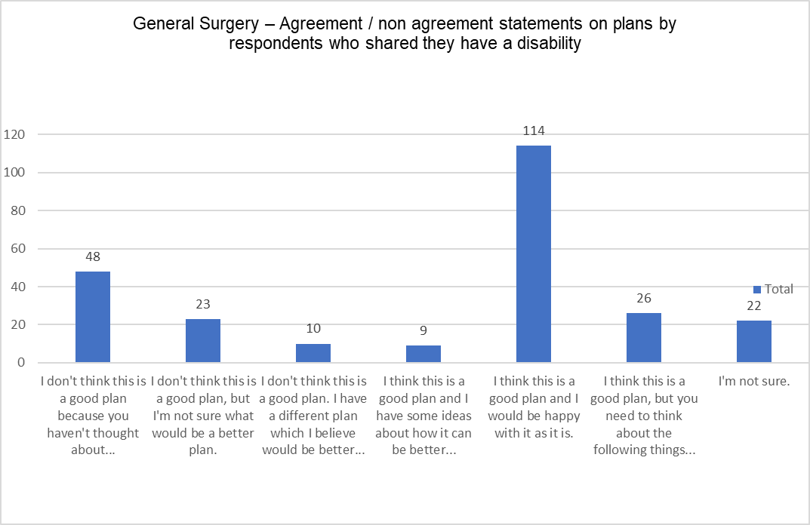
Just over 45% of respondents who shared that they have a disability selected that they thought it is a good plan and they would be happy with it as it is.
Respondents were invited to provide further narrative if they didn’t think it was a good plan and they had ideas which would be better, or if they thought it was a good plan and wanted to share ideas for further consideration.
The additional narrative provided by the respondents who selected the above-mentioned options included.
- Concerns in relation to travel, parking, and additional costs.
- Site preferences
- Concerns in relation to timely transfers between hospitals and access to timely treatment.
- Quality of care

General Surgery – Agreement / non agreement to statements on plans by ethnic groups (non-white British) 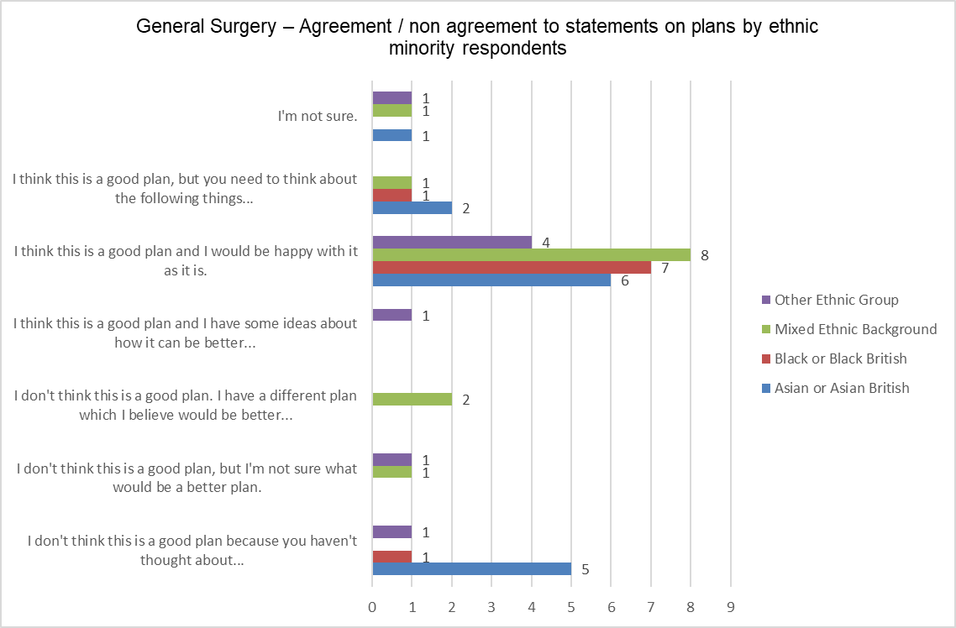

General Surgery – Agreement / non agreement to statements on plans by LGBQ+.
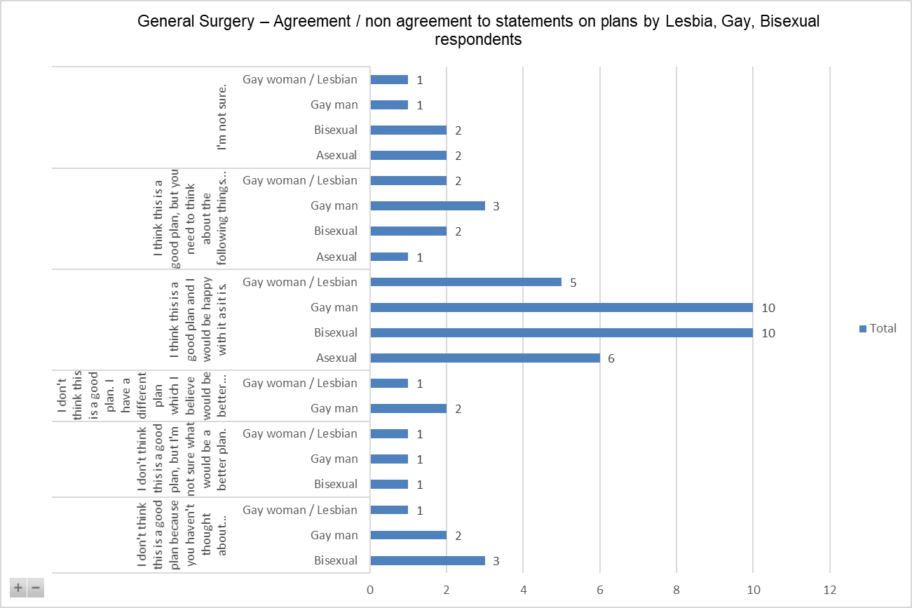

General Surgery – Agreement / non agreement to statements on plans by people who are currently using/ have used one of the services in the consultation and Age.
224 of the respondents who said they were currently or had previously used ones of the services in the consultation provided their age and their views on the general surgery reconfiguration plan as follows.
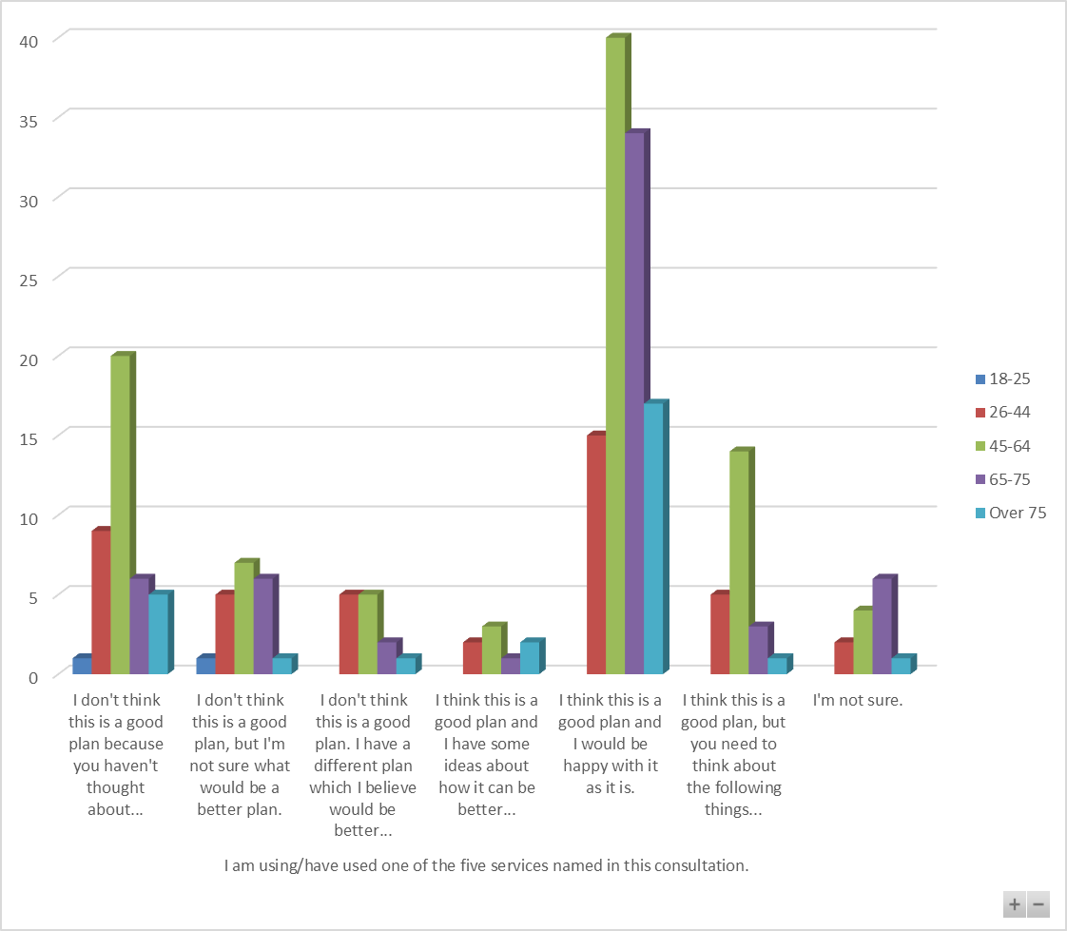
The statement selected the most across all protected characteristics was that the plan is good, and the respondent would be happy with it as it is. The questionnaire however gives the opportunity to report issues that might be disadvantageous.
The questionnaire asked: ‘Is there anything else that you would like to tell us about the plan for general surgery to help us make a final decision? For example, are there any parts of the plan that could have a negative effect on you or would put you at a disadvantage compared with other people?’ 257 people said ‘yes’.
The follow up question asks: ‘What would you like to tell us about the plan for general surgery to help make a final decision?’ Equality monitoring information was not provided by all respondents, where it was provided it is possible to highlight that females made 153 comments and males made 45.
The themes that recur are travel, distance, continuity and quality of care, cost of travel, parking, and extended waiting lists.
Below is an indicative sample of comments (comments are published verbatim however obvious spelling and grammatical errors have been corrected for ease of reading).

Comments provided by females
- Aintree hospital has poor quality of care and general hygiene. You need to bring in standards before sending people there
- Aintree is already overwhelmed with far longer waits to be seen in a&e and it will be adding an additional pressure to an already poorly tan department
- Aintree is far and it is expensive to travel so if I were to go in my family wouldn't visit
- Aintree is not on a direct access from all areas of ‘Liverpool whereas the royal is
- All plans still mean loss of beds, and the longer it takes ambulances to arrive to hospital in emergencies, the higher the mortality rate - is this worth the extra travel.
- Parking at both hospitals is a nightmare. To get from Kirkby to Broadgreen you would need to get a bus to Huyton, then change and get another bus to Broadgreen. Assuming the buses run on time, it would take 50 minutes to complete the journey. Add onto this the fact that sick people would be facing a long, tiring journey whilst relying on the efficiency of the bus operators.
- As an ED consultant at the Royal I would be forced to leave the trust if these unsafe plans go ahead - I know many of my colleagues feel the same. Patients will die whilst waiting transfer. Please, for the sake of our patients, do not go ahead with this move. We need emergency surgical cover on both sites.
- As before, if emergency stomach surgery is only at Aintree how would ambulance or the person themselves know the diagnosis and therefore to attend Aintree instead of the Royal in an emergency.
- Because of past negative experiences with the Royal, I find I have little confidence in that hospital.
- Broadgreen is a nice hospital and you are removing everything from there it seems. Displacing staff and again putting bed pressures on the other sites. Think about the health of staff and patients instead of trying to cram everything into one building because it will save you money. I know you say it will be better for drs to cover their patients. But all you are doing will cut staffing down adobe be in both sites. Also nursing staff morale is currently very low, and you are going to make it worse for all sites.
- Centralising services only benefits the people who live closest to a particular hospital. Merseyside is a large area and people deserve to be treated in their closest hospital, not one that will take a long time to get to (especially if relying on public transport, or the cost of taxis).
- Concern around risk to waiting times and distance for individuals to travel
- Delay in treatment for Liverpool patients with acute abdomens having to be transferred to Aintree; difficult for visitors/family to have to travel further to visit or patients travel for care or follow up
- Difficult to foretell but change is not managed well and may lead to lack of resources and longer waiting lists
- Distance and travel
- Distance for both patient and visitors to travel.
- Do the general public understand the severity of what is happening in the city. The public consultation is far too late in the day as services are set to move soon due to the opening of the royal
- Elective should be available at both to allow elderly, disabled and unwell patients to be treated as will be unable to travel to Royal.
- Ensure that patients are going to be confident that surgeons performing procedures are adequately trained
- Finding a parking speck to help my elderly parents
- Firstly, the idea to transport people via ambulance is very concerning when ambulances are already under a huge amount of strain and patients are waiting hours and hours for ambulances. Reality means those patients will have to wait hours or simply won’t be able to be transferred unless they know someone with a car who can help out or have to travel far on also unreliable public transport. On top of that, moving surgeries further away from where people live and away from their support systems makes no sense, and means those with responsibilities are less likely to take up surgeries that are necessary for them to live full and healthy lives.
- The Royal is not easily accessible by either public transport or car.
- Great if you live near these hospitals - not so good if you have to travel miles. Not enough car parking either that's if you have a car, but I'm sure you have already made your mind up.
- Having been treated for the past 5 years for severe abdominal trauma issues. Spending 12 days initially in intensive care and further care on wards my family would have found it very difficult to travel to and from Aintree to see me. A distance of 15 miles from my home. I am still under the care of UGI and to travel a total response miles for what could be a 15 minute appointment plus parking fees is very prohibitive in continuing any treatment
- supposed to be seen at least every 6 months never happened for past 3 years just left scan and bloods supposed to have been done last year never happened!!!
- I have an abdominal aortic aneurysm. If there were to be an emergency with this Aintree would be too far away to save me.
- I’m not sure if patients have the same trust or relationship with new consultants. How is the continuity of care delivered? Where would Outpatients be? As an out of area patient in Wigan Aintree is far more accessible. I just think that this plan will impact patient outcomes by moving a high performing service and merging it with one that is performing less well.
- I will not under any circumstances go to Southport and the royal is extremely far for my family to travel and I only have a husband and daughter and no other family.
- I think it worsens health inequalities within the city. The trust should offer the same service for emergency care on both sites.
- I think the plan is good
- I would like more information. I have never attended Aintree Hospital so I do not know what systems they have in place. I do know how the royal operates and they have been very efficient so why change!! Plus communication between different departments in one hospital is not always adequate so I would imagine communication between two sites would worsen. Staff on the ground are too busy to communicate with 2 sites.
- I would not travel to Aintree for any surgery as there is no bus route from where I live
- My family would be unable to visit
- Needing to provide a transfer service to provide this care in one site would overwhelm an already overwhelmed NWAS
- Patients already now have to wait too long for surgery. This waiting time will increase when patients are transferred back and forth between sites.
- Any traffic problems could have serious consequences.
- Recently I had emergency surgery and personally I would not be happy to be moved whilst in pain.
- Think about your staff who work at these sites, how this change will affect their work and home life. The negative impact it will have on patients needing emergency care and the demand all on one team at one site which struggle for bed capacity as it is. You have capable and trained staff at the sites why change and take healthcare back, we need to bring health care forward offering the best care possible. This is not offering that.
- This would have a negative effect on people living in the South of the city as they would have to travel further with extra cost issues and travel problems for emergency care. Planned outpatient etc would be more feasible as travel could be planned but emergency referrals are completely different
- travelling expenses
- Unfair to move services so far away
Comments provided by males:
- Aintree is not easy to get to by public transport.
- Distance for some people to travel for surgery may be an issue - particularly patients but considered ‘housebound’ and there expected to arrange their own travel arrangements
- Given current backlogs a sensible plan should be put in place to clear them. Sensible in the respect it is achievable and not aspirational.
- I am one such patient with a pre-existing medical condition, which prevents me from travelling due to hypersensitivity to vibrations. I would be in acute neuropathic pain in addition to any distress from whichever ailment would require general surgery and may not be in any fit state to receive the surgery in this circumstance.
- If anyone had to attend or visit from my area, it would be a nightmare to get there when I do not have a car. You have not provided a Travel and Accessibility Impact assessment or Equality Impact Assessment. I don't know what this means so object to these changes.
- If this is enacted, we will need an effective publicity campaign to inform the public about it - we still have people presenting to RLH ED with serious ENT conditions even though ENT services were stripped long ago. We would need the public to be aware that serious abdominal complaints are best seen at AUH
- I'm disabled and do not have my own transport, so public transport links should be considered when centralising services in such an area which is difficult to get to from a large heavily populated area such as Garston (south Liverpool) what may be convenient for the local health authority may not so convenient for those of us who will actually be needing the service provided
- Its discriminatory against poor people and the elderly
- Moving services will disadvantage people due to accessibility of services
- Stop cutting costs in patient care with changes like this.
- The idea of moving services out of RLUH and into AUH to create a cold surgical site will be a detriment to all with thin the close proximity of RLUH, particularly if the Women’s Hospital also moves onto this site.
- The Royal is difficult to reach for Visitors on a daily basis.
- The Royal is very difficult to get to and parking is atrocious
- Travel
- Travel is going to be hard and organising visits with the family
- Traveling to Aintree Hospital for less mobile is awful - a dedicated bus is needed. …. at present need to get two buses to any of the hospitals in Liverpool
- Why this consultation is so late
- you have already made up your mind. Do we have a choice?
- You haven’t stated what the proposals are, so how can we comment?
Comments made by people who shared that they have a disability
- it is extremely difficult for me to reach Liverpool Royal hospital due to mobility issues and sometimes not being able to drive/lack of close parking facilities. Aintree hospital is my local hospital and is also close by for my family which is especially important as I sometimes need them for support and help communicating due to having a neurological issue called fnd
- Because of past negative experiences with the Royal, I find I have little confidence in that hospital.
- Concerned about parking
- Distance and ease for getting to hospitals
- Ensure that patients are going to be confident that surgeons performing procedures are adequately trained
- Higher death rate. Longer waiting lists. Higher rates of hospital infections. Longer recovery rates. Difficulties in families visiting as poor transport links. Not patient focused.
- How are you going help people who can't afford to get to the appointment because of money issues. Are you going to put them to the back of the queue and have them wait longer.
- It would be very difficult for visitors who needed to use public transport
- I am one such patient with a pre-existing medical condition, which prevents me from travelling due to hyper sensitivity to vibrations. I would be in acute neuropathic pain in addition to any distress from whichever ailment would require general surgery and may not be in any fit state to receive the surgery in this circumstance.
- I think it worsens health inequalities within the city. I think the plan is good
- I'm disabled and do not have my own transport, so public transport links should be considered when centralising services in such an area which is difficult to get to from a large heavily populated area such as Garston (south Liverpool) what may be convenient for the local health authority may not so convenient for those of us who will actually be needing the service provided
- Many years ago (47 years) I needed a cosmetic abdominal procedure for medical reasons I was initially seen at RLUH but eventually had surgery at Whiston Had I have had to travel to Whiston with 2 babies I would have found it virtually impossible not to say expensive
- No way to Get there. No public transport. Edge lane will have one bus per hour serving the area. The taxi and ambulance transport service will collapse. Waiting times will increase
- We cannot have potential emergency patients requiring abdominal surgery waiting in ambulances or lying in corridors.
- Stop cutting costs in patient care with changes like this.
- The plan assumes that the public can get to each hospital easily which they cannot. The Royal is very difficult to get to and parking is atrocious
- This would pose some difficulties, in particular to our older residents and vulnerable/ disabled residents who depend on public transport or lifts from family/friends. It would also mean patient relatives are quite a distance away from patients. It would be an impossibly long using public transport, as from Sefton would require either an astronomical taxi fare or a trains & then bus ride into town and then up to the royal not to mention the finances to get there also. I have experienced all of these difficulties in the past when having to go to the royal instead of Aintree.
- Traveling to Aintree Hospital for less mobile is awful - a dedicated bus is needed.
- Travelling and access
- you have already made up your mind. Do we have a choice?
Comments from ethnic groups (non-white British)
- Why this consultation is so late
- Has the outpatient nursing establishment been reviewed?
- Stop cutting costs in patient care with changes like this.
- The cost of transport in getting to Aintree from the L8 area is high and I believe patients should be able to stay where they are most comfortable and know their surroundings, in my case this is the Royal Liverpool hospital. Clinic appointments changed from the royal Liverpool to Aintree, and I haven't attended any appointments due to cost of transport in getting there. It is approximately £2 each way and we weren't given any reasonable notice of the change of clinic appointments. As someone with a complex illness it is not realistic to be expected to make the journey by bus and also to be faced with a different consultant who doesn't know you like the previous one you had at the Royal.
- travelling expenses
- I am concerned about the distance to Aintree from South Liverpool. It would be very difficult for visitors who needed to use public transport
- The Royal site could lose Trauma Unit status due to inadequate Surgical cover/response. This will put further pressure on an already struggling Aintree A&E
Comments from Lesbian, Gay, Bisexual, Queer plus (LGBQ+)
- Distance and travel
- Aintree is far and it is expensive to travel so if I were to go in my family wouldn't visit
- travelling expenses
- Distance for some people to travel for surgery may be an issue
- All plans still mean loss of beds, and the longer it takes ambulances to arrive to hospital in emergencies, the higher the mortality
- Moving services will disadvantage people due to accessibility of services
- If I were to experience a general surgical emergency, I would now have to travel 25 minutes by road to Aintree from my home vs. five minutes to the Royal.
- Please be conscious of the distance some patients will need to travel to receive emergency general surgery treatment and how that may affect the outcome of their treatment/life. I'm sure no one wants the distance a patient travels to receive treatment to end in tragedy.
- Potential barriers relevant to the protected characteristics
Refer to differential matrix below.

Protected Characteristic | Issue | Remedy/Mitigation
Age | Age of patients undergoing surgery  Research published by the British Journal of Surgeons estimates that one-fifth of the 75 years and older age category will undergo surgery each year.  Under the new plans change of sites may have travel implications especially for older people and people with disabilities (also see disability section). Issues raised from the consultation covered travel, cost, quality of care. A sample of respondent’s comments:  - Finding a parking speck to help my elderly parents  - Distance for both patient and visitors to travel.  - The Royal is not easily accessible by either public transport or car.  There was a lower number of responses to the general surgery reconfiguration proposal from people aged 18 to 25, and those aged over 75. | *Commissioner and trust collaboration required to undertake further travel assessment to map public transport services and work with transport providers.  *Patients need to be informed of hospital travel services (eligibility for patient transport services), access to travel expenses reimbursement scheme. Continue public relations on the issue of travel and accessibility.  *Commissioner and trust ongoing monitoring of emergency and non-emergency patient transport services (North West Ambulance Service – NWAS) to reassure patients of transport times in an emergency from different parts of the area.  Ongoing collection of equality monitoring information.  Ongoing monitoring of patient experience.
Disability | There are several potential barriers to access to healthcare for people with disabilities.  - Not meeting information and communication needs.  - Behavioural problems resulting in difficulty attending treatment/ surgery.  - Diagnostic overshadowing  - Lack of participation in decision making for patients and their carers.  - Pressure on resources leading to reduced consulting time.  - Equipment and reasonable adjustments being made to support the person.  Issues raised from the consultation covered travel, cost and continuity of care. A sample of respondent’s comments:  - I'm disabled and do not have my own transport, so public transport links should be considered when centralising services in such an area which is difficult to get to from a large heavily populated area such as Garston (south Liverpool) what may be convenient for the local health authority may not so convenient for those of us who will be needing the service provided  - Ensure that patients are going to be confident that surgeons performing procedures are adequately trained  - How are you going help people who Can't afford to get to the appointment because of money issues. Are you going to put them to the back of the queue and have them wait longer  - It would be very difficult for visitors who needed to use public transport  - This would pose some difficulties, in particular to our older residents and vulnerable/ disabled residents who depend on public transport or lifts from family/friends. It would also mean patient relatives are quite a distance away from patients. It would be an impossibly long using public transport, as from Sefton would require either an astronomical taxi fare or a trains & then bus ride into town and then up to the royal not to mention the finances to get there also. I have experienced all of these difficulties in the past when having to go to the royal instead of Aintree | Clinicians must continue to consider disability and mobility functioning in making therapeutic recommendations to people with impairments or mobility difficulties who need medical treatment.  People with disabilities need to be encouraged to undergo all available treatment appropriate to them. The Trust is under a legal duty to ensure that all reasonable adjustments are made for disabled people.  This includes types of treatment and use of equipment and support packages post treatment.  *Further travel assessment needs to be undertaken to map out public transport services and work with transport providers.  *Patients need to be informed of hospital travel services (access to patient transport services), access to travel expenses reimbursement scheme and eligibility criteria. Continue public relations on the issue of travel and accessibility  *Commissioner and trust ongoing monitoring of emergency and non-emergency patient transport services (North West Ambulance Service – NWAS) to reassure patients of transport times in an emergency from different parts of the area.
Gender reassignment | Based on the experiences of more than 800 trans and non-binary people, a 2018 study by Stonewall looked at the discrimination trans people face on a daily basis in the UK. The report examined discrimination in their home life and in access to medical support for transition, which can significantly increase mortality rates. The Stonewall report revealed the discrimination against transgender individuals occurred in the healthcare environment  2 people identified as ‘trans’ in the recent consultation questionnaire. | No responses identified issues of indirect or direct discrimination linked to gender reassignment.  Ensure services are inclusive and staff trained appropriately to deliver good quality, personalised care and support.
Marriage and Civil Partnership | Partners, spouses etc being involved and able to visit is an important part of a patient’s recovery process. | No responses identified issues of indirect or direct discrimination linked to marriage/civil partnership.  Trust to undertake regular reviews of visiting policy.
Pregnancy and maternity | Routine data from English hospitals show that general surgery during pregnancy, such as removing the appendix or gallbladder, does not commonly harm mother or baby. This suggests that surgery in pregnant women is generally safe, but that mothers could be provided with more specific estimates of the risks.  One comment was made by someone who shared that they were currently pregnant or had a baby in the last 12 months:  - The plan makes sense from a financial standpoint, but emergency surgery should still be available on both sites as there will be events that will prevent Aintree from being able to deliver the care to some patients which could result in negative outcomes for those patients | No responses identified issues of indirect or direct discrimination linked to pregnancy and maternity.
Race | A report published by the NHS Race and Health Observatory in February 2022 highlights that the health of ethnic minority people has been negatively impacted by: lack of appropriate treatment for health problems by the NHS; poor quality or discriminatory treatment from healthcare staff; a lack of high quality ethnic monitoring data recorded in NHS systems; lack of appropriate interpreting services for people who do not speak English confidently and delays in, or avoidance of, seeking help for health problems due to fear of racist treatment from NHS healthcare professionals.  Issues raised from the consultation covered travel, cost, quality of care.  A sample of respondent’s comments:  - Why this consultation is so late  - Has the outpatient nursing establishment been reviewed?  - Stop cutting costs in patient care with changes like this.  - travelling expenses  - The Royal site could lose Trauma Unit status due to inadequate Surgical cover/response. This will put further pressure on an already struggling Aintree A&E | No responses identified issues of indirect or direct discrimination linked to race or ethnicity.  Ensure services are inclusive and staff trained appropriately to deliver good quality, personalised care and support.
Religion and belief | Healthcare services have a legal duty under the Equality Act 2010 to treat people of different faiths and beliefs fairly and without discrimination.  A person’s religion or belief may impact how the perceive or receive medical treatment. For example, a Jehovah’s witness may not accept blood transfusion or blood products. | Of those respondents that shared their religion and belief, none shared that they were a Jehovah’s witness.  No responses identified issues of indirect or direct discrimination linked to religion and/or belief.  Ensure staff are trained in understanding needs associated with religion and belief and engage with chaplaincy services.
Sex (M/F) | Reports show that women are far more likely to use public transport than men, women and older people are far more likely to use public transport as they have the lowest car ownership.  Issues raised from the consultation covered travel, cost, quality of care.  A sample of respondent’s comments:  Comments from females:  - All plans still mean loss of beds, and the longer it takes ambulances to arrive to hospital in emergencies, the higher the mortality rate - is this worth the extra travel.  - Parking at both hospitals is a nightmare  - As an ED consultant at the Royal I would be forced to leave the trust if these unsafe plans go ahead…  - Because of past negative experiences with the Royal, I find I have little confidence in that hospital.  - Delay in treatment for Liverpool patients with acute abdomens having to be transferred to Aintree; difficult for visitors/family to have to travel further to visit or patients travel for care or follow up  - Do the general public understand the severity of what is happening in the city. The public consultation is far too late in the day as services are set to move soon due to the opening of the royal  - I’m not sure if patients have the same trust or relationship with new consultants. How is the continuity of care delivered?  - My family would be unable to visit  - I think it worsens health inequalities within the city  - This waiting time will increase when patients are transferred back and forth between sites  - I will not under any circumstances go to Southport and the royal is extremely far for my family to travel and I only have a husband and daughter and no other family.  Comments from males:  - Why this consultation is so late  - Distance for some people to travel for surgery may be an issue  - If anyone had to attend or visit from my area, it would be a nightmare to get there when I do not have a car. You have not provided a Travel and Accessibility Impact assessment or Equality Impact Assessment. I don't know what this means so object to these changes.  - The Royal is very difficult to get to and parking is atrocious  - Travel is going to be hard and organising visits with the family  - you have already made up your mind. Do we have a choice? | *Commissioner and trust collaboration required to undertake further travel assessment to map public transport services and work with transport providers.  *Further travel assessment needs to be undertaken to map out public transport services and work with transport providers.  *Patients need to be informed of hospital travel services (access to patient transport services), access to travel expenses reimbursement scheme and eligibility criteria. Continue public relations on the issue of travel and accessibility  *Commissioner and trust ongoing monitoring of emergency and non-emergency patient transport services (North West Ambulance Service – NWAS) to reassure patients of transport times in an emergency from different parts of the area.
Sexual orientation | Healthcare services have a legal duty under the Equality Act 2010 to treat LGB people fairly and without discrimination. However, national research shows that LGBT people continue to face barriers in accessing healthcare treatment today in direct relation to their sexuality.  Issues raised from the consultation covered travel, cost, quality of care.  A sample of respondent’s comments:  - Distance and travel  - Aintree is far and it is expensive to travel so if I were to go in my family wouldn't visit  - travelling expenses  - All plans still mean loss of beds, and the longer it takes ambulances to arrive to hospital in emergencies, the higher the mortality  - Please be conscious of the distance some patients will need to travel to receive emergency general | Ensure services are inclusive and staff trained appropriately to deliver good quality, personalised care and support.  No responses identified issues of indirect or direct discrimination linked to sexual orientation.

- Does this service go the heart of enabling a protected characteristic to access health and wellbeing services?
Yes.
- Have you identified any key gaps in service or potential risks that need to be mitigated?
The consultation showed that people are in favour of the changes but had concerns about travel and cost. This needs to be addressed by undertaking a transport analysis and looking at the barriers that the participants in the consultation are highlighting; lack of bus routes, lack of parking, cost of parking, etc. and as such must show that the trust is working in a positive way to help patients, including information for them of any support the hospital can give and the criteria for that support.

Whilst hospital transport may be available, this in itself is not a full mitigation – this can only be fully mitigated when the number of eligible patients and those using the service are understood.

Moving services to alternative locations will always impact on travel for some individuals – that disadvantage (of being further away from accessing the service) is not discrimination in and of itself. However, how the trust responds, or does not respond to the challenges (for example not having disability parking spaces for blue badge holders) or understanding travel /parking issues can result in indirect discrimination.
Refer to table below.

Other Risk Areas | Required Action | By Who/ When
Activity Data – not provided by protected characteristic to assist in monitoring patient outcomes by protected characteristic. | Capture activity data by number as well as percentage.  Report activity by protected characteristic.  Monitoring outcomes by protected characteristic.  Compare outcomes in protected characteristics e.g. male v female.  *Monitor patient experience by protected characteristic.  Embed equality considerations in serious incident reporting process. | Trust / ongoing – linked to complying with Equality Act 2010.
Widening Health inequalities; Travel/ Transport issues | Undertake further travel/ transport analysis.  Share information with travel / transport, access to patient transport services, travel cost reimbursement scheme. | Trust and Commissioners/ timescale to be discussed and agreed.
Patient experience | *Monitor patient experience by protected characteristic.  Ensure staff are able to access training to support patients with specific needs linked to protected characteristic or other vulnerable groups and trust ongoing monitoring of compliance records.  N.B. employers are vicariously liable for the behaviour of staff whilst in the workplace. | Trust / ongoing – linked to complying with Equality Act 2010.
Staff engagement | Staff consultation | Trust/ in progress

Is there evidence that the Public Sector Equality Duties will be met (give details) Section 149: Public Sector Equality Duty (review all objectives and relevant sub sections)
PSED Objective 1: Eliminate discrimination, victimisation, harassment, and any unlawful conduct that is prohibited under this act.
The service is for all patients that have need of the service. Staff are trained to deliver a professional service to all patients – staff undertake specific training to ensure they can work with diverse individuals.

PSED Objective 2: Advance Equality of opportunity.
Refer to sub sections.
PSED Objective 2: Section 3. sub-section a) remove or minimise disadvantages suffered by people who share a relevant protected characteristic that are connected to that characteristic.
The service is accessible and can support people with different needs, especially people with disabilities.

Moving forward the service will; provide better monitoring of its service users and the outcomes they receive – looking for parity in service delivery and satisfaction levels.
PSED Objective 2: Section 3. sub-section b) take steps to meet the needs of people who share a relevant protected characteristic that are different from the needs of people who do not share it
During the consultation, all protected characteristics mentioned the need for access, parking, and ease of travel.

Whilst public travel is outside the remit of the trust, it can nonetheless liaise with commissioners and transport providers to identify better serving bus routes.

Patients need to be informed of any hospital transport services that they might be entitled to.
PSED Objective 2: Section 3. sub-section c) encourage people who share a relevant protected characteristic to participate in public life or in any other activity in which participation by such people is disproportionately low.
The service does cater for anyone in the catchment area, and it is maintaining local services.

PSED Objective 3: Foster good relations between persons who share a relevant protected characteristic and persons who do not share it. (Consider whether this is engaged. If engaged, consider how the project tackles prejudice, and promotes understanding -between the protected characteristics)
Objective is not engaged.
PSED Section 2: Consider and make recommendation regards implementing PSED into the commissioning process and service specification to any potential bidder/service provider (private/ public/charity sector)
Further work required to capture, report, and monitor services by protected characteristic.

The lead commissioner requires the trust to provide evidence of compliance with PSED through the NHS Standard Contract. Any proposed future changes to service model/ delivery will be subject to separate equality analysis.
Recommendation to Board
PSED will be met by the reconfiguration of services.
Actions that need to be taken
Public concern over transport and travel needs to be addressed and further work done on understanding concerns and barriers that this is presenting to some in the community.

Refer to sections 4 and 6.

https://www.liverpoolcityregion-ca.gov.uk/wp-content/uploads/Data-dashboard-2022022586.pdf
Heterosexuality/Straight is not included in the chart as more than 90% of the Cheshire and Merseyside population identifies as heterosexual. Homophobic behaviour and discrimination tends to be targeted at people who express their identify as having a different sexuality or identifying by a sex different to that they were assigned at birth.
https://bjssjournals.onlinelibrary.wiley.com/doi/abs/10.1002/bjs.11148
https://evidence.nihr.ac.uk/alert/general-surgery-is-mostly-safe-during-pregnancy/#:~:text=Routine%20data%20from%20English%20hospitals,specific%20estimates%20of%20the%20risks.
https://www.stonewall.org.uk/system/files/lgbt_in_britain_health.pdf

