Equality Analysis Report
Post-Consultation v3 Final
Integration and Reconfiguration Programme - Clinical Service Model Business Case – Urology Services
Start Date: | 30 May 2022
NHS Cheshire and Merseyside Integrated Care Board Equality and Inclusion Service (Knowsley, Liverpool, Sefton and St Helens Places) | Andy Woods  Jo Roberts | 22 August 2022  24 August 2022
Trust Lead Officer Signature and Date:
Finish Date: | 24 August 2022
Exec Sign Off Signature and Date
Date of Committee consideration

- Details of service / function:
Overview of services
Urology is the largest surgical specialty after general surgery and orthopaedics and involves the treatment of conditions of the Urinary tract and male genital tract. The includes some very common cancers including prostate cancer (which is now as common as lung cancer and bowel cancer put together), bladder, kidney and testicular cancer and some very common but debilitating benign conditions such as kidney stones (which cause severe pain and affect 6-18% of the population as some point in their lives), lower urinary tract symptoms (affecting about 50% of the population over 50), urinary sepsis and number of other problems.
Urological services for the people of Liverpool have been provided by 2 separate units based in each of the legacy trusts. With the exception of complex cancer work referred through the cancer network and small numbers of other tertiary cases, the units have largely functioned as separate, duplicated services although a common leadership structure was introduced in 2020.
Typically, more than 80% of all patient attendances for urology happen in outpatient services. These are currently provided at both Aintree University Hospital and at the Royal Liverpool Hospital.

The chart below shows how many people were treated as urology inpatients (care which
involves an overnight stay in hospital) at both Aintree and the Royal Liverpool during 2021/22:

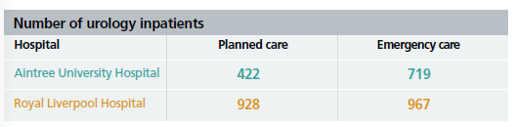

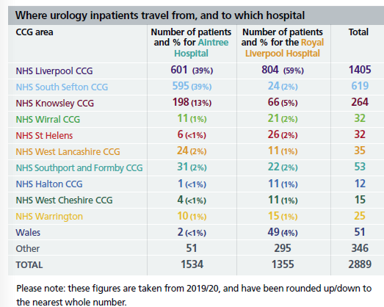

Activity information also indicates that Urology services are accessed by people across all ages groups, predominantly white people, and the sex of those accessing urology services is predominantly males (72%).

The urology service has seen a steady growth in patient numbers over recent years, which means that it is now struggling to cope with the current levels of demand for treatment and care.

This growing demand for care has seen the length of time that patients wait routine treatment by the urology service increase, both for general elective (planned) procedures and for a cancer diagnosis. It’s a problem that has also been made worse by the temporary suspension of many planned procedures during the COVID-19 pandemic. As a result of these issues, the service is currently failing to meet a number of NHS standards and targets as demonstrated by the table below:

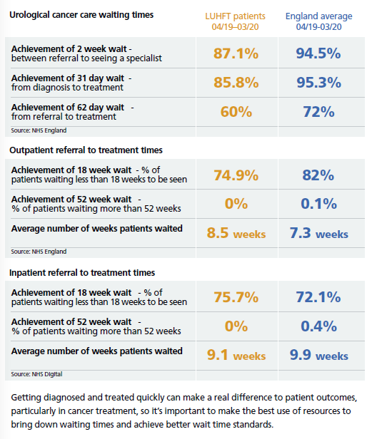

What is the legitimate aim of the service change / redesign?

- Demographic needs and changing patient needs are changing because of an ageing population.
- Value for Money-more efficient service
- Future sustainability
- Address variations in care
- Address clinical workforce issues
- Avoid duplication of resources
- Change to service

Proposed Clinical Model
The proposed clinical model is to configure all inpatient Urology work at the New Royal site with outpatient services to be split between the New Royal and Aintree sites. This will not only improve patient outcomes, access, and experience in addition to the benefits for staff, it also aligns and enables the Trust’s wider strategy for the reconfiguration of services across sites working on the principle of centralised where necessary and closer to home where possible. The benefits are manifold and include providing a better patient service, improved working environment, increased support to, and from, interdependent services whilst reducing duplication and improving sustainability. This configuration produces a central high-capacity hub to act as a focal point for high quality in-patient care which will achieve:
- Volume related improvement in clinical outcomes
- Urology patients more likely to be cared for by urology nurses
- Urology patients more likely to be cared for by condition-specific subspecialist teams
- Opportunity to streamline and improve pathways taking the best from each site and working together
- A more resilient service
- Better for staff training, career progression and staff retention
- Substantial reduction in duplication of expensive specialist equipment
- Much simpler to provide around the clock expert emergency cover
- Better for innovation, teaching and research
- Patients can still access the most commonly used services (outpatients) closer to home
- A balanced approach to proportionate deployment of out-of-hours resources to where most needed while providing a safe and accessible service to other specialties across site
This proposed model was informed by completing an options appraisal, analysing data from 2017 onwards as well as conducting external interviews with other Urology departments who have experienced an integration. Dedicated Urology inpatient beds will no longer be provided at the Aintree University Hospital site. All visitors of Urology inpatients will attend the New Royal Liverpool Hospital.
Dedicated Urology inpatient beds will no longer be provided at the Aintree University Hospital site. All patients requiring Urology inpatient care will be admitted to the new Royal Liverpool Hospital. This will improve the quality of care that is delivered and ensure that all patients are able to access the same standardised and consistent care.
Urology outpatient services will be maintained across Aintree and the Royal Liverpool to ensure that patients can continue to access care closer to home where it is clinically appropriate.
The proposed clinical model set out in the business case will impact on medical and nursing staff groups. The main changes will be linked to the transfer of inpatient Urology care to the New Royal Liverpool Hospital.
- Consultation
A public consultation about proposals for five Liverpool University Hospitals NHS Foundation Trust (LUHFT) services – breast surgery, general surgery, nephrology, urology, and vascular services took place between 7th June 2022 and August 2022.
Participants could choose which medical areas they wished to comment on (they could choose more than one). 897 people chose to comment on the proposed Urology service model.
This data includes those who shared that they were a healthcare professional as well as public responses.
N.B. This analysis is focused on ‘protected characteristics’, so any participant that does not give details cannot be included in the data, as the equality analysis is looking at the concerns of protected characteristics and what they have said in relation to each other. The task is to test for ‘consensus’ or ‘disagreement’ between protected characteristics which may point to specific needs for specific groups. A separate ‘consultation report’ has been produced which will give a detailed view of the overall responses.
Who participated in the Urology services questionnaire?

Urology services – responses by Sex
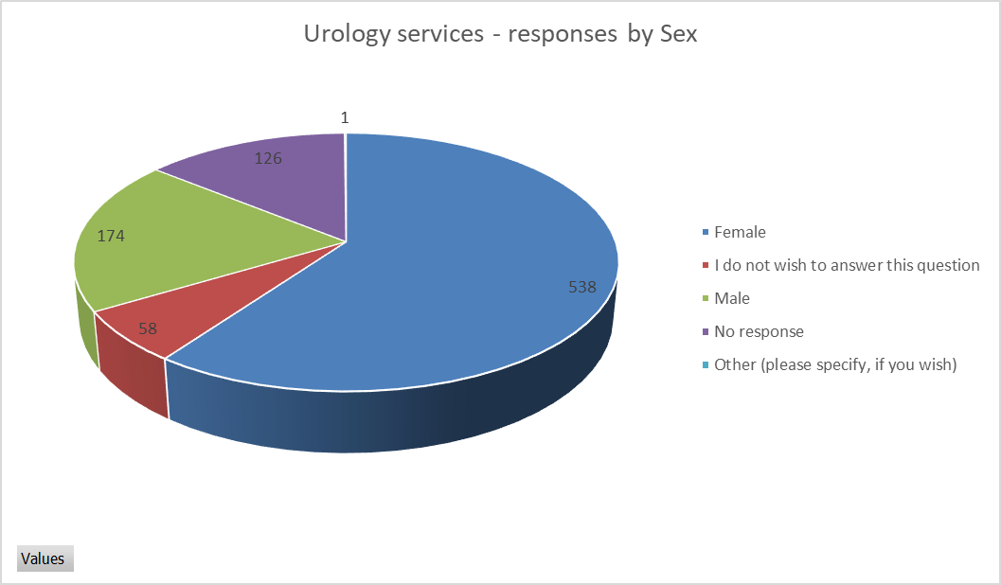
Female | 538
I do not wish to answer this question | 58
Male | 174
No response | 126
Other (please specify if you wish) | 1

Females responded more than males by approximately two thirds. The ONS mid-year population estimates (2020) Liverpool City Region has a male population of 48.9%. This highlights an under-representation in survey responses from males.
As this report is interested in protected characteristics it will focus on those when reporting tables and charts, where a person has not responded or specified, they will not be included.

Urology services – responses by Age and Sex
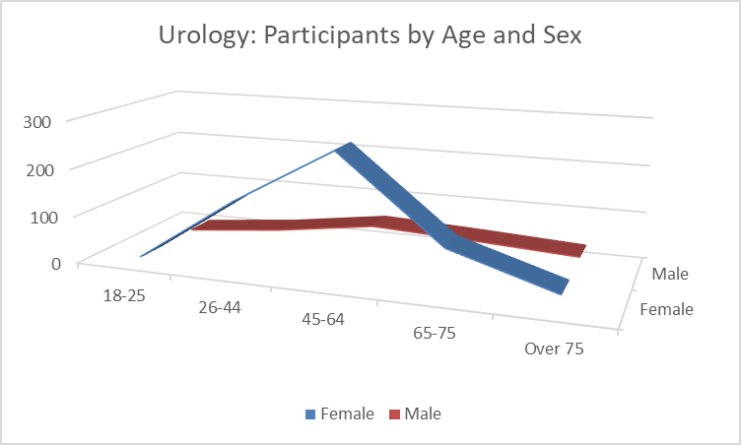

Age range Female Male
Age 18 – 25: 6 6
Age 26 – 44: 145 27
Age 45 – 64: 265 57
Age 65 – 75: 94 47
Over 75: 28 35

All age groups are represented. The largest group of participants by age is 45–64-year-olds for both men and women.
Urology services – responses by disability:
190 people identified as having a disability or long-term illness (people could select more than one disability category)
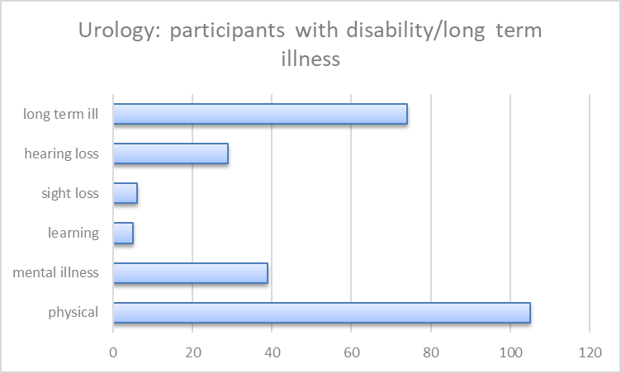
Urology services – responses by ethnicity
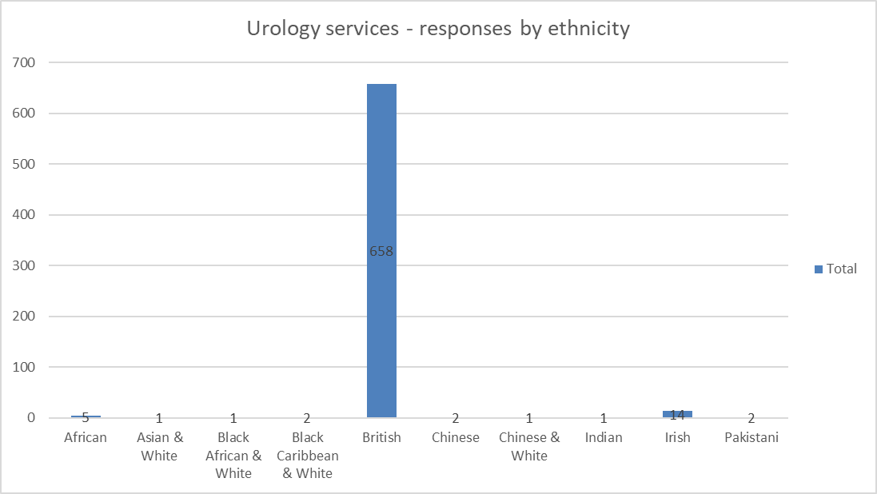
Urology services – responses by ethnic group (non-white British)
Out of the 897 participants, 26 identified as non-white British.
The 2011 census highlighted that 5.2% of the Liverpool City Region population were from ethnic minority backgrounds. Whilst 26 is a low representation of people from ethnic minorities, nonetheless, it is a proportionate amount in view of the results and size of the questionnaire.
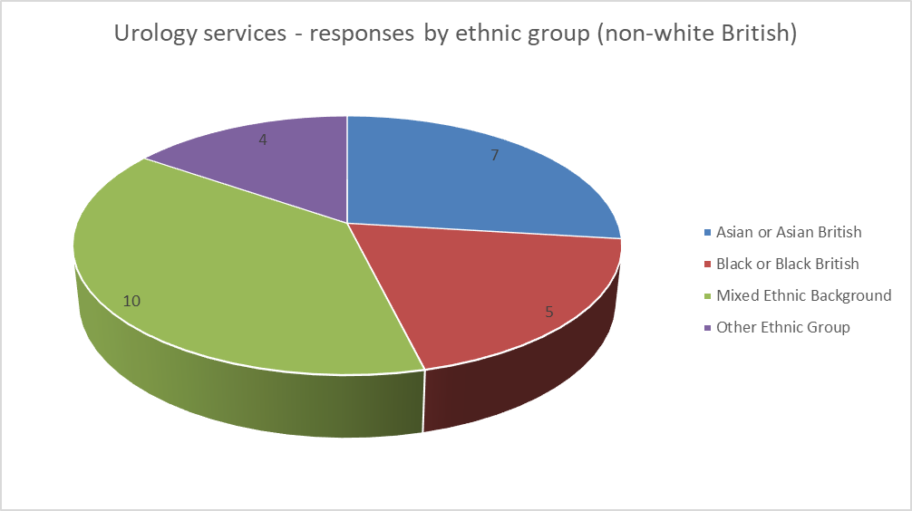
Asian or Asian British: 7
Black or Black British: 5
Mixed Ethnic Background: 10
Other Ethnic Group: 4

Urology services – responses by LGBQ+
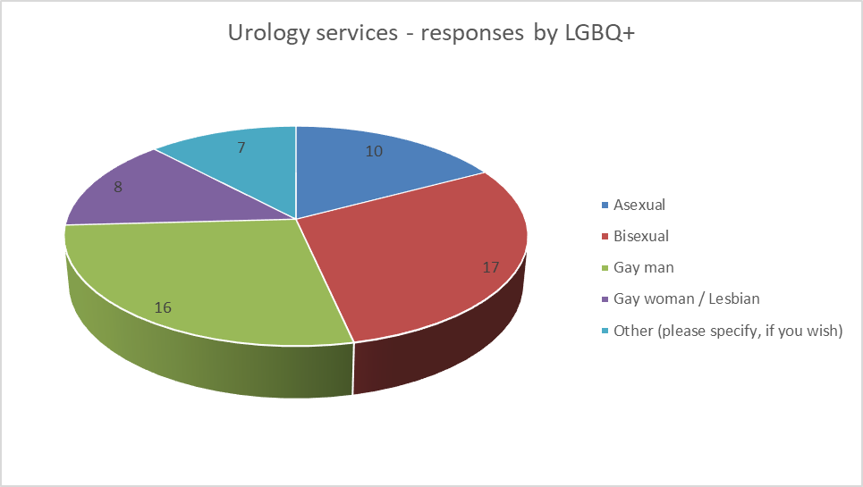
Asexual: 10
Bisexual: 17
Gay man: 16
Gay woman/ lesbian: 16
Other: 7

Urology services – responses by transgender
One person identified as transgender.
Where there are low numbers, the data and responses are checked to see if they are mentioning any particular problem linked to their protected characteristic.

What did participants think?
The questionnaire asked many questions however, there are three key questions for this analysis: 1) what people think of the options/plans. 2, Can they identify any negative effect on them,3) what are the negative effects.
The reason the Analysis focuses on ‘negatives’ is that it is trying to identify any indirect discrimination, as defined by the Equality Act 2010, If there is no discrimination, or any perceived discrimination can be mitigated then the process can move forward.

Response to the options:
Urology services – agreement / non- agreement to statements on plans by Sex
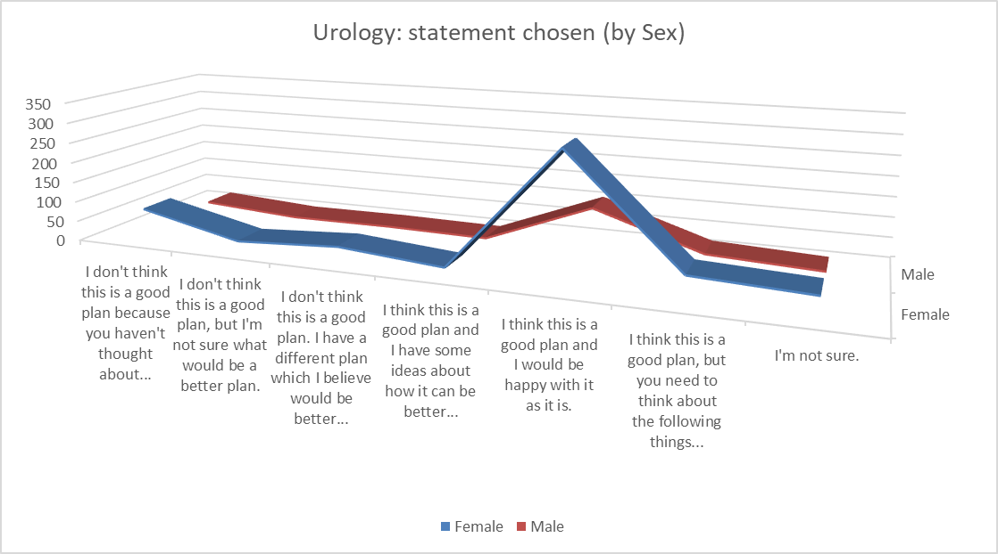
In relation to both males and females, the statement, ‘I think this is a good plan and I would be happy with it as it is’ was selected the most.
Urology services – agreement / non- agreement to statements on plans by disability
The statement, ‘I think this is a good plan and I would be happy with it as it is’ was selected the most.

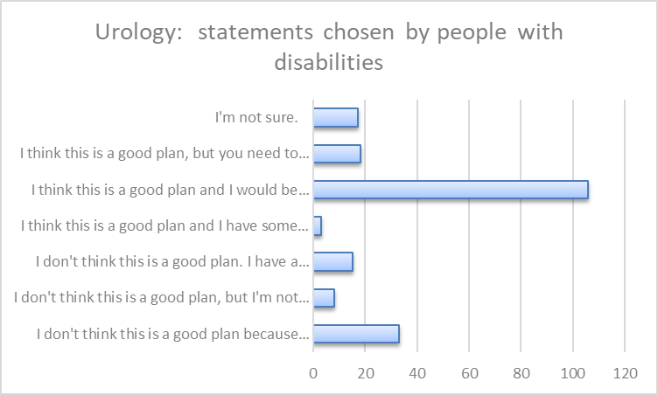
Concerns shared by respondents who didn’t think it was a good plan (33 people) related to:
- Not being sure on what the benefits to change are
- Concerns about staffing
- Difficulty with travel
- Access
Urology services – agreement / non- agreement to statements on plans by ethnic group
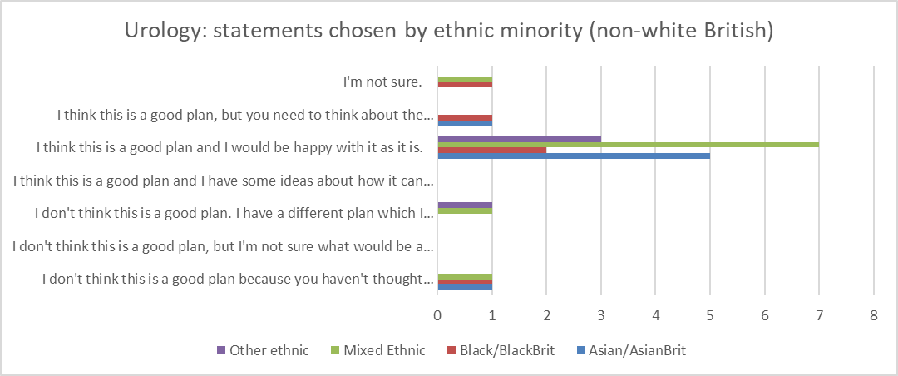
Of the 26 people that identified as black, Asian, mixed ethnic group or other ethnic group the highest number of responses across groups was that they thought it was a good plan.
The same pattern emerges when ‘Age’ is analysed against the statements.
The statement selected the most across all protected characteristics was that the plan is good, and the respondent would be happy with it as it is. The questionnaire however gives the opportunity to report issues that might be disadvantageous.
The questionnaire asked: ‘Is there anything else that you would like to tell us about the plan for urology to help us make a final decision? For example, are there any parts of the plan that could have a negative effect on you or would put you at a disadvantage compared with other people?’ 140 people said ‘yes’.
The follow up question asks: ‘What would you like to tell us about the plan for urology to help make a final decision?’ 67 comments were made by females and 35 by males.
The concerns that were evident related to: travel, access, distance, distance for families, quality of care and being oversubscribed, cost, parking, concern about staff.
Below is an indicative sample of comments (comments are published verbatim however obvious spelling and grammatical errors have been corrected for ease of reading).
Comments provided by females
- Elderly, disabled or unwell will not be able to travel to Royal and also not afford it
- It has a negative effect on me as a patient travelling between two hospitals firstly for clinics and then a different place e for surgery. Have anyone person putting these plans together ever been a patient undergoing any treatment. It can be traumatic and very stressful. Where on Gods planet would splitting all these services up make any of this less stressful for the patient.
- It's too far to expect patients to travel from southport to the centre of Liverpool for health care
- My husband can usually use extended lunch to attend appointments if they were moved further it would mean booking annual leave & more expense fir petrol too.
- Once again no thought has been given to patients and families who will have to attend from Sefton and Kirkby. Keep the same
- I have difficulty walking and using public transport, getting to the Royal would be expensive if using taxis, buses are not easy for me to access.
- It is difficult to get to the Royal from the Sefton area
- I have several medical conditions and, having discovered at the age of 61 that, I only have one kidney, I feel that my living in close proximity gives me peace of mind when it comes to treatment.
- Whilst the buildings are important, the communication between them, their medical personnel and the patient is PARAMOUNT: the patient MUST be owned. My late husband, XXXXX [name redacted], NHS number XXXXXX [Number redacted], had a diagnosis of metastatic prostate cancer and whilst Aintree Hospital warned of a malignant spinal cord compression (MSCC) their counterparts at Clatterbridge made no mention of it and didn't consider it when treating my husband –[He] died from MSCC. Whatever you decide for buildings there needs to be AGREED PROCEDURES ACROSS ALL SITES, INCLUDING CLATTERBRIDGE, FOR SHARING ALL RELEVANT INFORMATION; PROPER COMMUNICATION BETWEEN ALL MEDICAL STAFF INVOLVED IN THE PATIENTS CARE including SHARING OF RECORDS. My husband's dying wish was that, "Others should never be treated like this", for that to happen THE PATIENT NEEDS TO BE and FEEL 'owned by a named individual' across ALL hospital sites, clinics and GP.
- My daughter has to take me to the hospital, she lives near the aintree hospital which I am under after having bladder cancer, to go to the royal if I needed treatment would make things difficult for her and myself.
- As I have said I want to continue attending the women hospital for my treatment. It is an intimate treatment and I do not want to have to attend a large unfriendly unit. The staff at the Womens are unbelievable and always flexible that wonâ€™t happen in a large new unit that will also be treating men.
- Not all hospitals are easy to access if you dont have transport or live on a bus/train route. I am visually impaired and currently attend Broadgreen Hospital for bladder treatment. Whilst this is some distance away, I am familiar with the Urology Department here, I know the staff and feel very comfortable with them. After all this is a very sensitive area!
- You need to review the wait times currently it is unacceptable I don't care what hospital as long as I get the treatment required in a timely manner
- Parking again at Royal site for visitors. A plan needs to be in place.
- Make sure equipment like a wide range of catheter errs is available at bgh for existing in patients if they require intervention ie to relieve retention and none standard catheters are required
Comments provided by males
- If no on-call service is available, there may be no-one to deal with acute obstructions causing AKI, and the obstruction needs to be dealt with quickly.
- Stop being dishonest. This plan is about cutting services at Broadgreen not about improving options for patients.
- It would put me at a disadvantage for travelling also my wife to visit me
- Aintree is further away and difficult to get to.
- For some patients I think that the pubic services such as buses and train services maybe a problematic for them as there may be no direct service.
- Access issues and parking for the Royal are not good.
- Parking can be expensive when visiting

Comments provided by LGBQ+
- As I have said I want to continue attending the women hospital for my treatment. It is an intimate treatment and I do not want to have to attend a large unfriendly unit. The staff at the Womens are unbelievable and always flexible that wonâ€™t happen in a large new unit that will also be treating men.
- It would br difficult visiting patients or having treatment when working in Southport
- The plan is good. A choice of options such as urolift or rezum and other treatments with less side effects for bph might be worthwhile.
- Parking is a real issue at the Royal Liverpool. This can prive expensive when visiting. Whenever I have used the drop off area at the front the security team have allowed people to park their cars meaning there is a significant jam as people try to
- I think this is an excellent idea, selfishly I am under Urology and I live near the Royal, I have to travel and pay hideous parking fees at BGH, for me this is a no brainer. I can walk to my appointments
- Plans will disadvantage patients leaving them unable to access services appropriately
- Stop being dishonest. This plan is about cutting services at Broadgreen not about improving options for patients.
Comments provided by ethnic groups
- The OPD nursing team would be unhappy with having less lockers and rest room space with another service moving in. I do not believe this is the best for patients either. Unhappy staff... unhappy patients!
- It won’t be a urology centre
- Barriers relevant to the protected characteristics

Refer to differential matrix below.

Protected Characteristic | Issue | Remedy/Mitigation
Age | Older people  For a number of patients requiring inpatient urology services, the transfer to the Royal site will be required. This could disproportionately impact older people who will need to travel further to access the care they require.  Extract of some of the comments provided in the consultation:  - Elderly, disabled or unwell will not be able to travel to Royal and not afford it  - For some patients I think that the public services such as buses and train services maybe a problematic for them as there may be no direct service.  - Access issues and parking for the Royal are not good. | *Commissioner and trust collaboration required to undertake further travel assessment to map public transport services and work with transport providers.  *Patients need to be informed of hospital travel services (eligibility for patient transport services), access to travel expenses reimbursement scheme. Continue public relations on the issue of travel and accessibility.  *Commissioner and trust ongoing monitoring of emergency and non-emergency patient transport services (North West Ambulance Service – NWAS) to reassure patients of transport times in an emergency from different parts of the area.
Disability | The consultation identified a number of participants with disabilities/long term illness.  Their concerns related to access to care and reasonable adjustments, and staffing resource.  Some are concerned over the extra travel they may incur.  Extract of some of the comments provided by people with disabilities:  - I have difficulty walking and using public transport, getting to the Royal would be expensive if using taxis, buses are not easy for me to access.  - Not all hospitals are easy to access if you don’t have transport or live on a bus/train route. I am visually impaired and currently attend Broadgreen Hospital for bladder treatment. | *Commissioner and trust collaboration required to undertake further travel assessment to map public transport services and work with transport providers.  *Patients need to be informed of hospital travel services (eligibility for patient transport services), access to travel expenses reimbursement scheme. Continue public relations on the issue of travel and accessibility.
Gender reassignment | A number of publications (e.g. Stonewall 2018, Royal College of Nursing 2020) highlights that people who have undergone gender reassignment or planning to undergo gender reassignment frequently experience prejudice and discrimination. | No responses identified issues of indirect or direct discrimination linked to protected characteristic.  Ensure services are inclusive and staff trained appropriately to deliver good quality, personalised care and support.
Marriage and Civil Partnership | Partners, spouses etc being involved and able to visit is an important part of a patient’s recovery process.  The main concern from the consultation revolved around travel and costs and the difficulties linked to both. Survey response extract below:  - My husband can usually use extended lunch to attend appointments if they were moved further, it would mean booking annual leave & more expense fir petrol too. | Trust to undertake regular reviews of visiting policy.  No indirect or direct discrimination was identified via the consultation linked to the protected characteristics of marriage and civil partnership
Pregnancy and maternity | 15 people shared that they were currently pregnant / have been pregnant in the last 12 months. No additional comments were made in response to the question “What would you like to tell us about the plan for urology services to help make a final decision”. | No respondent identified issues of indirect or direct discrimination linked to pregnancy and maternity.
Race | The pre-consultation equality analysis report highlighted that men of African ancestry have demonstrated markedly higher rates of prostate cancer mortality than men of other races. This can be linked to late entry into the medical system and how they are treated by the medical profession. Two males of African origin responded to the urology services questions, both overall agreed or partly agreed that the proposal to reconfigure the service was a good plan for improving patient care. | Ensure services are inclusive and staff trained appropriately to deliver good quality, personalised care, and support.  No respondent identified issues of indirect or direct discrimination linked to Race.
Religion and belief | A person’s religion or belief may impact how the perceive or receive medical treatment. | No responses identified issues of indirect or direct discrimination linked to religion and/or belief.  Ensure staff are trained in understanding needs associated with religion and belief and engage with chaplaincy services.
Sex (M/F) | More males than females need urological intervention.  The consultation brought out concerns over travel, cost, and family visiting, comments from females included:  - It has a negative effect on me as a patient travelling between two hospitals firstly for clinics and then a different place e for surgery. Have anyone person putting these plans together ever been a patient undergoing any treatment. It can be traumatic and very stressful.  - My husband can usually use extended lunch to attend appointments if they were moved further, it would mean booking annual leave & more expense fir petrol too.  - As I have said I want to continue attending the women hospital for my treatment. It is an intimate treatment and I do not want to have to attend a large unfriendly unit. The staff at the Women’s are unbelievable and always flexible that won’t happen in a large new unit that will also be treating men.  - My daughter has to take me to the hospital… [if I have], to go to the royal…. would make things difficult for her and myself.  Comments from males included:  - It would put me at a disadvantage for travelling also my wife to visit me  - Access issues and parking for the Royal are not good.  - Parking can be expensive when visiting | No body identified issues of indirect or direct discrimination linked to sex.  *Commissioner and trust collaboration required to undertake further travel assessment to map public transport services and work with transport providers.  *Patients need to be informed of hospital travel services (eligibility for patient transport services), access to travel expenses reimbursement scheme. Continue public relations on the issue of travel and accessibility.  *Commissioner and trust ongoing monitoring of emergency and non-emergency patient transport services (North West Ambulance Service – NWAS) to reassure patients of transport times in an emergency from different parts of the area.
Sexual orientation | The consultation had 26 respondents identifying as LGBQ+  National data shows that LGBQ+ report difficulty in accessing NHS provision and being treated less favourably.  The local consultation did not highlight any issue with being treated in a lesser manner.  Concerns revolved around transport and distance. Extract of some of the comments provided:  - Plans will disadvantage patients leaving them unable to access services appropriately  - It would be difficult visiting patients or having treatment when working in Southport | No issue was identified that liked to indirect or direct discrimination on the grounds of sexual orientation.  Ensure services are inclusive and staff trained appropriately to deliver good quality, personalised care and support.

- Does this service go the heart of enabling a protected characteristic to access health and wellbeing services?
Yes

- Have you identified any key gaps in service or potential risks that need to be mitigated?
The consultation showed that people are in favour of the changes but had concerns about travel and cost. This needs to be addressed by undertaking a transport analysis and looking at the barriers that the participants in the consultation are highlighting; lack of bus routes, lack of parking, cost of parking, etc. and as such must show that the trust is working in a positive way to help patients, including information for them of any support the hospital can give and the criteria for that support.

Whilst hospital transport may be available, this in itself is not a full mitigation – this can only be fully mitigated when the number of eligible patients and those using the service are understood.

Moving services to alternative locations will always impact on travel for some individuals – that disadvantage (of being further away from accessing the service) is not discrimination in and of itself. However, how the trust responds, or does not respond to the challenges (for example not having disability parking spaces for blue badge holders) or understanding travel /parking issues can result in indirect discrimination.

Other Risk Areas | Required Action | By Who/ When
Activity Data – not provided by protected characteristic to assist in monitoring patient outcomes by protected characteristic. | Capture activity data by number as well as percentage.  Report activity by protected characteristic.  Monitoring outcomes by protected characteristic.  Compare outcomes in protected characteristics e.g. male v female.  *Monitor patient experience by protected characteristic.  Embed equality considerations in serious incident reporting process. | Trust / ongoing – linked to complying with Equality Act 2010.
Widening Health inequalities; Travel/ Transport issues | Undertake further travel/ transport analysis.  Share information with travel / transport, access to patient transport services, travel cost reimbursement scheme. | Trust and Commissioners/ timescale to be discussed and agreed.
Patient experience | *Monitor patient experience by protected characteristic.  Ensure staff are able to access training to support patients with specific needs linked to protected characteristic or other vulnerable groups and trust ongoing monitoring of compliance records.  N.B. employers are vicariously liable for the behaviour of staff whilst in the workplace. | Trust / ongoing – linked to complying with Equality Act 2010.
Staff engagement | Staff consultation | Trust/ in progress

- Is there evidence that the Public Sector Equality Duties will be met (give details) Section 149: Public Sector Equality Duty (review all objectives and relevant sub sections)
PSED Objective 1: Eliminate discrimination, victimisation, harassment, and any unlawful conduct that is prohibited under this act.
The service is for all patients that have need of the service. Staff are trained to deliver a professional service to all patients – staff undertake specific training to ensure they can work with diverse individuals.

PSED Objective 2: Advance Equality of opportunity.
Refer to sub-sections.
PSED Objective 2: Section 3. sub-section a) remove or minimise disadvantages suffered by people who share a relevant protected characteristic that are connected to that characteristic.
The service is accessible and can support people with different needs, especially people with disabilities.

Moving forward the service will; provide better monitoring of its service users and the outcomes they receive – looking for parity in service delivery and satisfaction levels.

PSED Objective 2: Section 3. sub-section b) take steps to meet the needs of people who share a relevant protected characteristic that are different from the needs of people who do not share it
During the consultation, all protected characteristics mentioned the need for access, parking, and ease of travel.

Whilst public travel is outside the remit of the trust, it can nonetheless liaise with commissioners and transport providers to identify better serving bus routes.

Patients need to be informed of any hospital transport services that they might be entitled to.

PSED Objective 2: Section 3. sub-section c) encourage people who share a relevant protected characteristic to participate in public life or in any other activity in which participation by such people is disproportionately low.
The service does cater for anyone in the catchment area, and it is maintaining local services.

A higher prevalence of some urological conditions is reported in ethnic minorities. Further work is needed to engage with communities to promote access to healthcare services.

PSED Objective 3: Foster good relations between persons who share a relevant protected characteristic and persons who do not share it
This objective is not engaged
PSED Section 2: Consider and make recommendation regards implementing PSED in to the commissioning process and service specification to any potential bidder/service provider (private/ public/charity sector)
Further work required to capture, report, and monitor services by protected characteristic.

The lead commissioner requires the trust to provide evidence of compliance with PSED through the NHS Standard Contract. Any proposed future changes to service model/ delivery will be subject to separate equality analysis.
- Recommendation to Board
PSED will be met by the reconfiguration of services.

- Actions that need to be taken
Public concern over transport and travel needs to be addressed and further work done on understanding concerns and barriers that this is presenting to some in the community.

Refer to sections 4 and 6.

https://www.liverpoolcityregion-ca.gov.uk/wp-content/uploads/Data-dashboard-2022022586.pdf
Heterosexuality/Straight is not included in the chart as more than 90% of the Cheshire and Merseyside population identifies as heterosexual. Homophobic behaviour and discrimination tends to be targeted at people who express their identify as having a different sexuality or identifying by a sex different to that they were assigned at birth.

