Equality Analysis Report
Post-Consultation v3 Final
Integration and Reconfiguration Programme - Clinical Service Model Business Case – Nephrology Service
Start Date: | 30 May 2022
NHS Cheshire and Merseyside Integrated Care Board Equality and Inclusion Service (Knowsley, Liverpool, Sefton and St Helens Places) | Andy Woods  Jo Roberts | 22 August 2022  24 August 2022
Trust Lead Officer Signature and Date:
Finish Date: | 24 August 2022
Exec Sign Off Signature and Date
Date of Committee consideration

- Details of service / function:
Nephrology services focus on caring for people with kidney problems and treating the diseases that can cause them. The service is sometimes referred to using the term ‘renal’, which relates to kidney care.

The nephrology service based at Liverpool University Hospitals NHS Foundation Trust (LUHFT) serves a population of about two million people throughout Merseyside, as well as parts of Cheshire, Lancashire and North Wales.

The service provides all aspects of kidney care — acute kidney injury, chronic kidney
disease, renal replacement therapy (dialysis), conservative management of
patients who choose not to have dialysis/ transplant, and kidney transplant surgery.

The service also provides a number of weekly dialysis sessions based at satellite clinics across the region, which help to bring care closer to home for more patients. These clinics are based at Broadgreen, St Helens, Warrington, Halton, Aintree, Waterloo and Southport
hospitals. There is also a specialist obstetrics outreach clinic based at the Liverpool Women’s Hospital, to help support women with kidney problems during pregnancy.

In addition to this, there is a small community-based team which supports
some patients with home therapies (dialysis at home). Outpatient clinics are also provided at the Royal Liverpool, Aintree, Whiston, St Helens, Warrington, and Southport hospitals, for patients with kidney disease.

The figures below from 2019/20 show how many people were admitted for either emergency or planned nephrology care, and which areas those patients came from.
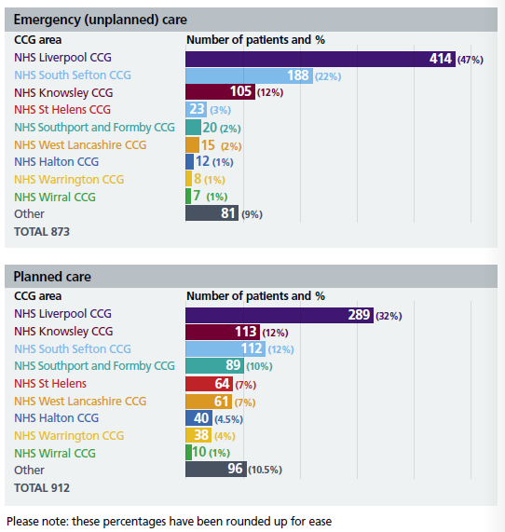
Activity data by protected characteristic is 54% males and 46% females.
Age breakdown is as follows:
Under 30: 5%
30 to 39: 6%
40 to 49: 8%
50 to 59: 16%
60 to 69: 19%
70 to 79: 21%
80 to 89: 20%
90 to 99: 6%

Renal disease is increasing in the local population. There are strong links between the number of patients requiring renal replacement therapy (dialysis) and wider factors, including ethnicity, ageing population, social deprivation, and the prevalence of other long-term conditions such as diabetes, high blood pressure, and cardiovascular diseases (CVD). Liverpool has higher than average levels of all of these things, which means that demand for renal (kidney) services – especially dialysis – is already high, and will continue to increase.
To continue to support these growing patient numbers, the service needs to plan for the future now.

The nephrology service currently provides dialysis to around 750 patients a year, across Aintree, the Royal Liverpool, and Broadgreen hospitals. Dialysis is a vital procedure that removes harmful waste products and excess fluid from the blood when the kidneys stop working properly. However, because each hospital developed their treatment pathways
for dialysis patients separately, before merging into one organisation in 2019, the way that they provide this treatment continues to vary. There also continues to be differences in the staff expertise available at each site. This means that different patients can experience
variations in the quality of care they receive.

There are also variations in care for patients awaiting a kidney transplant. Patients treated at Aintree University Hospital tend to have lower uptake of kidney transplants compared to patients being treated at the Royal Liverpool Hospital, because transplant services are
based at the Royal. NHS Blood and Transplant data from 2018 shows that the average waiting time for a kidney transplant for patients at Aintree University Hospital is 837 days, compared to just 613 days for patients at the Royal Liverpool Hospital. This is because patients at Aintree who need a transplant have to be referred to a transplant surgeon at
the Royal Liverpool, and this can lead to further delays in their care.

Likewise, both sites have active programmes of clinical research for nephrology. However, different studies and research focus have been developed at each hospital over the years.
This means that the trials available to patients at each site can differ. In some cases, patients might benefit from taking part in a clinical trial running on a different site to the one they’re being treated at but aren’t able to under the current arrangements.

Neither Aintree University Hospital or the Royal Liverpool Hospital currently meet national guidelines for permanent access to dialysis for patients who need haemodialysis (HD), which is when a dialysis machine is used to externally filter and clean the blood.
In addition, Aintree is currently failing to meet standards around timely access for patients to start peritoneal dialysis (PD), which is a way of filtering the blood without the need for a dialysis machine. This is mainly due to limited surgeon availability and limited theatre time to insert the catheter which is required for the procedure. Both hospitals also have different models of care for managing patients with acute kidney injury. Harmonising the best practice across both hospital sites is required to ensure that all patients treated by the service get the same quality of care and the best outcomes possible.

The way that the nephrology service is currently set up means that consultants, nurses, and other clinical specialists are spread too thinly across multiple hospital sites. This can lead to some patients receiving a poorer quality of care than others. For example, Aintree University Hospital is currently unable to provide 24-hour access to a nephrology-led care for patients requiring acute haemodialysis (dialysis) services. Instead, they are only able to provide this service 8am - 6pm. Outside of these hours, dialysis for inpatients at Aintree is provided in the Critical Care Unit, where patients do not have specialist nephrology care.

Likewise, nursing levels do not always meet NHS recommendations for renal care
at either Aintree or the Royal Liverpool. Both hospitals struggle to achieve the 1:3 patient to staff ratio which is recognised as best practice for renal patients. Instead, they tend to rely on rotating staff between wards to ensure sufficient cover, and using agency staff to fill the gaps, which can make it difficult to achieve continuity of care for patients. These issues around staff shortages can also mean that there are fewer staff available to support home therapy options, which can be a more flexible and convenient way for some patients to receive their care.
What is the legitimate aim of the service change / redesign?
- Rising demand, demographic needs and patient needs are changing because of an ageing population.
- Value for money-more efficient and equitable service for patients
- Address variation in access to dialysis care
- Address variation in access to transplants
- Address variation in research and clinical trials
- Meet national standards
- Address staff shortages
- Change to service
Proposed Clinical Model

The proposal is to create a single Merseyside and Cheshire Regional Renal Service, based at the Royal Liverpool Hospital.

This new renal centre would be purpose-built, to provide both planned and emergency renal care, and would offer more capacity for the service. It would include an increase in beds for kidney care, and more dedicated beds for transplant patients. A larger number of dialysis stations (62 in total) is also planned.

Centralising renal care in this way would mean that Aintree University Hospital
would no longer have any inpatient renal beds (inpatient beds are for treatment requiring an overnight stay in hospital), but it would still have a renal consultant presence and retain the ability to provide dialysis for patients at the hospital with renal failure.

The satellite sites based at Broadgreen, St Helens, Warrington, Halton, Aintree, Waterloo, and Southport would continue to operate just as they do now.

By reducing duplication between Aintree and the Royal Liverpool more resources and staff time could be freed up to help enhance the offer at these units – meaning more patients could receive care closer to home. It would also allow the service to provide an expanded Community Dialysis Team, able to support more patients with dialysis at home than is currently possible.

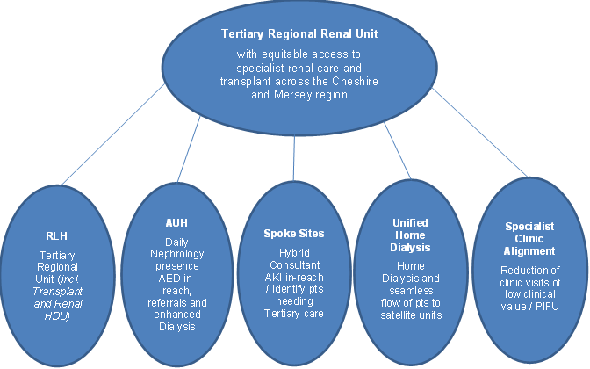
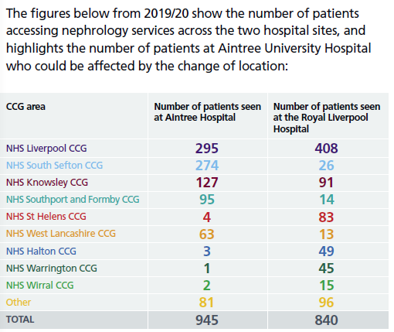
Proposed impact on patient care:
- Better health outcomes - ensuring that patients are cared for by doctors and nurses who are specialists in nephrology would lead to shorter hospital stays, reduced chance of readmission to hospital, and reduced mortality rates.
- More equitable care - Reorganising nephrology staff to work as a single, unified team providing all aspects of kidney care would help address current variations in care and ensure that all patients receive timely access to life-saving transplants and other treatments.
- More efficient use of staff - Reducing the number of different hospital sites that the nephrology inpatient team are spread across would help streamline the service, address staffing issues, and help improve capacity within the service.
- Enhance patient experience: Centralising the service would also help free up staff time to support more patients to access dialysis at home and improve their quality of life.
- Drawing together best practice: Taking the best of existing systems and practices from each hospital site could help to enhance patient care, particularly in those areas where the service is currently failing to meet national standards.
- More space - Reshaping the service in this way would also help to address the estates issues, as more space will be available for the service at the Royal Liverpool Hospital, as part of a new, purpose-built facility.
- Co-location with related services - Moving all renal care to the Royal Liverpool would mean that patients would benefit from closer collaboration between the nephrology team and several other supporting services such as interventional radiology (imaging and diagnostic testing), and transplant care.
- Better use of resources - Reducing duplication in the service would also create financial savings, as expensive equipment wouldn’t need to be purchased for two separate hospital sites, which could be reinvested into improving other parts of the service.
- Future sustainability - Improving capacity in the service now would also help ensure that it is able to continue to meet growing patient numbers from across the region in the future.
- Consultation
A public consultation about proposals for five Liverpool University Hospitals NHS Foundation Trust (LUHFT) services – breast surgery, general surgery, nephrology, urology, and vascular services took place between 7th June 2022 and August 2022.
Participants could choose which medical areas they wished to comment on (they could choose more than one). 873 people chose to comment on the proposed Nephrology service model.
This data includes those who shared that they were a healthcare professional as well as public responses.
N.B. This analysis is focused on ‘protected characteristics’, so any participant that does not give details cannot be included in the data, as the equality analysis is looking at the concerns of protected characteristics and what they have said in relation to each other. The task is to test for ‘consensus’ or ‘disagreement’ between protected characteristics which may point to specific needs for specific groups. A separate ‘consultation report’ has been produced which will give a detailed view of the overall responses.
Who participated in the Nephrology services questionnaire?
Nephrology services – responses by Sex
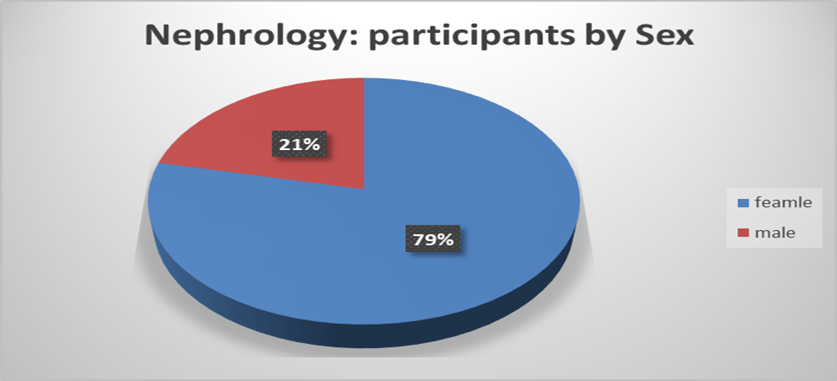
Female: 546
I do not wish to answer this question: 44
Male: 149
No response: 132
Other (please specify if you wish) 2

Females participated at 4 times the level of Males.

Nephrology services – responses by Age and Sex
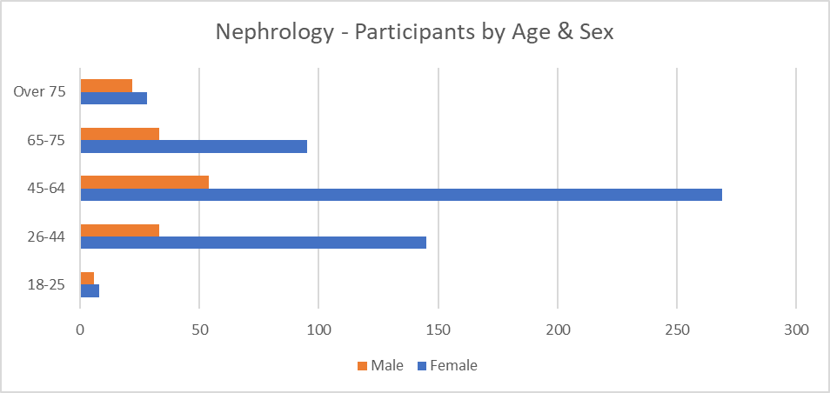
In looking at the age range of participants the biggest group of female participants is the 45-64 age range (similar for males).
Nephrology services – responses by disability
I do not wish to answer this question: 37
No: 484
No response: 127
Yes: 225

Of the 873 Nephrology participants, 225 shared that they have a disability or long-term illness. The mid-year ONS population estimates (2020) that the residents of Liverpool City Region are more likely to suffer from a disability or long-term illness that impacts their day-to-day life than regionally and nationally. It is estimated that 22.7% of the Liverpool City Region population have a disability or long-term illness that impacts their day-to-day activities. The responses from people who shared that they have a disability is 25.77% and is therefore a representative number of responses.
Nephrology services – responses by type disability
Respondents were able to add their own description of disability when selecting the “other” option. 26 respondents provided their own descriptions. All responses could be grouped into one of the above options or across multiple options where respondents provided information on multiple conditions.
Nephrology services – responses by ethnicity
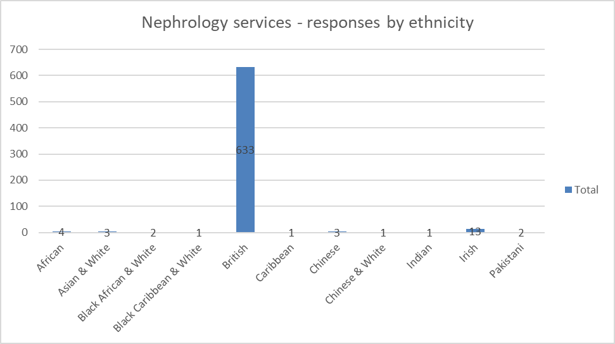

Nephrology services – responses by ethnic group (non-white British)
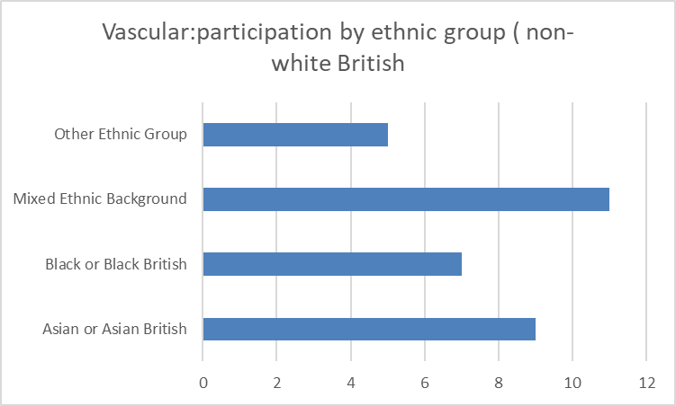
Ethnic minorities: Out of 873 participants in the Nephrology section, 38 were ‘non white British’.

Nephrology services – responses by sexual orientation
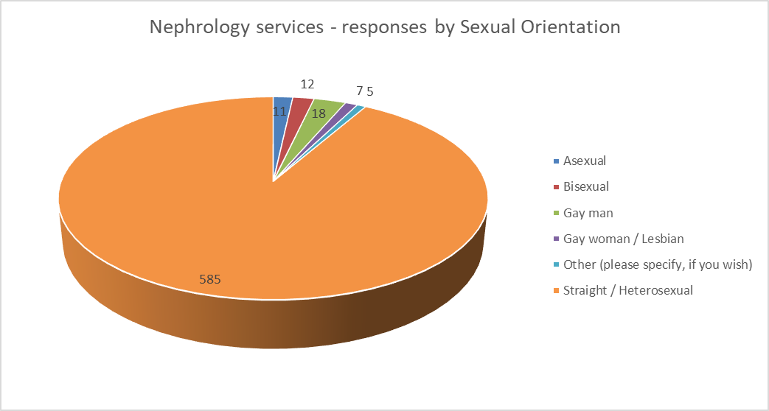
Where there are low numbers, the data and responses are checked to see if they are mentioning any particular problem linked to their protected characteristic, if not, their data is not publicly disclosed and simply included in the ‘general data (e.g., men and women)

What did participants think?
The questionnaire asked many questions, however, there are three key questions for this analysis: 1) what people think of the options/plans. 2, Can they identify any negative effect on them,3) what are the negative effects.
The reason the Analysis focuses on ‘negatives’ is that it is trying to identify any indirect discrimination, as defined by the Equality Act 2010, If there is no discrimination, or any perceived discrimination can be mitigated, then the programme of change can move forward.
Response to the options:
Nephrology services – agreement / non- agreement to statements on plans by Sex
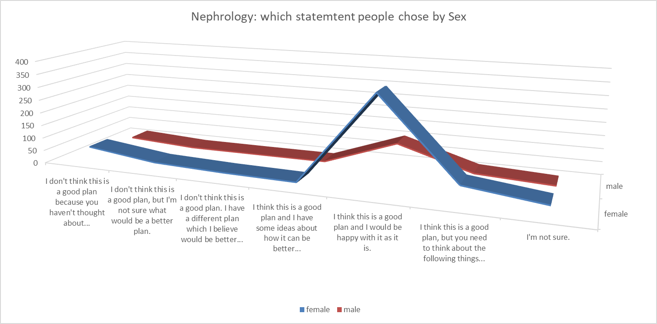
The option of ‘I think this is a good plan and I would be happy with it as it is’ was selected the most.
When looking at the views of people with disabilities, a similar pattern occurs, in that the most selected statement is for the current option to change.
On the last statement ‘I don't think this is a good plan because you haven't thought about... ‘ there is an uptick in numbers. In analysing the reasons put forward, ‘travel’ and ‘accessibility’ were the main points of concern.
The questionnaire also asked: ‘Is there anything else that you would like to tell us about the plan for nephrology to help us make a final decision? For example, are there any parts of the plan that could have a negative effect on you or would put you at a disadvantage compared with other people?’ 114 people said ‘yes’.
The follow up question asks: ‘What would you like to tell us about the plan for nephrology to help make a final decision?’ 68 comments were made by women and 28 by men.
The concerns covered: travel, access to services, distance, car parking, size of facilities and coping with demand, and concerns about local services.
Below is an indicative sample of comments (comments are published verbatim however obvious spelling and grammatical errors have been corrected for ease of reading).
Comments provided by males
- Surprised to see this as part of the consultation - very much comes across that a decision has already been made that this will be centred at RLH. Is this just a box ticking exercise?
- Taking my choice away where I have treatment. Cost of living it’s now going to be more expensive for me to go to Royal Liverpool. I will not attend
- New royal, am hoping sets a new effect for standard of excellence Been let down so many times by Aintree
- It would put me at a disadvantage as I live facing Aintree university hospital so if in the near future I was admitted to hospital my parents would not be able to visit me as easily due to their disabilities
- You don't seem to be giving enough information in this questionnaire to allow us to form a judgement. On the other hand, there's no use in swamping us with information. I suppose the problem is that we just don't trust these types of changes due to historic issues.

Comments provided by females
- Dialysis is a stressful lifestyle there should be as many satellite sites as possible to take this strain
- Many staff are unhappy about merging the trusts services, some staff may become redundant, and it is unclear how the ANPs will function within the new system. This has not been made clear. Reducing the number of beds and increasing the catchment area is madness. Increasing the number of outlying hospitals, we have to serve will massively increase the workload for Renal Registrars and increase the number of calls we receive. We have recently audited this and within a 12-hour period we can receive upwards of [number] response phone calls, many of which are from Whiston. I imagine patients won't be happy about increased travel times especially given many use public transport. Some Consultants will likely have to move to acute medicine are there will not be space for them within the new structure.
- Parking at the Royal for visitors (and staff) is simply dreadful. This needs to be considered. Nephrology patients spend a considerable amount of time on hospital when they become unstable. It is a huge cost burden to family visiting.
- People have little money as it is. Moving from Aintree will be an added cost and burden on local families
- Travel from Southport to the Royal is too far
- You have to think about easy access. Dialysis patients spend so much of their lives attending hospital. You have to do anything you can to ease that burden for them.
- I use a wheelchair and need all services to be fully accessible, including access to examination beds. There should be a selection of transfer aids available
Comments provided by ethnic groups (non-white British)
- Please think about bed space in the New Royal. Sometimes patients are sitting on the clinics for almost 3-4 hours waiting for a bed space or rather patients going through A&E in order to find a bed at some point thereby causing congestion in the emergency
- Many staff are unhappy about merging the trusts services, some staff may become redundant, and it is unclear how the ANPs will function within the new system. This has not been made clear. Reducing the number of beds and increasing the catchment area is
Comments from Lesbian, Gay, Bisexual, Queer plus (LGBQ+)
- Continue at Aintree & The Royal offering a choice to patients
- Travel
- waiting times regarding the size of the New Royal hospital

- Barriers relevant to the protected characteristics

Kidney disease can develop at any time, but those over the age of 60 are more likely than not to develop kidney disease. As people age, so do their kidneys.
Kidney disease has also been found to be more prevalent in those over the age of 60 when compared to the rest of the general population
- Kidney disease kills more people each year than breast or prostate cancer.
- Risk factors for kidney disease include high blood pressure, diabetes, kidney stones, a family history of kidney failure, prolonged use of over-the-counter pain medications, and being over the age of 60
- Kidney failure is up to five times more common in people from minority ethnic groups.
- Many spouses talk about how living with a sick partner weighs down on them, causing severe fatigue. Some aspects of the illness can also become traumatic. The disease regularly disrupts the daily life of the couple and the family. This can lead to a breakdown / reworking of family relations

Protected Characteristic | Issue | Remedy/Mitigation
Age | Older people, particularly those with co-morbidities, are disproportionately affected by renal conditions compared to younger adults.  The patient population is both ageing and characterised by multi-morbidities and higher levels of deprivation compared to national averages.  The transfer of inpatient services could disproportionately impact older people who will need to travel further to access the care they require  The main worry (across all groups) was incurring extra cost and difficulty in travel to the new unit. There was clear concern about bus routes and the difficulty of getting from Southport to Aintree.  A sample of respondent’s comments:  - People have little money as it is. Moving from Aintree will be an added cost and burden on local families  - Travel from Southport to the Royal is too far | *Commissioner and trust collaboration required to undertake further travel assessment to map public transport services and work with transport providers.  *Patients need to be informed of hospital travel services (eligibility for patient transport services), access to travel expenses reimbursement scheme. Continue public relations on the issue of travel and accessibility.  *Commissioner and trust ongoing monitoring of emergency and non-emergency patient transport services (North West Ambulance Service – NWAS) to reassure patients of transport times in an emergency from different parts of the area.
Disability | 225 people shared that they have a disability.  A report published by Kidney Research UK in 2019 reported high rates of severe mental illness in people with chronic kidney disease and people on dialysis. 38 out of 225 who shared that they have a disability shared they had a mental health condition.  Extract of comments provided by people who shared that they have a disability, concerns relate to accessibility and increase travel costs:  - I use a wheelchair and need all services to be fully accessible, including access to examination beds. There should be a selection of transfer aids available  - Taking my choice away where I have treatment. Cost of living it’s now going to be more expensive for me to go to Royal Liverpool. I will not attend  - You have to think about easy access. Dialysis patients spend so much of their lives attending hospital. You have to do anything you can to ease that burden for them. | Service to continue to signpost patients to other relevant support services.  The reconfiguration case sets out a clinical model for Nephrology services with simplified and equitable access for all.  Access to dialysis services at home, where it is clinically appropriate, will be improved, which may benefit patients and carers of people living with a disability.  Satellite dialysis units will continue to facilitate treatment near to home  Outpatient provision will continue at satellite sites.  The service will continue to provide reasonable adjustments.  The service is required to ensure compliance with the accessible information standard and meeting people’s information and communication needs.
Gender reassignment | A number of publications (e.g. Stonewall 2018, Royal College of Nursing 2020) highlights that people who have undergone gender reassignment or planning to undergo gender reassignment frequently experience prejudice and discrimination.  3 people identified as transgender in the nephrology services consultation. When asked overall if they thought the plan was good to improve patient care, 2 responded that they didn’t think it was a good plan and 1 responded that they felt it was partly a good plan. When asked if there were any further comments for consideration to help make a final decision on the plan no comments were provided. | Ensure services are inclusive and staff trained appropriately to deliver good quality, personalised care and support.  No responses identified issues of indirect or direct discrimination linked to protected characteristic.
Marriage and Civil Partnership | Coming to terms with a long-term condition like kidney disease can put a strain on patients, their partners and families.  Partners, spouses etc being involved and able to visit is an important part of patient’s journey. | Service to continue to signpost patients to other relevant support services.  Trust to undertake regular reviews of visiting policy.
Pregnancy and maternity | The pre-consultation equality analysis highlighted that women who have chronic kidney disease are at higher risk of complication during pregnancy.  12 people identified as ‘pregnant’ or had a baby in the last 12 months. Their main concern was travel and distance:  - Patients from the Aintree catchment area of the city may struggle to attend at the Royal site/family may struggle to be able to visit a family member whilst an impatient. If a shuttle bus service/dedicated bus service with reduced fares for patients and families was provided by the trust, this would help | Specialist team will continue to deliver clinics at Liverpool Women’s Hospital.  *Commissioner and trust collaboration required to undertake further travel assessment to map public transport services and work with transport providers.  *Patients need to be informed of hospital travel services (eligibility for patient transport services), access to travel expenses reimbursement scheme. Continue public relations on the issue of travel and accessibility.  *Commissioner and trust ongoing monitoring of emergency and non-emergency patient transport services (North West Ambulance Service – NWAS) to reassure patients of transport times in an emergency from different parts of the area.
Race | There is a complex interaction between ethnicity and socioeconomic status. People from South Asian and Black backgrounds are three to five times more likely to start dialysis. The pre-consultation equality analysis highlighted that people from minority ethnic groups are more likely to need a kidney transplant, but less likely to receive one due to a shortage of donors.  38 people identified as ‘non white British’ within the Nephrology consultation.  A sample of respondent’s comments:  - ‘Please think about bed space in the New Royal. Sometimes patients are sitting on the clinics for almost 3-4 hours waiting for a bed space or rather patients going through A&E in order to find a bed at some point thereby causing congestion in the emergency Dept. This will become worse in the New Royal’.  - Many staff are unhappy about merging the trusts services, some staff may become redundant, and it is unclear how the ANPs will function within the new system. This has not been made clear. | Ensure services are inclusive and staff trained appropriately to deliver good quality, personalised care, and support.  No respondent identified issues of indirect or direct discrimination linked to Race.  *Commissioner and trust collaboration required to undertake further travel assessment to map public transport services and work with transport providers.  *Patients need to be informed of hospital travel services (eligibility for patient transport services), access to travel expenses reimbursement scheme. Continue public relations on the issue of travel and accessibility.  *Commissioner and trust ongoing monitoring of emergency and non-emergency patient transport services (North West Ambulance Service – NWAS) to reassure patients of transport times in an emergency from different parts of the area.
Religion and belief | A person’s religion or belief may impact how the perceive or receive medical treatment. | No responses identified issues of indirect or direct discrimination linked to religion and/or belief.  Ensure staff are trained in understanding needs associated with religion and belief and engage with chaplaincy services.  .
Sex (M/F) | Both males and females expressed similar concerns around the changes to services:  - Travel  - Cost  - Not seeing family  - Car parking  - Access to services  - Concerns about local services  Extract of some of the comments:  - New royal, am hoping sets a new effect for standard of excellence Been let down so many times by Aintree  - People have little money as it is. Moving from Aintree will be an added cost and burden on local families | No respondent identified issues of indirect or direct discrimination linked to sex.  *Commissioner and trust collaboration required to undertake further travel assessment to map public transport services and work with transport providers.  *Patients need to be informed of hospital travel services (eligibility for patient transport services), access to travel expenses reimbursement scheme. Continue public relations on the issue of travel and accessibility.  *Commissioner and trust ongoing monitoring of emergency and non-emergency patient transport services (North West Ambulance Service – NWAS) to reassure patients of transport times in an emergency from different parts of the area.
Sexual orientation | National data shows that LGBQ+ report difficulty in accessing NHS provision and being treated less favourably.  Out of 873 survey responses, 11 shared that they identified as asexual, 12 bisexual, 18 gay man, 7 gay woman/ lesbian, and 5 as ‘other’ identity. 44 of those 53 respondents felt that overall, the proposal was a good plan to improve patient care. 8 of the 53 felt it wasn’t a good proposal, two provided additional comments to help inform decision making, both of which related to site preference. | No issue was identified that liked to indirect or direct discrimination on the grounds of sexual orientation.  Ensure services are inclusive and staff trained appropriately to deliver good quality, personalised care and support.

- Does this service go the heart of enabling a protected characteristic to access health and wellbeing services?
It’s a vital service with an increasing demand as the population ages.

- Have you identified any key gaps in service or potential risks that need to be mitigated
The consultation showed that people are in favour of the changes but had concerns about travel and cost. This needs to be addressed by undertaking a transport analysis and looking at the barriers that the participants in the consultation are highlighting; lack of bus routes, lack of parking, cost of parking, etc. and as such must show that the trust is working in a positive way to help patients, including information for them of any support the hospital can give and the criteria for that support.

Whilst hospital transport may be available, this in itself is not a full mitigation – this can only be fully mitigated when the number of eligible patients and those using the service are understood.

Moving services to alternative locations will always impact on travel for some individuals – that disadvantage (of being further away from accessing the service) is not discrimination in and of itself. However, how the trust responds, or does not respond to the challenges (for example not having disability parking spaces for blue badge holders) or understanding travel /parking issues can result in indirect discrimination.

Other Risk Areas | Required Action | By Who/ When
Activity Data – not provided by protected characteristic to assist in monitoring patient outcomes by protected characteristic. | Capture activity data by number as well as percentage.  Report activity by protected characteristic.  Monitoring outcomes by protected characteristic.  Compare outcomes in protected characteristics e.g. male v female.  *Monitor patient experience by protected characteristic.  Embed equality considerations in serious incident reporting process. | Trust / ongoing – linked to complying with Equality Act 2010.
Widening Health inequalities; Travel/ Transport issues | Undertake further travel/ transport analysis.  Share information with travel / transport, access to patient transport services, travel cost reimbursement scheme. | Trust and Commissioners/ timescale to be discussed and agreed.
Patient experience | *Monitor patient experience by protected characteristic.  Ensure staff are able to access training to support patients with specific needs linked to protected characteristic or other vulnerable groups and trust ongoing monitoring of compliance records.  N.B. employers are vicariously liable for the behaviour of staff whilst in the workplace. | Trust / ongoing – linked to complying with Equality Act 2010.
Staff engagement | Staff consultation | Trust/ in progress

- Is there evidence that the Public Sector Equality Duties will be met (give details) Section 149: Public Sector Equality Duty (review all objectives and relevant sub sections)
PSED Objective 1: Eliminate discrimination, victimisation, harassment and any unlawful conduct that is prohibited under this act.
The service is for all patients that have need of the service. Staff are trained to deliver a professional service to all patients – staff undertake specific training to ensure they can work with diverse individuals.

PSED Objective 2: Advance Equality of opportunity.
Refer to sub-sections.
PSED Objective 2: Section 3. sub-section a) remove or minimise disadvantages suffered by people who share a relevant protected characteristic that are connected to that characteristic.
The service is accessible and can support people with different needs, especially people with disabilities.

Moving forward the service will; provide better monitoring of its service users and the outcomes they receive – looking for parity in service delivery and satisfaction levels.
PSED Objective 2: Section 3. sub-section b) take steps to meet the needs of people who share a relevant protected characteristic that are different from the needs of people who do not share it
During the consultation, all protected characteristics mentioned the need for access, parking, and ease of travel.

Whilst public travel is outside the remit of the trust, it can nonetheless liaise with commissioners and transport providers to identify better serving bus routes.

Patients need to be informed of any hospital transport services that they might be entitled to.

PSED Objective 2: Section 3. sub-section c) encourage people who share a relevant protected characteristic to participate in public life or in any other activity in which participation by such people is disproportionately low.
The service does cater for anyone in the catchment area, home dialysis is available.

Ethnic communities have a low transplant rate and engagement with communities to increase the transplant options must be undertaken.

PSED Objective 3: Foster good relations between persons who share a relevant protected characteristic and persons who do not share it. (Consider whether this is engaged. If engaged, consider how the project tackles prejudice, and promotes understanding -between the protected characteristics)
This objective is not engaged: however, the work of the unit helps people to understand kidney issues both as a patient and a family member of the patient.
PSED Section 2: Consider and make recommendation regards implementing PSED into the commissioning process and service specification to any potential bidder/service provider (private/ public/charity sector)
Further work required to capture, report, and monitor services by protected characteristic.

The lead commissioner requires the trust to provide evidence of compliance with PSED through the NHS Standard Contract. Any proposed future changes to service model/ delivery will be subject to separate equality analysis.
- Recommendation to Board
PSED will be met by the reconfiguration of services.

- Actions that need to be taken
Public concern over transport and travel needs to be addressed and further work done on understanding concerns and barriers that this is presenting to some in the community.

Refer to sections 4 and 6.

https://www.liverpoolcityregion-ca.gov.uk/wp-content/uploa7ds/Data-dashboard-2022022586.pdf
https://www.kidneyresearchuk.org/wp-content/uploads/2019/09/Health_Inequalities_lay_report_FINAL_WEB_20190311.pdf

