Equality Analysis Report
Post-Consultation v4 Final
Integration and Reconfiguration Programme - Clinical Service Model Business Case – Breast Service
Start Date: | 30 May 2022
NHS Cheshire and Merseyside Integrated Care Board Equality and Inclusion Service (Knowsley, Liverpool, Sefton and St Helens Places) | Andy Woods  Jo Roberts | 18 August 2022  24 August 2022
Trust Lead Officer Signature and Date:
Finish Date: | 24 August 2022
Exec Sign Off Signature and Date
Date of Committee consideration

- Details of service / function:
Overview of Services
Liverpool University Hospitals breast services deal with both benign (non-cancerous) breast problems, and breast cancer. Breast cancer is the most common type of female cancer in the UK. With over 55,000 women (and 370 men) diagnosed each year, this accounts for 15% of all new cancer cases. Nationally, rates for breast cancer are projected to rise by 2% by 2035. The teams treat more than 750 cancer cases each year. They provide a full range of diagnostic, treatment and support services, including one-stop diagnostic clinics, breast cancer removal, reconstructive and cosmetic procedures, family history assessment and patient support clinics.

The service aims to provide a world class individualised service to patients with breast concerns throughout the highly specialised multidisciplinary team that take pride in offering patients an efficient, high-quality service.
Liverpool University Hospitals breast services take place at three locations:
• The Marina Dalglish Breast Unit at Aintree Hospital
• Broadgreen Hospital
• The Linda McCartney Centre at the Royal Liverpool Hospital

Each location provides different types of care:
• Clinics to diagnose patients take place at both Aintree Hospital and the Royal
Liverpool Hospital.
• Breast screening for women aged 50 to 70, as part of the National Breast Screening Programme, is based at Broadgreen Hospital, and via mobile units.
• Breast surgery currently takes place at Broadgreen Hospital and the Royal Liverpool Hospital. Before the COVID-19 pandemic, breast surgery took place at Aintree Hospital and the Royal Liverpool Hospital. However, because of the pandemic a series of temporary changes were put into place, to allow services to continue and minimise disruption for patients. In autumn 2021, the majority of breast surgery was moved to Broadgreen Hospital, with a small number of more complex patients being treated at the
Royal Liverpool Hospital. This arrangement is part of the plan to recover services after COVID-19. Currently, no breast surgery is taking place at Aintree Hospital. This is a temporary change – the purpose of this public consultation is to put forward a permanent proposal for the future of breast surgery at Liverpool University Hospitals.

The table below shows which areas the majority of patients who use breast services come from, and whether they use Aintree Hospital or the Royal Liverpool Hospital (they don’t reflect the patients currently using Broadgreen as this is a temporary change).
The figures shown are for 2019/20 (rounded to the nearest whole number). Where there are only a very small number of patients from a particular area, they have been included in the ‘other’ listing.
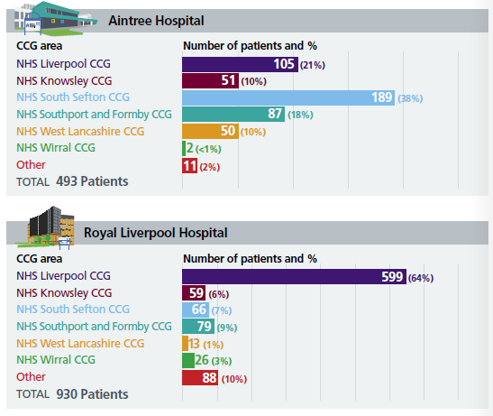
Service activity by sex is 94% female and 6% male.
Service activity by age is as follows:
Under 30: 5%
30 – 39: 9%
40 – 49: 16%
50 – 59: 26%
60 – 69: 21%
70 – 79: 16%
80 – 89: 6%
90 – 99: 1%
What is the legitimate aim of the service change / redesign
- Demographic needs and changing patient needs are changing because of an ageing population.
- Value for Money-more efficient and equitable service for patients
- Duplication and inefficiency across sites
- Differences in capacity across sites
- Shortage of Radiology support.
- Variation in patient pathways
- Access to radio pharmacy
Case for Change – Current Challenges
The greatest challenges within the Breast service currently, is that of capacity, as well as the different care pathways that exist.
These challenges impact on the Trust’s ability to provide timely access to care and subsequently on patient outcomes and experience.
This also affects the services ability to standardise care and operate as an integrated and merged service.
- Change to service
Proposed Clinical Model
Overview
The proposed model is for all surgery, both cancer and benign, to be consolidated at the New Royal Liverpool Hospital site. This model includes an allocation of 2 dedicated Breast inpatient beds, as well as 6 day-case beds. Outpatients, diagnostic and surveillance services would remain at both sites, however Aintree Hospital patients who require cancer treatment or surgery would be referred to the Royal Site.
Changes for patients & visitors
Breast surgery and inpatient beds will all be accommodated on the New Royal Liverpool Hospital site. All patients requiring Breast surgery and inpatient care will be admitted to the Royal, which will house increased theatre and bed capacity and will benefit from being co-located with other cancer specialties. This will improve the quality of care that is delivered and ensure that all patients are able to access safe, timely and consistent care.
All outpatient diagnostic, and surveillance services will remain at the Royal Liverpool Hospital and Aintree Hospital Sites, maintaining patient choice where it is clinically appropriate. Furthermore, Breast Screening Services will remain at Broadgreen Hospital as part of the NHS Breast Screening Programme.
The proposed clinical model will impact visitors due to centralising location that may have an effect on travel and traveling. Breast inpatient and Day-Case beds will be provided at the Royal Liverpool Hospital. All visitors of Breast inpatients will attend the Royal Liverpool Hospital Site.
The proposed model aims;
- To streamline care and improving standards.
- To better manage demand and capacity.
- To have smoother arrangements for pre-operative assessment.
- To have a dedicated breast day and inpatient ward.
- To draw together best practice
- To have access to an on-call breast consultant, seven days a week.
- Consultation
A public consultation about proposals for five Liverpool University Hospitals NHS Foundation Trust (LUHFT) services – breast surgery, general surgery, nephrology, urology, and vascular services took place between 7th June 2022 and August 2022.
Participants could choose which medical areas they wished to comment on (they could choose more than one). 1489 people chose to comment on the proposed Breast service model.
This data includes those who shared that they were a healthcare professional as well as public responses.
N.B. This analysis is focused on ‘protected characteristics’, so any participant that does not give details cannot be included in the data, as the equality analysis is looking at the concerns of protected characteristics and what they have said in relation to each other. The task is to test for ‘consensus’ or ‘disagreement’ between protected characteristics which may point to specific needs for specific groups. A separate ‘consultation report’ has been produced which will give a detailed view of the overall responses.
Who participated in the Breast services questionnaire?
Breast services – responses by Sex 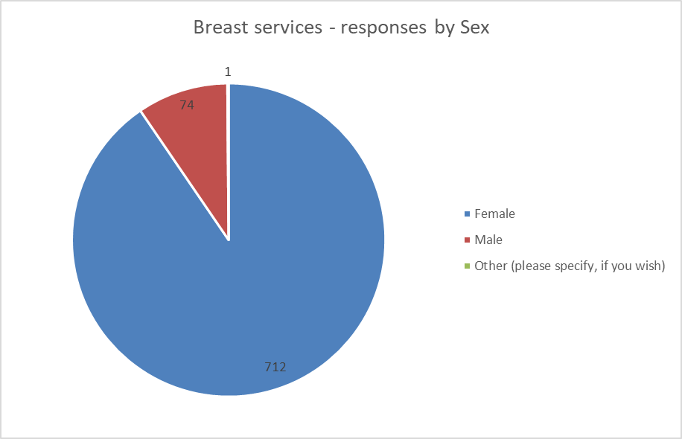

Female: 712 responses 47.82%
Male: 74 responses 4.97%
Other: 1 response 0.07%

228 of the responses from females confirmed that they were healthcare professionals and 29 of the male responses confirmed that they were healthcare professionals.
Participants were also asked to confirm which best described their gender identity from a number of options, 695 responses were female, 70 male, 2 transgender, 8 other identity, 57 did not wish to answer and 657 did not answer.

Breast services – responses by Age
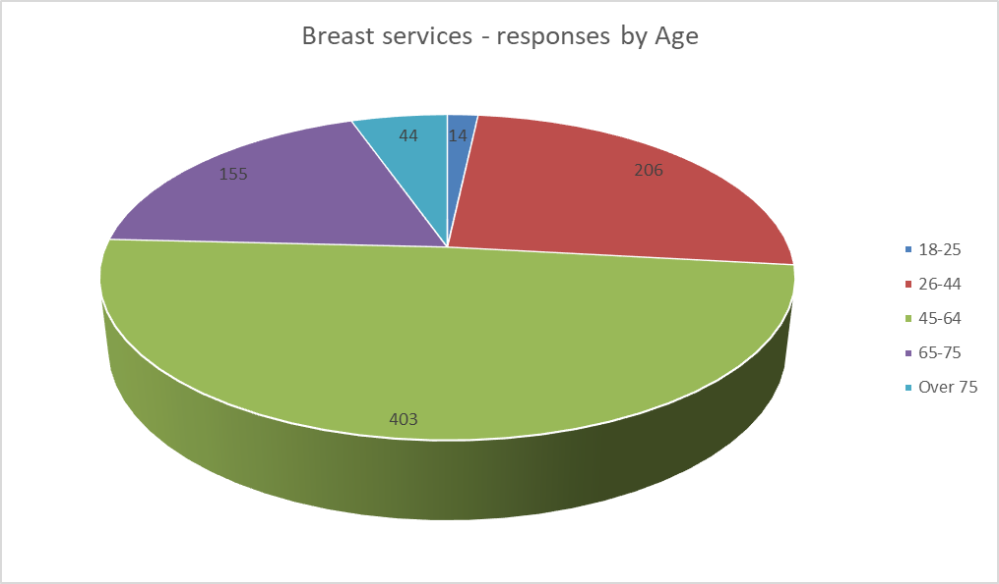
Age 18 – 25: 14 responses 0.94%
Age 26 – 44: 206 responses 13.83%
Age 45 – 64: 403 responses 27.07%
Age 65 – 75: 155 responses 10.41%
Age Over 75: 44 responses 2.96%

Breast services – responses by Age and Sex 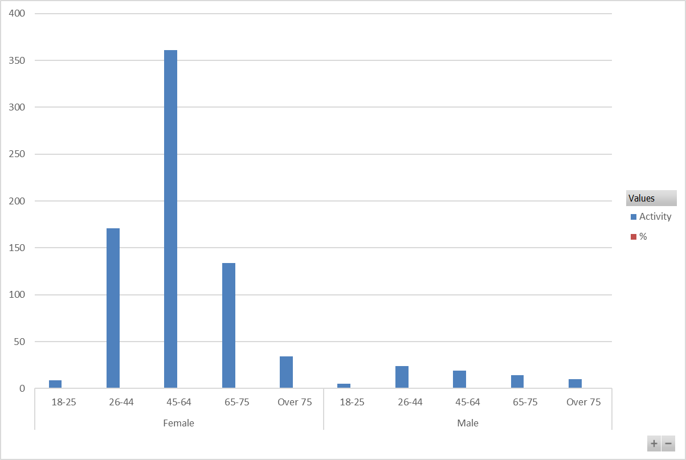
Female
18-25: 9 responses 1.15%
26-44: 171 responses 21.90%
45-64: 364 responses 46.22%
65- 75: 134 responses 17.16%
Over 75: 34 responses 4.35%

Male
18-25: 5 responses 0.64%
26-44: 24 responses 3.07%
45-64: 19 responses 2.43%
65- 75: 14 responses 1.79%
Over 75: 10 responses 1.28%
Breast services – responses disclosing a disability 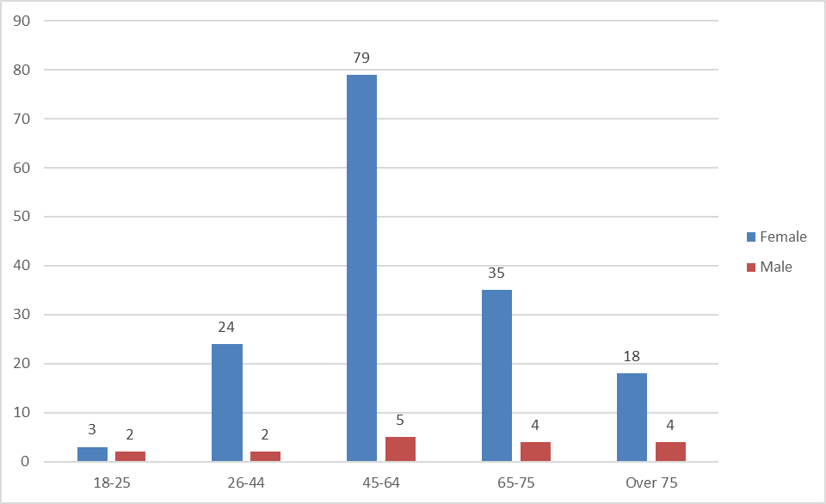
185 people out of 1489 shared that they have a disability.
The mid-year ONS population estimates (2020) that the residents of Liverpool City Region are more likely to suffer from a disability or long-term illness that impacts their day-to-day life than regionally and nationally. It is estimated that 22.7% of the Liverpool City Region population have a disability or long-term illness that impacts their day-to-day activities.
Of the 1489 responses, 185 shared that they had a disability. This is 12.42% which is a significant under-representation.
Respondents were able to select multiple options to this question from the following options; physical disability, learning disability, mental health condition, long-term illness, sight loss, blind, or partially sighted, or other disability which they could then provide their own response.
The percentage of responses by Age and Sex is as follows:
Female
18-25: 1.70%
26-44: 13.64%
45-64: 44.89%
65-75: 19.89%
Over 75: 10.23%

Male
18-25: 1.14%
26-44: 1.14%
45-64: 2.84%
65-75: 2.27%
Over 75: 2.27%

Breast services – physical disability by Age and Sex
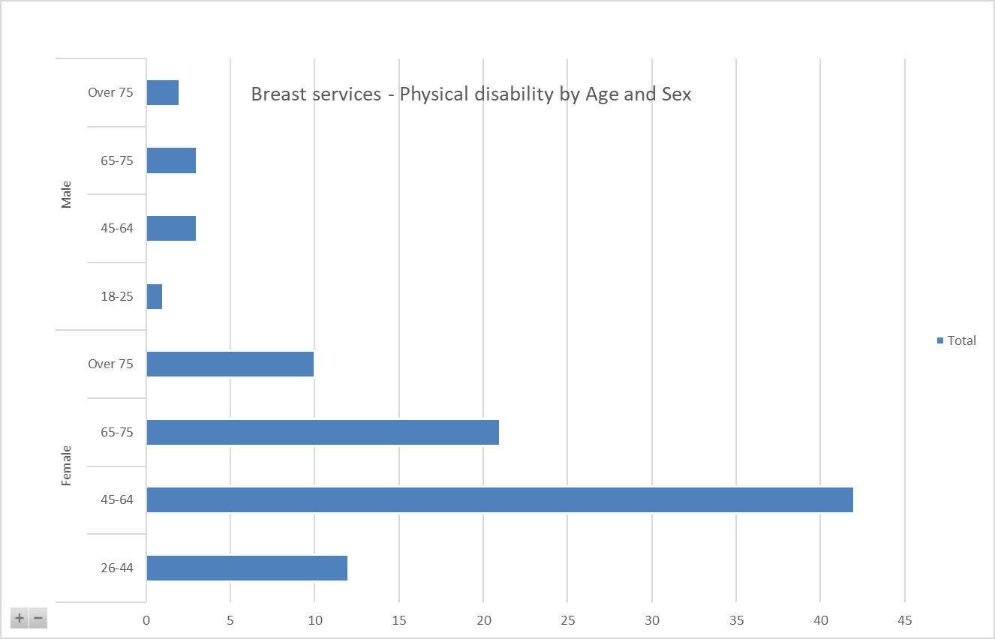
85 female respondents shared that they have a physical disability compared to 9 male respondents.
The age range of those respondents is provided below.
Female
18-25: 0%
26-44: 12.77%
45-64: 44.68%
65-75: 22.34%
Over 75: 10.64%

Male
18-25: 1.06%
26-44: 0%
45-64: 3.19%
65-75: 3.19%
Over 75: 2.13%

7 respondents shared that they have a learning disability. The responses were split across female and males across all ages under 75.
The number of respondents who shared that they have a mental health condition was 38. Responses by age for those sharing their age and sex is as follows:

Breast services – mental health condition by Age and Sex.
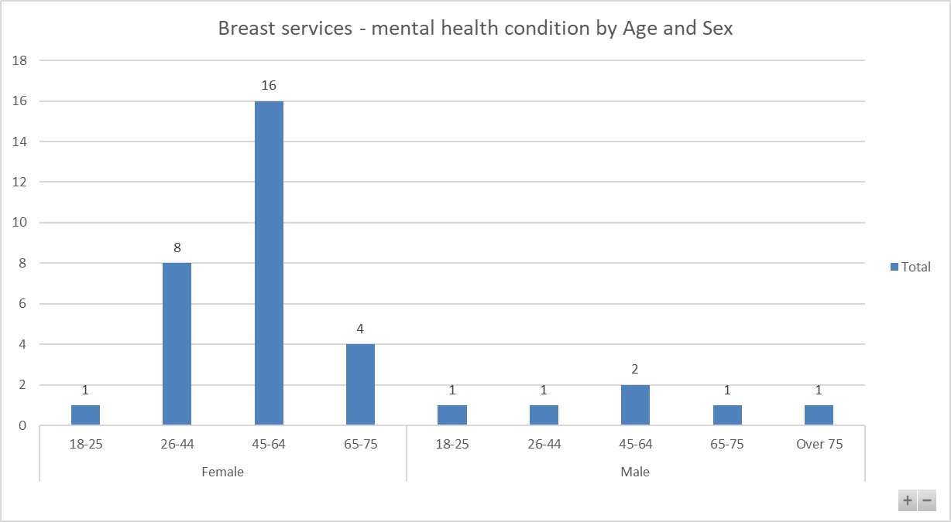
Female
18-25: 2.86%
26-44: 22.86%
45-64: 45.71%
65-75: 11.43%
Over 75: 0%

Male
18-25: 2.86%
26-44: 2.86%
45-64: 5.71%
65-75: 2.86%
Over 75: 2.86%

Breast services – Long term illness that affects daily activity or a progressive condition
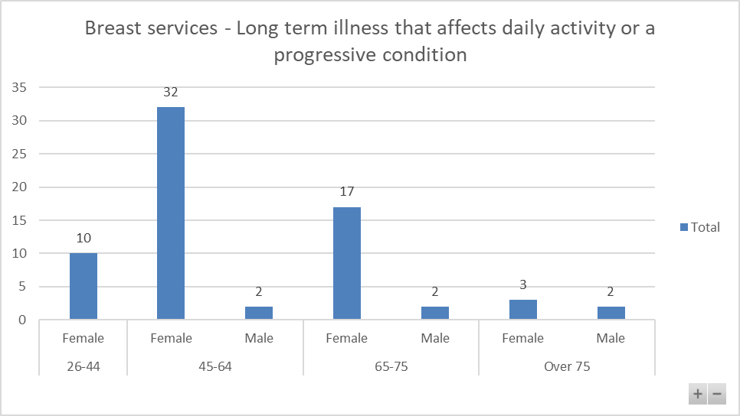
70 respondents shared that they have a long-term illness that affects their daily activity or a progressive condition. 68 of those shared their Age and Sex and a further breakdown of those is provided below:
Female
18-25: 0%
26-44: 14.71%
45-64: 47.06%
65-75: 25.00%
Over 75: 4.41%

Male
18-25: 0%
26-44: 0%
45-64: 2.94%
65-75: 2.94%
Over 75: 2.94%

Breast services – Sight loss, blind, partially sighted
Three females across different age groups (26 to 75) shared that they have sight loss or are blind or partially sighted.
Breast services – Hearing loss
26 respondents shared that they have a hearing loss.
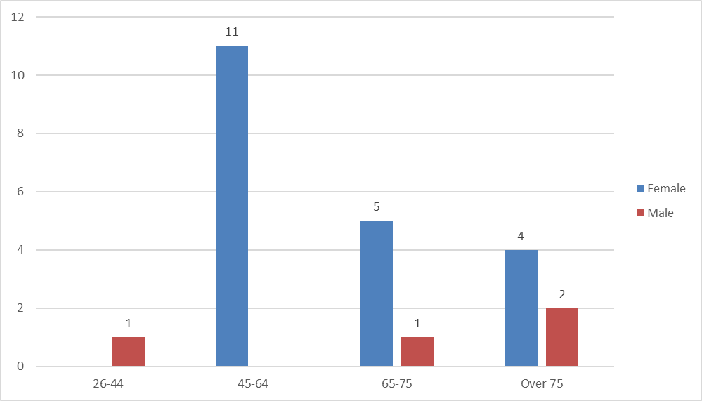
24 of those shared their Age and Sex which is broken down further below:

Female
18-25: 0%
26-44: 0%
45-64: 45.83%
65-75: 20.83%
Over 75: 16.67%

Male
18-25: 0%
26-44: 4.17%
45-64: 0%
65-75: 4.17%
Over 75: 8.33%

Respondents were able to add their own description of disability when selecting the “other” option. 24 respondents provided their own descriptions. All responses could be grouped into one of the above options or across multiple options where respondents provided information on multiple conditions.
Breast services – responses by ethnicity 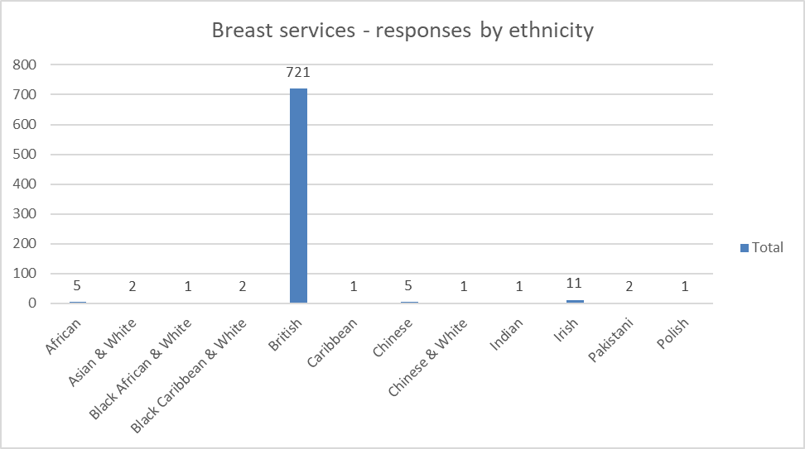
Breast services – responses by ethnic group (non-white British)
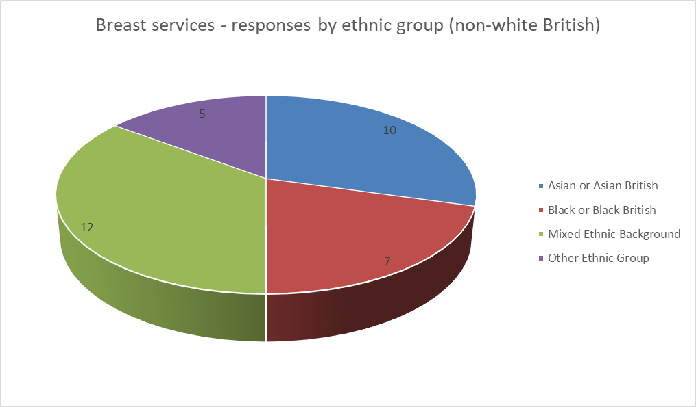
Out of 1489 respondents, 34 shared that they were Asian or Asian British, Black or Black British, Mixed Ethnic Background or Other Ethnic Group. The percentage of responses from non-white ethnic groups is an under-representation of the local population at 2.2%. Responses as follows:
Asian or Asian British: 10
Black or Black British: 7
Mixed Ethnic Background: 12
Other Ethnic Group: 5

Breast services – responses by LGBQ+
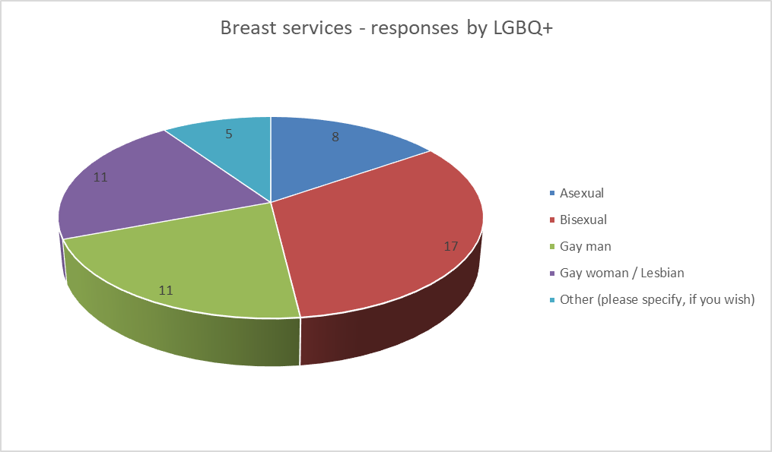
Out of 1489 participants in the Breast service questionnaire, 52 identified as LGBQ+ or other identity as follows:
Asexual: 8
Bisexual: 17
Gay man: 11
Gay woman / Lesbian: 11
Other: 5

Breast services – responses by transgender
When asked which option best describes gender identity, two people identified as transgender.

What did participants think?
The questionnaire asked many questions, however, there are three key questions for this analysis: 1) what people think of the options/plans. 2, Can they identify any negative effect on them,3) what are the negative effects.
The reason the Analysis focuses on ‘negatives’ is that it is trying to identify any indirect discrimination, as defined by the Equality Act 2010, If there is no discrimination, or any perceived discrimination can be mitigated, then the programme of change can move forward.
Response to the options:
Breast services – agreement / non- agreement to statements on plans
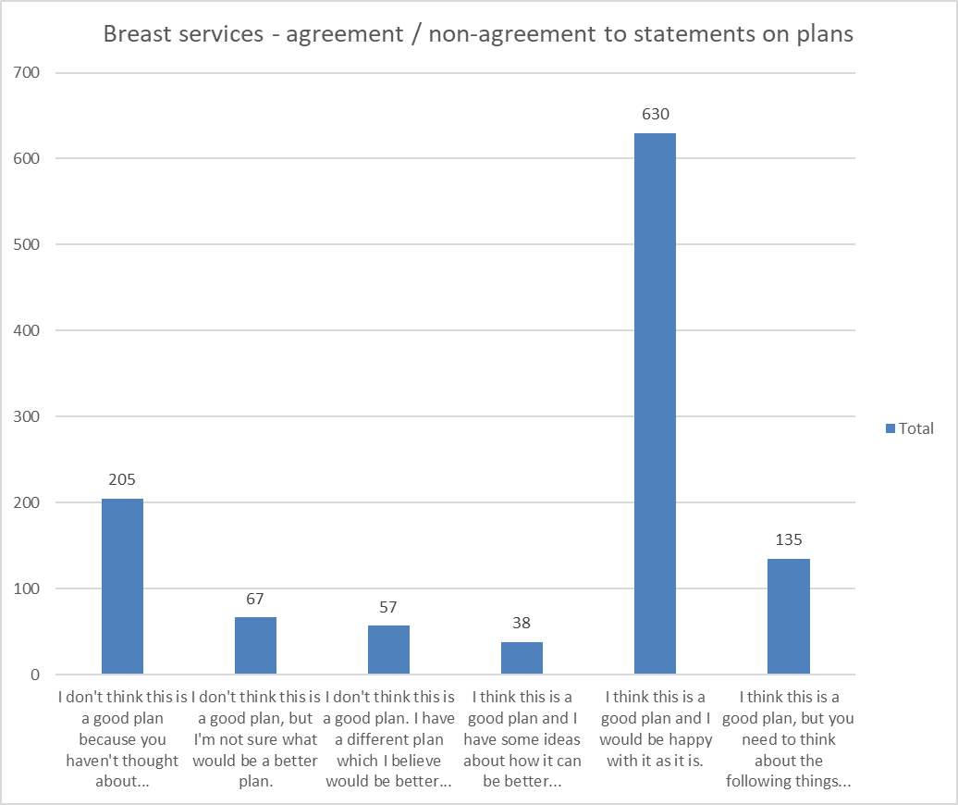

Of the 1132 who responded to this question, 755 shared their sex as follows:

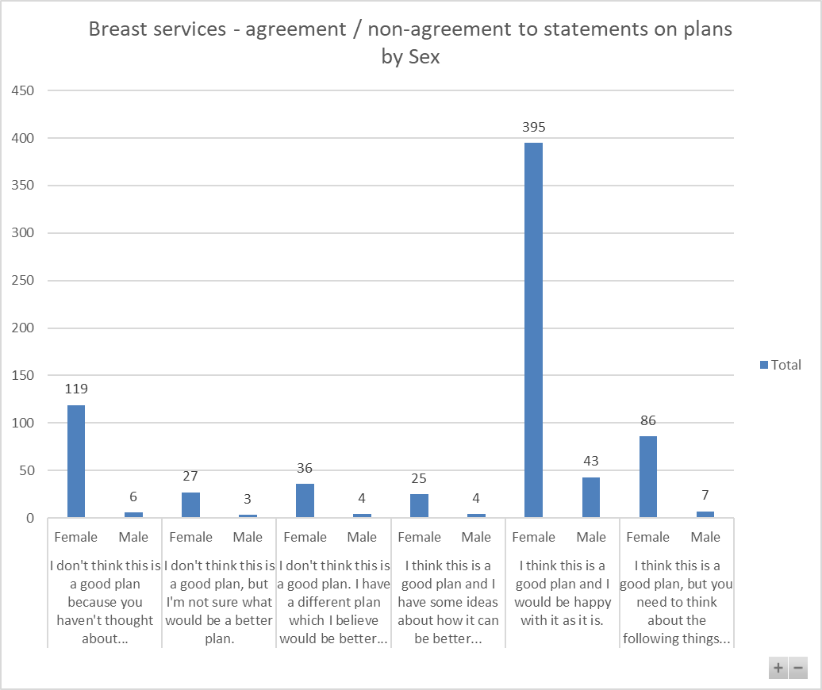
Respondents were invited to provide further narrative if they responded that they had a better plan, or if they had ideas about how it could be better or if they thought it was a good plan but further things needed to be considered.
Themes from the 145 comments provided relate to preference to keep services as they currently are, site preferences, travel/ parking, continuity of care, patient choice, capacity/ waiting times.
101 of the 145 respondents who provided additional comments shared their sex, 98 comments were provided by female respondents and 3 from male respondents.
People who shared that they had a disability provided further comments for consideration, 17 related to keeping services as they are or sharing their site preference/s, 2 related to concerns on patient choice, and 2 concerns related to travel/ parking.

Breast services- pregnancy and maternity.
13 respondents shared that they were currently pregnant or had a baby in the last 12 months. One respondent provided additional narrative for trust and commissioner consideration with the plans which related to their preferred location of service.

Breast services – Overall agreement of plan being good for improving care by sexual orientation
Of the 723 respondents who shared their sexual orientation, 77.45% agreed or partly agreed that overall, it was a good plan for improving care. Of the 52 respondents who shared their sexual orientation as asexual, bisexual, gay man, gay woman or other, 40 responded that they weren’t sure, agreed or partly agreed that it was a good plan.
The statement selected the most across all protected characteristics was that the plan is good, and the respondent would be happy with it as it is. The questionnaire however gives the opportunity to report issues that might be disadvantageous.
The questionnaire asked: ‘Is there anything else that you would like to tell us about the plan for Breast services to help us make a final decision? For example, are there any parts of the plan that could have a negative effect on you or would put you at a disadvantage compared with other people?’ 158 responded ‘yes’ to this question.
The follow up question asks: ‘What would you like to tell us about the plan for Breast services to help make a final decision?’ Equality monitoring information was not provided by all respondents, where it was provided it is possible to highlight that woman made 134 comments and men made 8.
The concerns that were evident revolved around: travel, access, distance, distance for families, quality of care and being oversubscribed, cost, parking, concern about staff.
Below is an indicative sample of comments (comments are published verbatim however obvious spelling and grammatical errors have been corrected for ease of reading).
Comments provided by females
6 years ago, I had all my treatment, diagnosis, surgery and radiotherapy at Aintree which was excellent. Public transport links are not good for people having to attend the Liverpool site from West Lancs. What will happen to the radiotherapy suite at Aintree?
Ability to travel between multiple sites very difficult and costly. Potential job opportunities and experience lost
Access for public travel as previous stated not everyone can afford taxis, this would also people having visitors when in hospital which all affects mental health when a patient in hosp. Nothing worse being in hospital and not being able to get visitors
Aintree Hospital is all set up for Breast Cancer care etc. Radiotherapy is done there, chemotherapy is done there, consultations are done there. The Breast Care team are exceptional, I have not found that at the Royal and would be loath to move. I had the choice of Aintree or the Royal and chose Aintree due to the stress of driving through Liverpool for appointments. If you live in Southport you need to be able to go local.
Am disabled and as stated before elderly disabled or unwell will not be well enough or afford to get to the Royal when in catchment area for Aintree.
Consider the distance
consultations and help and advice should remain at the Linda McCartney Centre as it is a specialist centre
for physically disabled people living in south Liverpool would find it excessively expensive to travel to diagnostic clinic at Aintree Hospital
Getting into the city may be harder than parking up at Aintree
I am a single parent of 3 children I would rely on others to support me during hospital admissions the distance would create further stress in those helping me during this time
I have a family member who is affected by breast cancer and having to travel to the Royal would have a negative impact
I have no faith in RLH they made several mistakes in my diagnosis
are referred for 2ww breast consultations they may struggle to pay the bus fare to attend as parking at the royal site is so poor. I would suggest putting on a patient bus to avoid this
I think you need to consider the capacity to perform surgery in just one place. There seems to be an increasing need and you would have to ensure waiting lists are not negatively affected by a single site service
I'm not mobile and have a medical condition that makes travelling far difficult.
Keeping detection clinics spread locally has to be a priority - I have no concerns about surgery being relocated
Move everything to Aintree. moving to the Royal is a dirty hospital and no parking
Public transport/cost of taxis would be a worry should I ever need to travel to the Royal - services need to be kept local.
Parking charges are extortionate
Royal is very difficult to get to and park particularly for people in a wheelchair
The ability to house these patients in one hospital for which there's also little parking. A reduction in experienced staff and resources, longer wait lists
Too much travel
Travel and parking if there is a prolonged period of treatment
Travel for disabled people without a car, as have to rely on taxis. The Marina Dalglish Unit at Aintree is well enough established enough to deal with Breast care and Surgery.
Treatment being provided in different location to other care can be distressing for some older patients or those with additional needs. There is also no patient choice in first appointment. Patients would be allocated the first slot - this could be in a place inaccessible to the patient. Public transport is poor. Royal Liverpool hospital has worse availability of parking and there is no connection to the car park for disabled patients.
What effects are these plans going to have on existing waiting lists?
Whilst having all specialist services together may make sense, it is very far for people to come if you live Sefton and some other areas.
I think public transport needs to be improved. There is no bus route to any site from our area and I think it needs to be addressed
Please keep the surgery at the royal and broad green
Some virtual tours of the facilities for patients who might be unfamiliar with settings different to where they were screened
Let people go to their nearest hospital for diagnostic tests and any treatment
As a non-driver it's much easier to get to royal Liverpool than Aintree using public transport.
You need to take into consideration access, transport & parking especially for patients based in Sefton
I use a wheelchair and have had problems using services in Liverpool Hospitals and clinics. The services must comply with the Equality Act
Ensure cancer breast services have a shop where patients can buy false breast inserts, wigs, headscarves etc
I could not afford to keep travelling to the Royal especially as Aintree is so much nearer for me. I also do not know how to drive to the Royal as I do not drive into Liverpool
If people are in a situation that they need breast surgery, why make it more difficult for their families. Putting them in a hospital further away
Accessibility, maybe a free shuttle bus to and from Aintree rluh and bgh
Mersey Gateway bridge costs would be incurred for those living on the 'wrong' side of the bridge, but technically fall within Halton
Broadgreen has a more calming relaxed atmosphere and all breast patients have complimented on this
People who don’t have access to transport and don’t qualify for an ambulance would be disadvantaged
Think about accessibility to these services. We are a big city. Poverty is an issue and the cost of attending hospital can be a huge disadvantage to some, which can often mean they don’t attend at all or their attendance is sporadic because they can’t afford to get there - especially now in this economic nightmare.
Public Transport is a major issue for all patients not able to drive themselves or be dropped off. This is especially the case for the elderly, low-income patients, and refugees with limited income.

Comments provided by Males
Lack of investment and infrastructure in Breast radiology services has led to dangerous work patterns for staff, specifically on AUH site. If this is not rectified, LUHFT will be liable for the downfall of the service, potential patient harm and loss of specialist staff due to dangerous working practices and pressures, currently being ignored by management team
The Royal can be harder to get to and park at than Aintree. What about these issues?
the staff in the royal theatres have worked with the breast team for a very long time and I think that this should be kept together with the same staff.
getting there could be difficult for elderly patients
Please make it a one stop shop for diagnosing, Surgery and Breast screening
Distance, opening times, capacity and capability

Comments provided by people who shared they have a disability
Liverpool for appointments. If you live in Southport you need to be able to go local.
Am disabled and as stated before elderly disabled or unwell will not be well enough or afford to get to the Royal when in catchment area for Aintree.
for physically disabled people living in south Liverpool would find it excessively expensive to ravel to diagnostic clinic at Aintree Hospital
I have no faith in RLH they made several mistakes in my diagnosis
I think the royal is too far away
I think you need to cover both north and south Liverpool. Ease of access takes so much pressure off anxious patients
I would prefer it at Aintree Hospital. We already have the Marina Dalglish Centre of excellence in my opinion and lots of available parking
it would be further away from my home, I'm not mobile and have a medical condition that makes travelling far difficult.
Travelling costs involved
I think patients should be treated at their nearest Hospital. A lot of these patients will be very ill and having to make a longer journey for treatment would be something else they would have to deal with.
Too much travel
Transport and accessibility
Travel for disabled people without a car, as have to rely on taxis. The Marina Dalglish Unit at Aintree is well enough established enough to deal with Breast care and Surgery.
Travel times will increase
I use a wheelchair and have had problems using services in Liverpool Hospitals and clinics. The services must comply with the Equality Act
Ensure cancer breast services have a shop where patients can buy false breast inserts, wigs, headscarves etc
I could not afford to keep travelling to the Royal especially as Aintree is so much nearer for me. I also do not know how to drive to the Royal as I do not drive into Liverpool
If people are in a situation that they need breast surgery, why make it more difficult for their families. Putting them in a hospital further away
Distance, opening times, capacity and capability

Comments provided by ethnic groups (non-white British)
Distance, opening times, capacity and capability
Please keep the surgery at the royal and broad green
I am currently booked in for my part mastectomy at Clatterbridge hospital, it is much easier to get to. just one bus from where I live
Mersey Gateway bridge costs would be incurred for those living on the 'wrong' side of the bridge, but technically fall within Halton

Comments from Lesbian, Gay, Bisexual, Queer plus (LGBQ+)
Accessibility, maybe a free shuttle bus to and from Aintree rluh and bgh
I am unclear what happens to those who have had breast surgery and promised that can contact the specialist breast nursing service at any time by self-referral if there are any concerns. I currently have a telephone number for Aintree Hospital that is convenient for me, and I know the staff. I would not want to have to go to another hospital and try and search for a contact person.
It is a stressful time & the added stress of travelling to Liverpool is not necessary when Aintree is well equipped to offer excellent facilities that Marina Dalglish has helped to provide
Travel
Ensure cancer breast services have a shop where patients can buy false breast inserts, wigs, headscarves etc
Travel distances
- Barriers relevant to the protected characteristics
The proposed changes aim to address capacity issues and variations in care that currently impact on the Breast service, which often lead to delays in care, duplicate tasks and appointments with patients which is impacting on the experience of care and the health outcomes for patients.
Through the proposed model, access to Breast services will be improved and the capacity of the service increased, which will benefit all patients.

Protected Characteristic | Issue | Remedy/Mitigation
Age | The pre-consultation Equality Analysis report highlighted that the age group requiring treatment at the trust were largely women who are 50+ in age. Patients under the age of 30 were the smallest cohort of patients. This is reflective in breakdown of responses by age group.  There were 1489 responses to the proposal on reconfiguring breast services only some of which declared an age group.  This data includes those who identified themselves as a healthcare professional as well as public responses. Age breakdown of responses is as follows. 18–25 (14), 26–44 (206), 45–64 (403), 65–75 (155), Over 75 (44).  A sample of respondent’s comments:  - getting there could be difficult for elderly patients  - People who don’t have access to transport and don’t qualify for an ambulance would be disadvantaged  - Public transport/cost of taxis would be a worry should I ever need to travel to the Royal - services need to be kept local.  - I think public transport needs to be improved. There is no bus route to any site from our area and I think it needs to be addressed  - As a non-driver it's much easier to get to royal Liverpool than Aintree using public transport. | Outpatient and diagnostic services remain on Royal and Aintree sites.  Patients who would have previously used Aintree would have better access to Saturday operating slots under these proposals, which would provide more choice for people who might find it harder to attend during the week.  *Commissioner and trust collaboration required to undertake further travel assessment to map public transport services and work with transport providers.  *Patients need to be informed of hospital travel services (eligibility for patient transport services), access to travel expenses reimbursement scheme. Continue public relations on the issue of travel and accessibility.  *Commissioner and trust ongoing monitoring of emergency and non-emergency patient transport services (North West Ambulance Service – NWAS) to reassure patients of transport times in an emergency from different parts of the area.
Disability | The pre-consultation equality analysis highlighted reports that cancer diagnoses in women with disabilities can complicate their perceptions of their physical and emotional well-being and how they consider treatment options.  185 people out of 1489 respondents shared that they have a disability. A sample of respondent’s comments:  - I have no faith in RLH they made several mistakes in my diagnosis  - I'm not mobile and have a medical condition that makes travelling far difficult.  - Travelling costs involved  - Transport and accessibility  - Travel for disabled people without a car, as have to rely on taxis.  - I use a wheelchair and have had problems using services in Liverpool Hospitals and clinics. The services must comply with the Equality Act  - Distance, opening times, capacity and capability | Ensure service meets information and communication needs to enable patients to make informed decisions, providing inclusive and personalised care.  Clinicians must continue to consider disability and mobility functioning in making therapeutic recommendations to people with impairments or mobility difficulties who need medical treatment.  People with disabilities need to be encouraged to undergo all available treatment appropriate to them. The Trust is under a legal duty to ensure that all reasonable adjustments are made for disabled people.  This includes types of treatment and use of equipment and support packages post treatment.  *Commissioner and trust collaboration required to undertake further travel assessment to map public transport services and work with transport providers.  *Patients need to be informed of hospital travel services (eligibility for patient transport services), access to travel expenses reimbursement scheme. Continue public relations on the issue of travel and accessibility.  *Commissioner and trust ongoing monitoring of emergency and non-emergency patient transport services (North West Ambulance Service – NWAS) to reassure patients of transport times in an emergency from different parts of the area.
Gender reassignment | There were two people who responded to the survey who shared that they were transgender. One of those respondents provided additional comments to the question “what would you like to tell us about the plan to help make a final decision” linked to travel and recruitment concerns. | No responses identified issues of indirect or direct discrimination linked to protected characteristic.  Ensure services are inclusive and staff trained appropriately to deliver good quality, personalised care and support.
Marriage and Civil Partnership | The pre-consultation equality analysis highlighted a report on cancer incidence by marital status. A cancer diagnosis imposes significant emotional distress on a substantial proportion of patients and their partners.  Partners, spouses etc being involved and able to visit is an important part of a patient’s recovery process. | The service will continue to provide signposting support as appropriate to individual patient / partner needs.  Trust to undertake regular reviews of visiting policy.  No respondent identified issues of indirect or direct discrimination linked marriage or civil partnership.
Pregnancy and maternity | 13 respondents shared that they were currently pregnant or had a baby in the last 12 months. One respondent provided additional narrative for trust and commissioner consideration about the plans which related to preferred location of services. | No responses identified issues of indirect or direct discrimination linked with pregnancy and maternity.
Race | The pre-consultation equality analysis report highlighted a National Cancer Patient Experience audit undertaken in 2019 which details experiences in a sample of cancer patients. Poorer experience of cancer care is consistently reported in ethnic minority groups but the reasons for this are poorly understood.  Out of 1489 respondents, 56 identified as ‘non-white British’  Concerns related to distance, opening times, capacity, and capability.  A sample of respondent’s comments:  - Mersey Gateway bridge costs would be incurred for those living on the 'wrong' side of the bridge, but technically fall within Halton | Ensure services are inclusive and staff trained appropriately to deliver good quality, personalised care, and support.  No respondent identified issues of indirect or direct discrimination linked to Race.
Religion and belief | A person’s religion or belief may impact how the perceive or receive medical treatment. | No responses identified issues of indirect or direct discrimination linked to religion and/or belief.  Ensure staff are trained in understanding needs associated with religion and belief and engage with chaplaincy services.
Sex (M/F) | Reports show that women are far more likely to use public transport than men, women and older people are far more likely to use public transport as they have the lowest car ownership.  Concerns from both men and women respondents linked to:  Travel, distance, cost of travel, quality of services, Losing good facilities, parking, local services. A sample of respondent’s comments:  Comments from female respondents:  - Public transport links are not good for people having to attend the Liverpool site from West Lancs.  - I have a family member who is affected by breast cancer and having to travel to the Royal would have a negative impact  - What effects are these plans going to have on existing waiting lists?  - Poverty is an issue and the cost of attending hospital can be a huge disadvantage to some, which can often mean they don’t attend at all, or their attendance is sporadic because they can’t afford to get there - especially now in this economic nightmare.  Comments from male respondents:  - The Royal can be harder to get to and park at than Aintree.  - Please make it a one stop shop for diagnosing, Surgery and Breast screening  - Distance, opening times, capacity and capability | *Commissioner and trust collaboration required to undertake further travel assessment to map public transport services and work with transport providers.  *Further travel assessment needs to be undertaken to map out public transport services and work with transport providers.  *Patients need to be informed of hospital travel services (access to patient transport services), access to travel expenses reimbursement scheme and eligibility criteria. Continue public relations on the issue of travel and accessibility  *Commissioner and trust ongoing monitoring of emergency and non-emergency patient transport services (North West Ambulance Service – NWAS) to reassure patients of transport times in an emergency from different parts of the area.
Sexual orientation | Nationally, LGBQ+ community reports difficulty in accessing and being treated with respect whilst using the NHS.  Out of 1489 respondents, 52 identified as LGBQ+  A sample of their concerns:  - Travel  - Ensure cancer breast services have a shop where patients can buy false breast inserts, wigs, headscarves etc  - Accessibility, maybe a free shuttle bus to and from aintree rluh and bgh  - I am unclear what happens to those who have had breast surgery and promised that can contact the specialist breast nursing service at any time by self-referral | Ensure services are inclusive and staff trained appropriately to deliver good quality, personalised care and support.  No responses identified issues of indirect or direct discrimination linked to sexual orientation.
- Does this service go the heart of enabling a protected characteristic to access health and wellbeing services?
Yes – the service is essential for women’s health.
- Have you identified any key gaps in service or potential risks that need to be mitigated?

The consultation showed that people are in favour of the changes but had concerns about travel and cost. This needs to be addressed by undertaking a transport analysis and looking at the barriers that the participants in the consultation are highlighting; lack of bus routes, lack of parking, cost of parking, etc. and as such must show that the trust is working in a positive way to help patients, including information for them of any support the hospital can give and the criteria for that support.

Whilst hospital transport may be available, this in itself is not a full mitigation – this can only be fully mitigated when the number of eligible patients and those using the service are understood.

Moving services to alternative locations will always impact on travel for some individuals – that disadvantage (of being further away from accessing the service) is not discrimination in and of itself. However, how the trust responds, or does not respond to the challenges (for example not having disability parking spaces for blue badge holders) or understanding travel /parking issues can result in indirect discrimination.
Refer to table below.

Other Risk Areas | Required Action | By Who/ When
Activity Data – not provided by protected characteristic to assist in monitoring patient outcomes by protected characteristic. | Capture activity data by number as well as percentage.  Report activity by protected characteristic.  Monitoring outcomes by protected characteristic.  Compare outcomes in protected characteristics e.g. male v female.  *Monitor patient experience by protected characteristic.  Embed equality considerations in serious incident reporting process. | Trust / ongoing – linked to complying with Equality Act 2010.
Widening Health inequalities; Travel/ Transport issues | Undertake further travel/ transport analysis.  Share information with travel / transport, access to patient transport services, travel cost reimbursement scheme. | Trust and Commissioners/ timescale to be discussed and agreed.
Patient experience | *Monitor patient experience by protected characteristic.  Ensure staff are able to access training to support patients with specific needs linked to protected characteristic or other vulnerable groups and trust ongoing monitoring of compliance records.  N.B. employers are vicariously liable for the behaviour of staff whilst in the workplace. | Trust / ongoing – linked to complying with Equality Act 2010.
Staff engagement | Staff consultation | Trust/ in progress

- Is there evidence that the Public Sector Equality Duties will be met (give details) Section 149: Public Sector Equality Duty (review all objectives and relevant sub sections)
PSED Objective 1: Eliminate discrimination, victimisation, harassment, and any unlawful conduct that is prohibited under this act.
The service is for all patients that have need of the service. Staff are trained to deliver a professional service to all patients – staff undertake specific training to ensure they can work with diverse individuals.
PSED Objective 2: Advance Equality of opportunity.
Refer to sub-sections.
PSED Objective 2: Section 3. sub-section a) remove or minimise disadvantages suffered by people who share a relevant protected characteristic that are connected to that characteristic.
The service is accessible and can support people with different needs, especially people with disabilities.

Moving forward the service will; provide better monitoring of its service users and the outcomes they receive – looking for parity in service delivery and satisfaction levels.
PSED Objective 2: Section 3. sub-section b) take steps to meet the needs of people who share a relevant protected characteristic that are different from the needs of people who do not share it
During the consultation, all protected characteristics mentioned the need for access, parking, and ease of travel.

Whilst public travel is outside the remit of the trust, it can nonetheless liaise with commissioners and transport providers to identify better serving bus routes.

Patients need to be informed of any hospital transport services that they might be entitled to.

PSED Objective 2: Section 3. sub-section c) encourage people who share a relevant protected characteristic to participate in public life or in any other activity in which participation by such people is disproportionately low.
The service does cater for anyone in the catchment area, and it is maintaining local services.
PSED Objective 3: Foster good relations between persons who share a relevant protected characteristic and persons who do not share it. (Consider whether this is engaged. If engaged, consider how the project tackles prejudice, and promotes understanding -between the protected characteristics)
Objective not engaged.
PSED Section 2: Consider and make recommendation regards implementing PSED into the commissioning process and service specification to any potential bidder/service provider (private/ public/charity sector)
Further work required to capture, report, and monitor services by protected characteristic.

The lead commissioner requires the trust to provide evidence of compliance with PSED through the NHS Standard Contract. Any proposed future changes to service model/ delivery will be subject to separate equality analysis.
Recommendation to Board
PSED will be met by the reconfiguration of services.
Actions that need to be taken
Public concern over transport and travel needs to be addressed and further work done on understanding concerns and barriers that this is presenting to some in the community.

Refer to sections 4 and 6.

https://www.liverpoolcityregion-ca.gov.uk/wp-content/uploads/Data-dashboard-2022022586.pdf
Heterosexuality/Straight is not included in the chart as more than 90% of the Cheshire and Merseyside population identifies as heterosexual. Homophobic behaviour and discrimination tends to be targeted at people who express their identify as having a different sexuality or identifying by a sex different to that they were assigned at birth.

